Delaware State Fire School

Course Catalog 2026

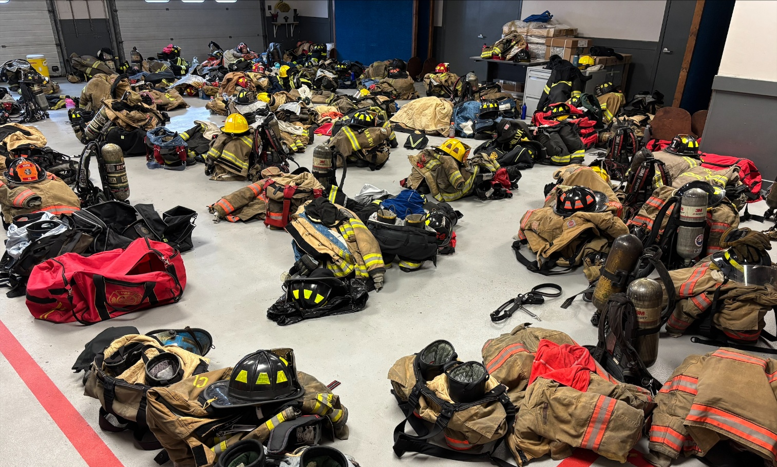

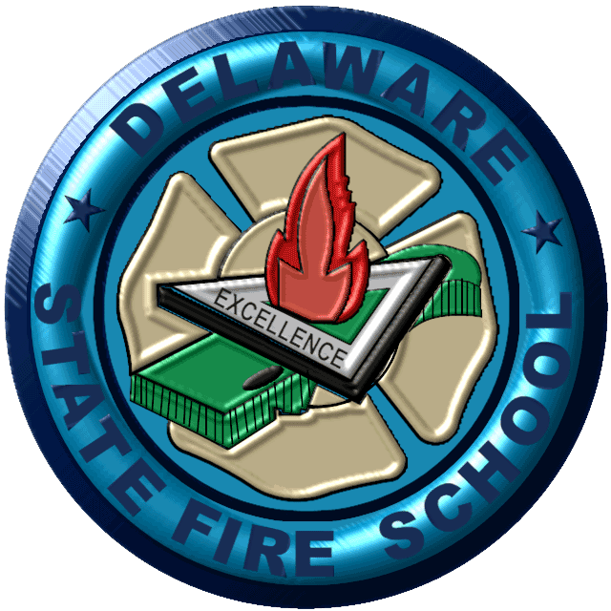

Fire - Rescue - EMS

Industrial Brigades - Fire Safety

TABLE OF CONTENTS

TABLE OF CONTENTS 2-3
D.S.F.S. PROBOARD/IFSAC CERTIFICATIONS 6
ADDRESS, CONTACT INFORMATION, HOLIDAYS, HOTELS 7
DIRECTIONS TO ALL DIVISIONS 8-9
REGISTRATION PROCEDURES, CLASS HOURS, CANCELLATIONS, REUNDS, NO-SHOWS 10
CERTIFICATES, MEDICAL DISABILITIES, PERSONAL PROTECTIVE EQUIPMENT 11
BEARD POLICY, AGE REQUIREMENTS, ELECTRONIC DEVICES 12
STUDENT DRESS CODE & BEHAVIOR POLICIES, COURSE CODING 13
FIREFIGHTER TRAINING PROGRAMS 14-33
FIRE POLICE TRAINING 34
DRONE PILOT TRAINING-CERTIFICATION 35
NATIONAL FIRE ACADEMY PROGRAMS 36
RESCUE TRAINING PROGRAMS 37-42
EMERGENCY MEDICAL SERVICES TRAINING PROGRAMS 43-52
INDUSTRIAL TRAINING PROGRAMS 53-58
HAZARDOUS MATERIALS TECHNICIAN TRAINING 59-61
AGENCY AND INSTITUTIONAL TRAINING PROGRAMS 62-63
PUBLIC FIRE SAFETY EDUCATION-INJURY PREVENTION TRAINING PROGRAMS 64-68
D.S.F.S. SUMMER CAMPS 69
D.S.F.S. RECIPROCITY POLICY FOR OUT OF STATE TRAINING 70
STUDENT DISCLOSURE POLICY 71-72

FIRE TRAINING PROGRAMS
Advanced Fire Behavior Observation & Evolutions 27
Aerial Apparatus Operations 18
Arson Awareness 20
Certification Testing for Pro Board and IFSAC 23
Delaware State Fire School Instructor Orientation 25
Driver/Operator 18
Emergency Vehicle Operations, EVO Online, Competency Course & Refresher Course 25
Engine Company Operations 19
Enhancing Grant Writing 29
Firefighter I-II Accelerated Program 14
Firefighter I-II Regular Program 15
Firefighter Self Survival 16
Firefighting Foam 16
Firefighting Tactics 16
Fire Ground Operations – Size-up – High Rise 27
Fire Inspector 1030 Course 20
Fire Officer I NFPA 1021 21
Fire Officer II NFPA 1021 21
Fire Officer III NFPA 1021 22
Fire Officer IV NFPA 1021 22
Fire Service Instructor I & II Certification Courses 25
Harassment/Discrimination Awareness Training 33
Incident Command Courses 29-30
Incident Safety Officer (NFA) NFPA 1521 16
Introduction to Firefighting 14
National Traffic Management Responder Training Program 20
In-Service Fire Company Training - Fire 31-32
In-Service Fire Company Training – Rescue and Hazardous Materials 31
In-Service Fire Officer Continuing Education 32
Tactical Thermal Imaging Cameras 17
Truck Company Operations 19

FIRE POLICE PROGRAMS:
Basic Fire Police Certificate 34
Delaware Fire Police Orientation Course 34

DRONE PILOT TRAINING:
Drone Pilot Certification Test Preparation 35
Drone Pilot Qualification 35

NATIONAL FIRE ACADEMY:
National Fire Academy Classes 36

RESCUE TRAINING PROGRAMS
Advanced Vehicle Rescue 37
Confined Space Rescue 39
Elevator Rescue 38
High Angle Rescue 37
Rapid Intervention Training – Basic – Leader - Advanced 40-41
Rescue Boat Operations 40
Rope Rescue Operations and Technician 38-39
Vehicle Rescue 37
Water Rescue I and II 41

EMERGENCY MEDICAL SERVICES TRAINING PROGRAMS
BLS Provider CPR/AED Certification/Recertification 49
EMS Continuing Education Units 43
Emergency Medical Responder Certification Requirements 44
Emergency Medical Responder Certification Requirements Through Reciprocity 45
Emergency Medical Responder Full and Refresher Courses 45
Emergency Medical Technician - Requirements to Take Course 46
Emergency Medical Technician Full and Refresher Courses 47
Emergency Medical Technician Reciprocity Class 48
Field Training Officer Courses 48
Heartsaver CPR, AED, First Aid Courses 52
NAEMT Programs (PHTLS, TECC, AMLS) 49
NAEMT Programs (EPC, GEMS, EMS Safety) 50-51
Quality Assurance Officer Training Program 49

INDUSTRIAL TRAINING PROGRAMS
Advanced Exterior Brigade Skills 54
Advanced Interior Brigade Skills 55
Basic Brigade Skills 54
Brigade Leadership Skills 55
Brigade Review - Flammable Liquids/Gas Firefighting 55
Brigade Review - Structural Firefighting 56
Incipient Brigade 53
NFPA 1081 Advanced Exterior Brigade Certification Course 56
Industrial Confined Space Rescue 56
Industrial Confined Space Rescue Refresher 57
Special Fire Brigade Training 58

HAZARDOUS MATERIALS TECHNICIAN TRAINING
Hazardous Materials Awareness 59
Hazardous Materials Operations 59
Hazardous Materials Awareness and Operations 60
Hazardous Materials Technician Certification Course 60
Hazardous Materials Technician Refresher Course 61

AGENCY AND INSTITUTIONAL TRAINING PROGRAMS
Custodial Fire Procedures Course 62
Division of Development Disabilities Services: Special Home Fire Safety Level 62
Fire Extinguisher Training 63
Healthcare Fire Safety 63
Law Enforcement Fire Orientation 63
Patient Evacuation 63

PUBLIC FIRE SAFETY EDUCATION – INJURY PREVENTION TRAINING PROGRAMS
Campus Fire Safety 64
Children’s Fire Safety Programs 65
Delaware State Fire School Field Trips/Tours 66
Escape Planning 67
Fire Safety Displays 67
Fire Safety for Scouting 67
Fire Safety Tour at a School 66
Home Fire Safety for Adult Groups 65
Injury Prevention Programs 68
Kitchen Fire Safety 64
Smoke Alarms 67

DSFS SUMMER PROGRAMS
Junior Fire Academy 69

Visit Our Web Site:
www.statefireschool.delaware.gov
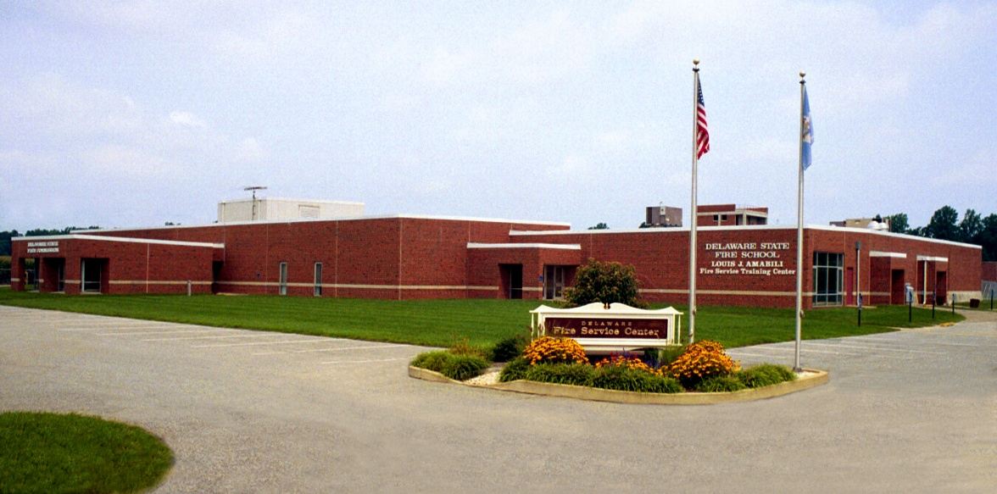

Follow us on our Social Media pages


https://www.facebook.com/DeStateFireSchool/


https://twitter.com/DE_Fire_School



https://www.instagram.com/de_fire_school/

THE DELAWARE STATE FIRE SCHOOL EMBLEM

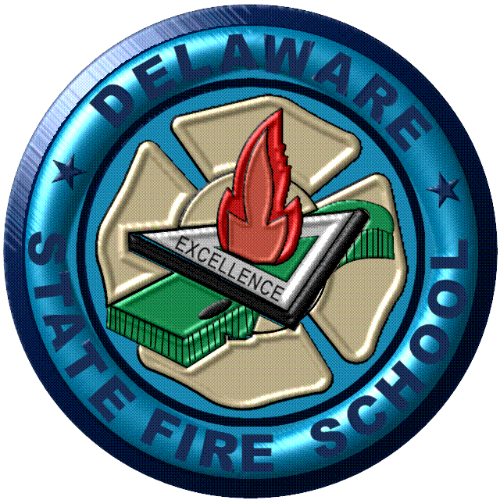

The Dominant Colors Of The Emblem Are Blue And Gold, The State’s Official Colors. The Gold Maltese Cross In The Background Is Symbolic Of The Fire Service; Its Out Stretched Arms Signify A Mantle Of Protection. The State Of Delaware Is Shown In Relief, Stating That Delaware Stands Out In The Area Of Fire Protection. The Green Color Of The State Denotes Continuing Growth. The Triangle, A Symbol Familiar To The Fire Service Encloses A Free Burning Flame. In This Case, The Three Legs Of The Triangle Represent Manpower, Equipment And Training. When These Three Elements Are Combined With “Excellence” As The Goal, Fire Can Be Effectively Contained. When Combined With Companion Chevrons, The Fire School Emblem Attests The Level Of Proficiency That The Wearer Has Attained Through Formal Training.

The Delaware State Fire School

is accredited by the

National Board on Fire Service Professional Qualifications
and
International Fire Service Accreditation Congress

to offer certification in the following:

NFPA 470 Hazardous Material Awareness

NFPA 470 Hazardous Materials Operations
NFPA 470 Hazardous Materials Technician

NFPA 1006 Rope Technical Rescuer (Awareness/Ops/Tech)

NFPA 1006 Passenger Vehicle Rescue (Awareness/Ops/Tech)

NFPA 1006 Confined Space Tech Rescuer (Awareness/Ops/Tech)
NFPA 1010 Driver/Operator-Aircraft Rescue & Fire
NFPA 1010 Driver/Operator-Aerial Operator
NFPA 1010 Driver/Operator-Mobile Water Supply
NFPA 1010 Driver/Operator-Pump Operator
NFPA 1010 Driver/Operator-Tiller
NFPA 1010 Airport Fire Fighter
NFPA 1010 Firefighter I, II
NFPA 1010 Support Person

NFPA 1020 Fire Officer III, IV

NFPA 1021 Fire Officer I, II

NFPA 1030 Fire Inspector

NFPA 1041 Fire Instructor I, II, III

NFPA 1041 Live Fire Instructor, Instructor In-Charge

NFPA 1081 Advanced Exterior Industrial Fire Brigade Member
NFPA 1081 Incipient Facility Fire Brigade Member
NFPA 1091 Traffic Incident Management Personnel NFPA 1550 Incident Safety Officer
NFPA 1550 Health and Safety Officer
NFPA 2400 Remote Pilot for Small UAS (Drone)
NFPA 2400 Visual Observer for Small UAS (Drone)
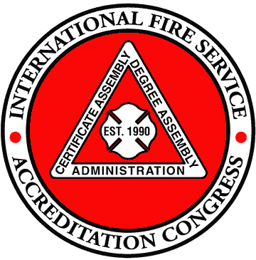

NFPA 470 Hazardous Material Awareness

NFPA 470 Hazardous Materials Operations
NFPA 470 Hazardous Materials Technician

DELAWARE STATE FIRE SCHOOL
1461 CHESTNUT GROVE ROAD
DOVER, DE 19904

OFFICE HOURS: 8:00 A.M. - 4:30 P.M.
Monday through Friday
Telephone.................... (302) 739-4773
Fax...24 Hours............. (302) 739-6245
Web Address………. www.statefireschool.delaware.gov
Email us at………. fire.school@delaware.gov

STATE OF DELAWARE HOLIDAYS:

NEW YEAR'S DAY January 01, 2026 (Thursday)
MARTIN LUTHER KING'S DAY January 19, 2026 (Monday)
GOOD FRIDAY April 03, 2026 (Friday)
MEMORIAL DAY May 25, 2026 (Monday)
JUNETEENTH June 19, 2026 (Friday)
INDEPENDENCE DAY July 03, 2026 (Friday)
LABOR DAY September 07, 2026 (Monday)
ELECTION DAY November 03, 2026 (Tuesday)
VETERANS' DAY November 11, 2026 (Wednesday)
THANKSGIVING DAY November 26, 2026 (Thursday)
DAY AFTER THANKSGIVING November 27, 2026 (Friday)
CHRISTMAS DAY December 25, 2026 (Friday)

HOTELS IN VICINITY:

(Not an all-inclusive list)

Comfort Inn & Suites 764 Dover Leipsic Road, Dover, DE 19901 (302) 677-0505

Comfort Suites 1654 N. DuPont Highway, Dover, DE 19901 (302) 736-1204

Fairfield Inn 655 N. DuPont Highway, Dover, DE 19901 (302) 677-0900

Hampton Inn 1568 N. DuPont Highway, Dover, DE 19901 (302) 736-3500

Hilton Garden Inn 1706 N. DuPont Highway, Dover, DE 19901 (302) 674-3784

Holiday Inn Express 1780 N. DuPont Highway, Dover, DE 19901 (302) 678-0600
Home2 Suites Hilton 222 S. DuPont Highway, Dover, DE 19901 (302) 674-3300

Mainstay Suites 201 Stover Boulevard, Dover, DE 19904 (302) 678-8383
Residence Inn 600 Jefferic Boulevard, Dover, DE 19901 (302) 677-0777
TownePlace Suites, Newark 410 Eagle Run Road, Newark, DE 19702 (302) 369-6212
Quality Inn and Suites 20530 DuPont Blvd. Georgetown, DE 19947 (302) 339-8506

Original 01/01/2026, V1

DIRECTIONS TO DELAWARE STATE FIRE SCHOOL

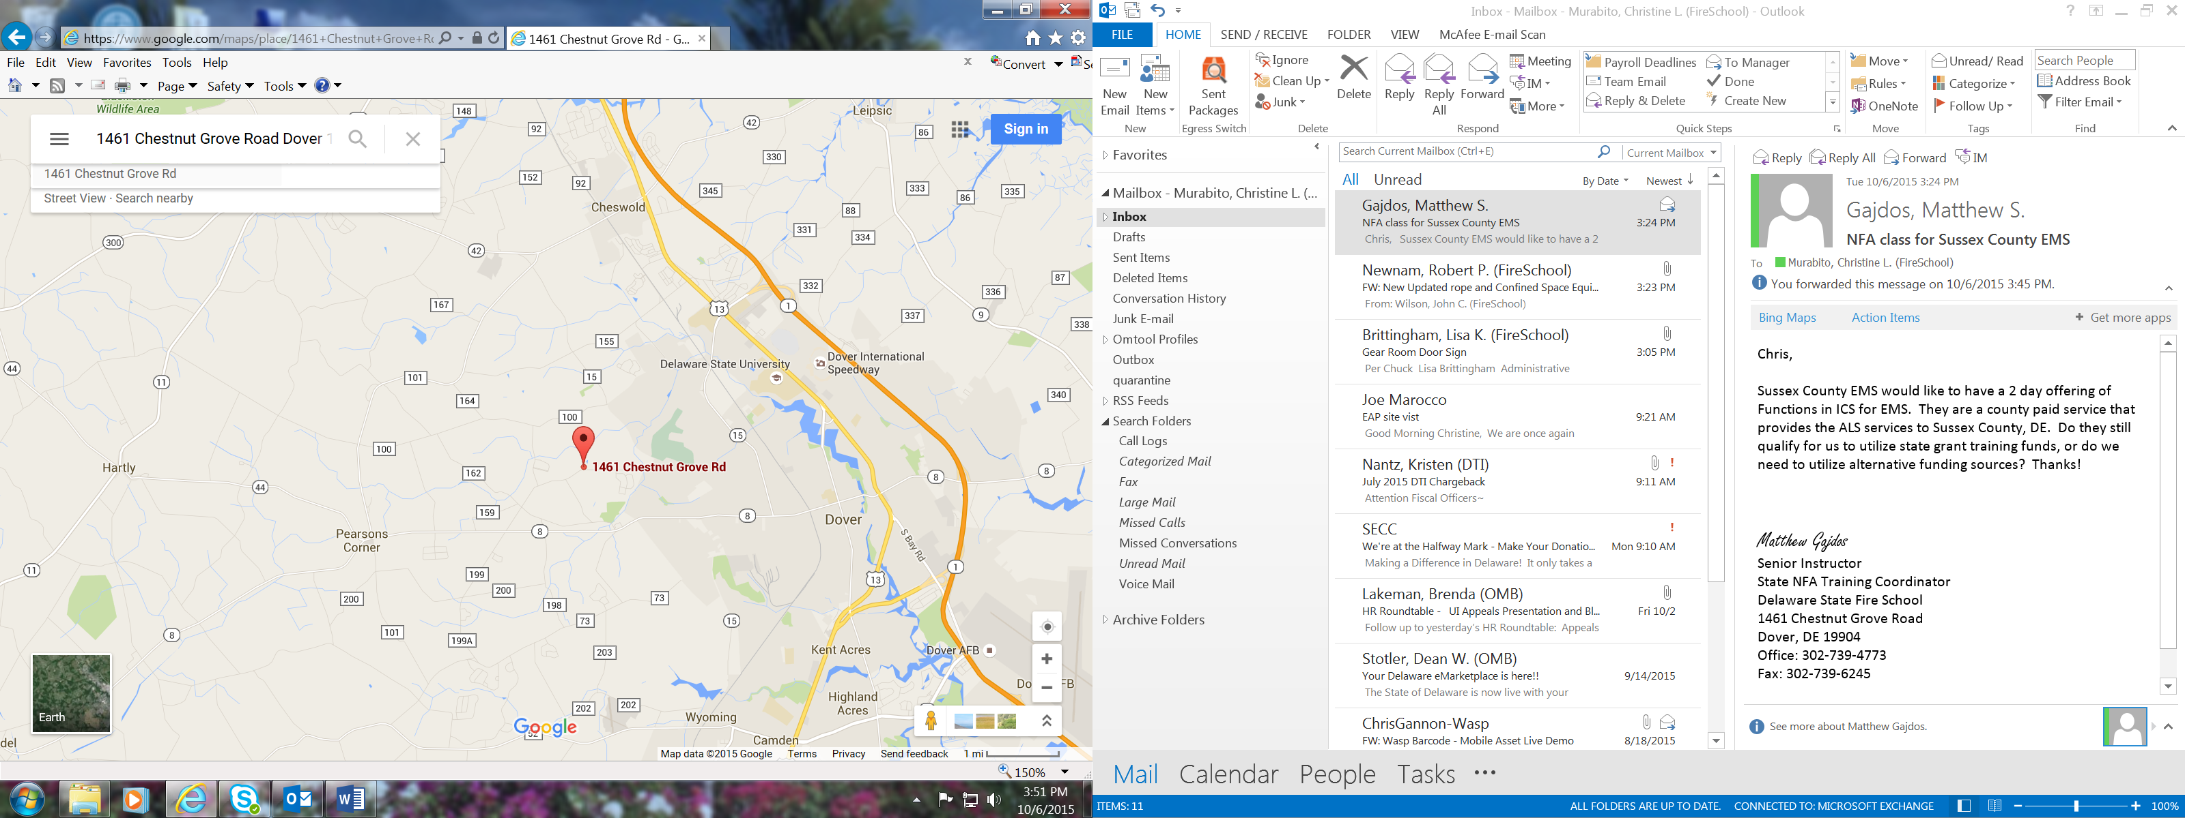
KENT DIVISION
1461 Chestnut Grove Road
Dover, DE 19904

DIRECTIONS FROM NORTH OR SOUTH OF DOVER:
- Follow US Route 13 (no tolls) or DE Route 1 (toll) to Dover.
- From Route 1, follow DE Route 1 to the Scarborough Road exit. From Route 13, follow Route 13 until you approach Scarborough Road intersection.
- Turn onto Scarborough Road. Go through first light (Delaware Technical and Community College Terry Campus should be on your right). Keep going straight through the second light which is at the McKee Road intersection. (Scarborough Road merges into McKee Road)
- At the third light, turn right onto College Road (Road #99), which ends at Kenton Road.
- Turn right onto Kenton Road (Road 104). Follow Kenton Road for 6/10 of a mile until you come to a small green sign that says, “Delaware Fire Service Center.”
- Turn left on Chestnut Grove Road. Go 1 mile. Delaware State Fire School will be on right, the second brick building.

DIRECTIONS FROM CHESAPEAKE BAY BRIDGE (THE WEST)

- Proceed on 50 East/301 North. They will split after Bay Bridge. Stay on 301 North.
- After Rest Area on left, proceed approximately 5 miles.
- Take Right onto 302 (Barclay Road) to Barclay, Maryland. Will come to stop in Barclay. Proceed through stop until you come to Templeville.
- Turn Right on Road 454, to Marydel. You will cross Delaware Line. Road changes into Route 8/Halltown Road once in Delaware.
- Proceed on Route 8/Halltown Road. At second stoplight you will be in Dover, a McDonald's will be to your Right, Citizen’s Bank on far-left corner. Turn Left at that light onto Kenton Road. (Road 104)
- Once on Kenton Road (pass Fire Station on right, Fox Hall West housing development on left), until you come to a small green sign that says, “Delaware Fire Service Center.”
- Turn left onto Chestnut Grove Road. Go 1 mile. Delaware State Fire School will be the second brick building on the right.

NEW CASTLE DIVISION
2311 MacArthur Drive, New Castle, DE 19720

DIRECTIONS FROM NORTHERN DELAWARE
- Follow Route 13 South to Rt. 141 Basin Road.
- Turn Right going North on Basin Road. Follow approximately 1 mile.
- Turn Left onto Commons Blvd. (Rt. 37) Follow approximately 1 mile.
- Turn Right onto Old Airport Road. You will see a small green sign that says, “Delaware Fire Service Center.” Follow approximately 3/4 miles.
- Turn Right onto MacArthur Drive. (past the treatment plant)

FROM INTERSTATE 95
- Go South on Basin Road. (RT. 141)
- Follow Basin Road until you get to Commons Blvd. (Rt. 37)
- Turn Right onto Commons Blvd. Follow approximately 1 mile.
- Turn Right onto Old Airport Road. You will see a small green sign that says, “Delaware Fire Service Center.” Follow approximately 3/4 miles.
- Turn Right onto MacArthur Drive. (past the treatment plant)

DIRECTIONS FROM PHILADELPHIA
- Take Interstate 95 South to Basin Road. (Rt. 141)
- Refer to directions – “From Interstate 95”

DIRECTIONS FROM BALTIMORE:
- Take Interstate 95 North to Basin Road. (Rt. 141)
- Refer to directions – “From Interstate 95”

DIRECTIONS FROM SOUTHERN DELAWARE
- Follow Route 13 North to Rt. 141 Basin Road.
- Go North on Rt. 141Basin Road. Follow approximately 1 mile.
- Turn Left onto Commons Blvd. (Rt. 37) Follow approximately 1 mile.
- Turn Right onto Old Airport Road. You will see a small green sign that says, “Delaware Fire Service Center.” Follow approximately 3/4 miles.
- Turn Right onto MacArthur Drive. (past the treatment plant)

ALTERNATE DIRECTIONS FROM SOUTHERN DELAWARE – (Use only if familiar to area
- Follow Route 13 North to Route 1
- Follow Route 1 to Christiana Bypass Road Exit. (Rt. 273)
- Turn Right at the Bottom of the EXIT Ramp going East on Rt. 273.
- Turn Left on Airport Road. (37 North)
- Follow 2 miles to Old Airport Road. (through the light at Rt. 58 Churchman’s Rd)
- Turn Left onto Old Airport Road. You will see a small green sign that says, “Delaware Fire Service Center.” Follow approximately 3/4 miles.
- Turn Right onto MacArthur Drive. (Past the treatment plant)

SUSSEX DIVISION
22705 Park Avenue, Georgetown, DE 19947

DIRECTIONS FROM NORTH/WEST
- Take 113 South/DuPont Blvd. south past Georgetown
- Make left turn onto Arrow Safety Road across from 1st State Chevy, south of Georgetown
- From Arrow Safety Rd. turn left at stop sign – onto Truck Route 9/South Bedford Street
- Go ¼ mile on South Bedford Street and make a Right – onto Park Avenue/Truck Route 9
- Go 1 ¼ miles on Park Ave. following Truck Route 9 east around Airport
- Fire Marshal's Office and Fire School will be on left -- - use Nanticoke Ave./Sussex Airpark Industrial Park Entrance

DIRECTIONS FROM SOUTH
- Take 113 North/DuPont Blvd
- Make right turn onto Truck Route 9 / South Bedford Street at Del DOT/Troop 4, south of Georgetown
- Go 1 mile on Truck Rt. 9 / South Bedford Street and make a Right onto Park Avenue -- following TR 9
- Go 1 1/4 miles following TR 9 / Park Avenue east around the Airport
- Fire Marshal's Office and Fire School will be on left -use Nanticoke Ave. the Sussex Airpark Industrial Park Entrance

DIRECTIONS FROM EAST
- Take RT. 9/Lewes Georgetown Highway west to Truck Route 9/ Park Avenue (2 miles East of Georgetown)
- Make left turn onto Truck Route 9-Park Avenue
- Go 1 1/2 miles following Truck Route 9 (Park Avenue)
- Fire Marshal's Office and Fire School will be on right – use Nanticoke Ave. - the Sussex Airpark Industrial Park Entrance
GENERAL INFORMATION

FIRE COMPANY REGISTRATION PROCEDURES - IN-STATE FIRE COMPANIES:
Class registration is an important part of our management process. Knowing how many students will be attending a class allows us to contract the correct number of instructors for the class. Knowing who is registering for the class allows us to confirm that they have the correct pre-requisites for those courses that require them. Having the correct count of students allows us to furnish the correct number of meals when they are being provided.

Registrations must be made on the form provided by the Delaware State Fire School. Registration closing dates for weekend classes are on Friday two weeks prior to the scheduled class date. Registration should be received by the Fire School on or before the closing date. The closing date will be the course announcement.

Telephone registrations cannot be accepted. Faxed/emailed registrations are acceptable and must be signed and properly completed by the Fire Department or organization.

Confirmation emails are sent to students and their Chief/Training Officer of whom have been accepted into each of the classes. This notice will come out by the Friday of the week after registration closes. We DO NOT accept walk-ins or substitutions as students must have required pre-requisites to attend classes.

FIRE COMPANY REGISTRATION PROCEDURES - OUT-OF-STATE FIRE COMPANIES:
All out-of-state students must have completed the Delaware State Fire School Pre-Requisite courses or have met the reciprocity requirements stated in this catalog prior to taking the next level of classes.

Tuition must be prepaid by out-of-state students with the registration forms. Absolutely no walk-ins will be accepted. Registrations will not be accepted without payment.

If class registration becomes too large, out-of-state students can be subject to cancellation up to the day before the actual class begins.

CLASS HOURS: Refer to the Course Listing under “Sign-Up for Classes” on our website for class times. Please arrive 15 minutes prior to that time.

MEALS: A lunch meal will be provided in our cafeteria for most daytime classes at the Kent Division in Dover.

CANCELLATION POLICY:
Cancellations for students who are registered for a course must be received by the Delaware State Fire School no later than noon on the Wednesday preceding the scheduled class day. Cancellations received after Wednesday noon will be considered "no shows" and will be handled in accordance with the NO SHOW POLICY. Cancellations will be accepted only from the Fire Chief or the authorized Training Officer.

The Delaware State Fire School reserves the right to cancel classes when it is necessary. The reasons for cancelling classes may include insufficient registrations, weather, safety & health, or other reasons at the discretion of the Director. If a cancellation occurs, the students and instructors will be notified with as much notice as possible.

REFUND POLICY:
Refunds are issued only when a course cancellation is received by the Delaware State Fire School by the designated deadline prior to the scheduled class date and submitted through the proper channels—either by email at fire.school@delaware.gov or by phone at 302-739-4773—by the Fire Chief or authorized Training Officer. Cancellations made after the deadline or failure to attend a scheduled course are not eligible for a refund, and the full course fee will be charged. If the Fire School cancels a class, a full refund or course credit will be provided. Approved refunds will be processed within 30 days, and any exceptions must be submitted in writing for review.

NO-SHOW POLICY:
Students who register for Delaware State Fire School courses and do not show up for class on the scheduled date will be placed on a "hold list" and will not be accepted for registration of future courses. If space is available the students on the "hold list" will be advised on Wednesday afternoon, three (3) days prior to class time that they may attend the course. "No Shows" will be made as a part of the students’ training record. No Shows" will be assessed the tuition fee for the entire course.

STUDENT RECORDS:
All training records will be recorded for all courses attended with the exception of some special courses of less than three hours, such as Public Education, Agency, and Industrial classes.

COURSE COMPLETION POLICY:
All Delaware State Fire School courses are performance based. All students must meet the minimum participation requirements during the class and must pass the written and/or skills test when appropriate. Students who fail to meet the performance objectives will not receive credit for the class nor receive a certificate of completion. The sponsoring organization will be notified in writing of any failures.

CERTIFICATES:
Certificates will be provided for most Delaware State Fire School courses successfully completed.certificates will be emailed to the student within 14 working days after a class is completed. Date shown on the certificate of completion will be actual date of the class, not when it is prepared.

RE-ISSUANCE OF CARDS AND CERTIFICATES:
Class Certificates (reprints only) for classes after 2004 can be reissued for a fee of $10.00 per certificate. BLS Healthcare Provider, Heartsaver CPR AED and Heartsaver First Aid certificates are digital eCards and will not printed. They are available online through the American Heart Association at no cost.

FINANCIAL RESPONSIBILITY FOR MEDICAL/FIRST AID TREATMENT:
All payments for any and all medical, first aid, and related charges will be the responsibility of the sponsoring organization.

MEDICAL DISABILITIES AND ACCOMMODATIONS POLICY
Students with known disabilities that cause them not to meet the essential eligibility requirements for participation in the classes or may cause a substantial interference with the operation of the program or pose a significant risk to the health and safety of others that cannot be eliminated by reasonable accommodation shall not be permitted to participate in the classes. The Delaware State Fire School will accept no responsibility for any consequences suffered by the student and/or sponsoring organization who knowingly violate this policy.

A reading or hearing disability must be documented in advance by a qualified healthcare provider or other professional qualified to make the diagnosis. The diagnosis should recommend an appropriate accommodation.
A request for accommodation must be submitted in writing and at least two weeks in advance in order for us to plan for the accommodation.

PERSONAL PROTECTIVE EQUIPMENT (PPE):
Includes approved coat, bunker pants, boots, gloves, helmets, and eye protection. Must be NFPA approved. Appropriate clothing must be provided as indicated on the registration form. The department must provide their members with proper fitting and safe personal protective equipment. Students with ill-fitting and/or improper personal protective equipment will not be permitted to participate in classes requiring personal protective equipment.

CONFINED SPACE RESCUE EQUIPMENT:
Due to the nature of the course and the types of evolutions, special equipment is required for the Confined Space Rescue Course. Firefighting gear is not worn because it is too bulky and cumbersome for some evolutions. All students participating in the Confined Space Rescue Class must have the following personal protective equipment: hardhat with chin straps, gloves, eye protection, and optional equipment (coveralls, ankle-high work boots, elbow and need pads).

SCBA:
Students can feel assured when using the Delaware State Fire School SCBA equipment, the facepiece and air pack will be completely disinfected before being issued to them for any class. The Delaware State Fire School permits students to bring and use their department's Self-Contained Breathing Apparatus for training classes. Students MUST show up for class clean shaven. The Delaware State Fire School has an air system for re-filling bottles at Training Centers. The system is capable of filling high-pressure bottles only. The Fire School is not responsible for loss or damage to personal units.

BEARDS, BREATHING APPARATUS AND LIVE FIRE TRAINING:
Delaware State Fire School has a “no beard” policy for students participating in State Fire School sponsored fire and rescue training programs. This action is consistent with recommended national standards, which have been in effect since 1988. To clarify when the policy applies and when it does not apply, the following guideline has been adopted:

Delaware State Fire School Center or Divisions
Students with beards or any facial hair in contact with the face piece seal of self-contained breathing
apparatus (SCBA) or respirators will not be permitted to participate or attend any training activity which
requires the use of personal protective equipment, turnout gear, helmets and/or breathing apparatus.
Officers and Drivers of fire and rescue apparatus are included.

In-Service Training at Station or Off-Site Locations
Students with beards or any facial hair in contact with the face piece seal of a self-contained breathing
apparatus (SCBA) or respirators will not be permitted to participate in any training activity that
requires the student to wear breathing apparatus (SCBA).

AGE REQUIREMENT POLICY
The following policies have been put into effect regarding minimum age requirements for various courses at the Delaware State Fire School. This policy has been implemented to assure the safety of the students who attend the classes at the Fire School. NO WAIVERS ARE PERMITTED AT ANY LEVEL.

Fire Training:
- Students must be 16 years of age or older or obtain the age of 16 during the course, to attend any regularly scheduled Fire class. The only exception is Introduction to Firefighting which can be attended at age 14.
- Students must be 18 years of age or older to obtain and attend the Emergency Vehicle Operator Course.

Emergency Medical Services Training:
- Students must be 16 years of age or older prior to the completion of the Emergency Medical Technician program. Students can take the National Registry exam at 16 years of age. Students must be 17 years of age to obtain their State of Delaware EMT Card.
- Students must be 16 years of age or older upon registration to attend the Emergency Medical Responder Course.

In-Service Training:
- There is no age requirement for the Basic, Advanced, and EMS CEUs in-service classes where the Fire Company Officer is in attendance and responsible for the supervision of the members.

Fire Officer I - IV Curriculum
- Students must be 18 years of age or older, or obtain the age of 18 during the course, to attend the Fire Officer I through IV courses.

USE OF ELECTRONIC DEVICES: (Mobile Phones, Cameras, Laptops, Tablets, etc.)

The Delaware State Fire School permits students to use a laptop, notebook, tablet device, or electronic textbook to take notes and other course-related activities of the class with approval of the lead Instructor. It is the responsibility of the instructor to decide when and what types of technology are permitted during class.

Unless required for use in a course, electronic devices, including mobile phones, operated in a classroom or on the drill grounds, is prohibited by all personnel. Instructors or Instructor Aides may use a mobile phone in the performance of their duties only. All mobile phones must be in the off or vibrate mode and non-visible during class instruction.

No pictures or recordings shall be taken of class instruction for personal use or publication in the social media environment without the approval of the Fire School Director or his designee by any personnel.

Individuals who do not adhere to the policies concerning appropriate use of electronic devices during a class may be asked to leave the facility.

DRESS CODE:

As times have changed so have some of today’s fashions. The Delaware State Fire School, however, is foremost an educational facility. With that constantly in mind, the dress code is designed to promote a healthy and safe, distraction-free learning environment.

- No sleeveless shirts
- No flip-flops or open toe shoes
- No bare midriffs
- Visible body piercings shall be limited to the ear
- No dangling earrings shall be worn when performing evolutions
- No exposed jewelry shall be worn, with the exception of wedding rings
- No sexually explicit logos on shirts
- Hats (including bandanas or do-rags) cannot be worn during classroom instruction

Students are permitted to wear shorts. Shorts must extend from the waist to a point at or just above the knees (as referenced in NFPA 6.2.2, Fire and Emergency Services Protective Clothing and Equipment).

The dress code policy will be enforced for any DSFS class that is held at a center (including New Castle and Sussex), including In-service classes held at a center. In-service classes held off-site are not subject to this policy.

Chiefs and Training Officers are to make sure students coming to classes at the DSFS are dressed properly.

STUDENT BEHAVIOR:

- The use of tobacco products and e-cigarettes (including smokeless tobacco and vapor) is prohibited within boundaries of all state workplaces including all buildings, facilities, indoor and outdoor spaces, and surrounding grounds owned by State.
- Students are expected to be on time for all classes and to remain in class unless excused. In keeping with sound educational practice, and in fairness to those students who do comply, those who miss the roll call or who leave during the class will NOT be given credit for that block of instruction.
- All students are expected to act professionally and courteously and to show respect to others at all times. Anyone displaying aggressive or offensive behavior WILL BE REMOVED from class.
- Walking on the grass is prohibited.
- Students are not to discard trash, etc. on the property except in the designated containers.
- Students are to respect the community and not speed, drive recklessly, or sound their sirens in the vicinity of the Delaware State Fire School property.
- Transportation to/from the Delaware State Fire School is the responsibility of the student and/or their department. Students are not to linger on the property after class has ended.

TC | DOVER CENTER ONLY
IS | IN-SERVICE ONLY
TC/IS | DOVER TRAINING CENTER or IN-SERVICE
IS/RC | IN-SERVICE W/ PORTION AT TRAINING CENTER
RC | REGIONAL TRAINING LOCATIONS
BL | BLENDED LEARNING (Classroom + Online)
OL | ONLINE Only

COURSE LOCATION CODING

Delaware State Fire School courses are designed to provide up-to-date training in the various subject areas.

This necessitates some classes only being offered in Dover. Other classes are available in-service or at other designated locations.

The following codes appearing next to each course title will indicate where that course is offered:
FIREFIGHTER TRAINING

SUPPORT FIREFIGHTER (36 HOURS) TC/RC/IS

PURPOSE: This course has been designed to provide the student with the knowledge and skills to successfully meet the requirements of NFPA 1010 standard for a Support Person, NFPA 470 Hazardous Materials Awareness, and CPR/AED certification. Students who successfully attend this course will be eligible to obtain the National Pro-Board Support Person and Hazardous Material Awareness Certifications as well as CPR/AED Certification.

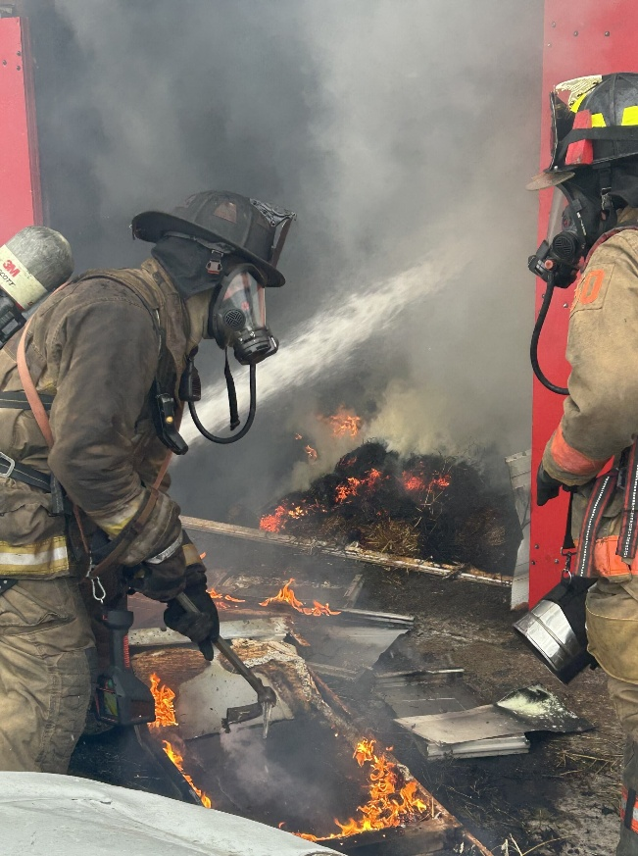
CONTENT: This course will cover the material to provide students with the knowledge and skills to perform the Support Person role. This will include a history of the fire service, PPE Donning/Doffing, safe emergency scene operations, hydrant operations, extinguisher operations, fire behavior, ropes & knots, hose loads, hose lays, and water supply systems. This course will also provide the students with the knowledge and skills to identify Hazardous Materials and identify their hazards. Additionally, through this course students will receive CPR/AED knowledge and skills. Exam questions and skill evolutions are based on the Jones & Bartlett Fundamentals of Firefighter Skills for Support Person manual current edition, the NFPA 1010 standard for Support Person, NFPA 470 Hazardous Materials Awareness, and AHA CPR/AED.

AUDIENCE: All fire service personnel, specifically the new member too young to attend the Firefighters I & II class, a non-interior firefighter, or EMS personnel

PREREQUISITES: 14 years of age

TUITION PER STUDENT: $200 In-State Fire Companies
$300 Out-of-State Fire Companies

CLASS LIMIT: Minimum 10 Maximum 30 Students

EQUIPMENT NEEDED: Full PPE refer to Page 11

FIREFIGHTER I-II ACCELERATED PROGRAM (176 Hours) TC
PURPOSE: This course has been designed to provide the student, both from a fire company or those seeking a career in the fire service, with the necessary training and skills to successfully meet the requirements of the NFPA 1010 standard for a Fire Fighter I & II, the NFPA 1006 Passenger Vehicle Rescue Technician, the option of NREMT immediately following the firefighter class, and the NFPA 470 Hazardous Materials/WMD Awareness and Operations levels. The Accelerated format runs Monday through Friday for 22 days at the Kent Division. Students will be eligible to obtain their National Pro-Board Firefighter I and II, Hazardous Materials Awareness and Operations, and Vehicle Rescue Awareness, Operations, and Technician Certifications, along with ICS 100, 200, 700, and 800 and CPR/AED Certification.

CONTENT: This course will cover the various subject areas covered in the traditional sequential training program: Fire Service Orientation, Hose Handling, Hazmat Awareness & Operations, Ladders, Tools, Salvage and Overhaul, SCBA, PPE, and Fire Fighter Safety, with an option for certification as an NREMT. Exam questions and skill evolutions are based on the IFSTA “Essentials” manual current edition, the NFPA 1010 standard for Fire Fighter I and II, NFPA 1006 standard for Common Passenger Vehicle Technician, and NFPA 470 Standard for Hazardous Materials Response Personnel at the Awareness and Operations levels.
AUDIENCE: This course is open to any individual wishing to become a Firefighter or Firefighter-EMT
PREREQUISITES: Individuals must be at least 16 years of age.
CLASS LIMITS: Minimum 10 Maximum 30 Students
EQUIPMENT: Individuals will be required to bring “Full Turn-out Gear” See Full PPE on Page 11, Department owned SCBA optional.
TUITION PER STUDENT: $1,800.00 In-State Students - $2,500.00 Out-of-State Students
FIREFIGHTER I-II REGULAR PROGRAM (168 Hours) TC/RC
PURPOSE: This course has been designed to provide the student, both from a fire company or those seeking a career in the fire service, with the necessary training and skills to successfully meet the requirements of the NFPA 1010 standard for a Fire Fighter I & II, the NFPA 1006 Passenger Vehicle Rescue Awareness and Operations levels and the NFPA 470 Hazardous Materials Awareness and Operations levels. The Regular format runs for approximately 9 weeks for two nights a week and every other weekend held at a combination of the Fire School Divisions. Students will be eligible to obtain their National Pro-Board Firefighter I and II, Hazardous Materials Awareness and Operations, and Vehicle Rescue Awareness and Operations Certifications, along with ICS 100, 200, 700, and 800, and CPR/AED Certification.

CONTENT: This course will cover the various subject areas covered in the traditional sequential training program: Fire Service Orientation, Hose Handling, Hazmat Awareness & Operations, Ladders, Tools, Salvage and Overhaul, SCBA, PPE, and Fire Fighter Safety, with an option for certification as an NREMT. Exam questions and skill evolutions are based on the IFSTA “Essentials” manual current edition, the NFPA 1010 standard for Fire Fighter I and II, NFPA 1006 standard for Common Passenger Vehicle Technician, and NFPA 470 Standard for Hazardous Materials/WMD Response Personnel at the Awareness and Operations levels.
AUDIENCE: This course is open to any individual wishing to become a Firefighter or Firefighter-EMT
PREREQUISITES: Individuals must be at least 16 years of age.

CLASS LIMITS: Minium 10 Maximum 30 Students
EQUIPMENT: Individuals will be required to bring “Full Turn-out Gear” – See Full PPE on Page 11, Department owned SCBA optional.
TUITION PER STUDENT: $1,500.00 In-State Students
$2,500.00 Out-of-State Students

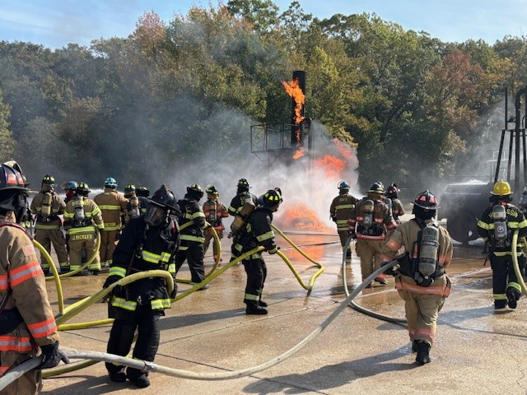

FIRE FIGHTER SELF SURVIVAL (12 HOURS) TC/RC

PURPOSE: The Firefighter Self Survival course is designed to provide the firefighter with critical knowledge and skills along with a safe attitude on the fire ground, allowing a firefighter the ability to “save” themselves at a fire.

CONTENT: This course consists of Tactics, Skills, and Strategies that can be used by a firefighter who find themselves experiencing an emergency. The course will cover Risk Reduction, Personal Evacuation/Exiting Strategies, Air Management, and Survival Strategies. Practical evolutions include calling MAYDAY, wall breaching, window exiting, collapse simulations, and re-orientation evolutions.

AUDIENCE: All Fire Service Personnel

PREREQUISITES: 16 years of age, Pro-Board Firefighter I or the State of Delaware Equivalent

EQUIPMENT NEEDED: Full PPE refer to Page 11

CLASS LIMIT: 25 students

TUITION PER STUDENT: $150 In-State Fire Companies
$300 Out-of-State Fire Companies

FIREFIGHTING TACTICS (48 HOURS) TC

PURPOSE: The purpose of this course is to provide the firefighter advanced instruction and real-world problem-solving skills.

CONTENT: This course will provide the necessary information for the firefighter to handle the dynamic and ever-changing environment at the emergency scene and teach the student how to confidently tackle them. This course is high paced with well-informed instruction from reputable instructors. The program ends with several scenarios to reinforce the knowledge the student has gained.

AUDIENCE: Designed for fire officers and firefighters who will be making decisions at the fire scene.

PREREQUISITES: 16 years of age, Pro-Board Firefighter II or the State of Delaware Equivalent

EQUIPMENT NEEDED: Full PPE refer to Page 11

CLASS LIMIT: 40 students

TUITION PER STUDENT: $500 In-State Companies
$750 Out-of-State Companies

FIREFIGHTING FOAM (6 HOURS) IS

PURPOSE: The purpose of this course is to provide fire suppression personnel with the knowledge and skills to properly apply and utilize firefighting foam.

CONTENT: This course will provide the necessary information to effectively use firefighting foam and the equipment necessary to make firefighting foam. The course will be delivered using illustrative lectures and practical evolutions.

AUDIENCE: Designed for fire officers and firefighters who will be making decisions concerning the use, purchase and maintenance of foam and related equipment.

PREREQUISITES: 16 years of age, Pro-Board Firefighter I or the State of Delaware Equivalent
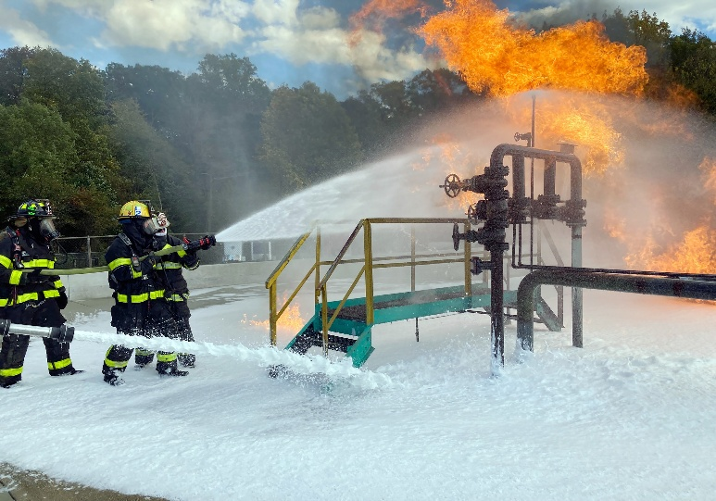
EQUIPMENT NEEDED: Full PPE refer to Page 11

CLASS LIMIT: 40 students

TUITION PER CLASS: $1,000 In-State Companies
Quote for Out-of-State Companies

INCIDENT SAFETY OFFICER (NFA)-NFPA 1521 (40 Hours) TC

PURPOSE: This course is designed for firefighters, emergency response personnel, and safety officers who are responsible for managing safety on the scene of an emergency incident.

CONTENT: This course consists of comprehensive training covers the principles, duties, and best practices outlined in NFPA 1521, the Standard for Fire Department Safety Officer Professional Qualifications. Participants will gain the knowledge and skills needed to identify hazards, evaluate risks, and ensure the safety of all personnel during both routine and complex incidents. This course combines classroom instruction with real-world scenarios and practical exercises to ensure that participants can apply safety concepts effectively in the field. Upon successful completion, attendees will be prepared to serve as an Incident Safety Officer, capable of safeguarding personnel and minimizing risk at fire scenes, technical rescues, hazardous materials incidents, and other emergencies.

AUDIENCE: Career and volunteer firefighters, safety officers and incident commanders seeking to enhance their knowledge of safety management in the field.

PREREQUISITES: Fire Officer I, ICS 100 & 200

CLASS LIMIT: 20 students

EQUIPMENT NEEDED: Full PPE refer to Page 11

TUITION PER STUDENT: $300 In-State Fire Companies
$500 Out-of-State Fire Companies

TACTICAL THERMAL IMAGING CAMERAS (8 HOURS) TC/IS

PURPOSE: This course is designed to equip firefighters with the specialized skills and knowledge required to effectively use thermal imaging technology in fire and rescue operations. Participants will learn the fundamentals of thermal imaging cameras (TICs), their operation, and their practical application in various firefighting scenarios.

CONTENT: This course consists of introduction to thermal imaging; hands-on training using the thermal imaging camera; fire scene applications in fire suppression, search and rescue, and overhaul; safety considerations including potential hazards and how to safely navigate challenging situations during operation; and advanced techniques and strategies for using the thermal imaging in specialized firefighting situations, such as flashover prevention, ventilation tactics, and structural assessments. By the end of the course, students will have a comprehensive understanding of how thermal imaging can improve situational awareness, decision-making, and overall firefighter safety.

AUDIENCE: All fire service personnel looking to incorporate thermal imaging technology into their response strategies.

PREREQUISITES: Firefighter I or equivalent

CLASS LIMIT: 20 students

EQUIPMENT NEEDED: Full PPE refer to Page 11

TUITION PER STUDENT: $150 In-State Fire Companies
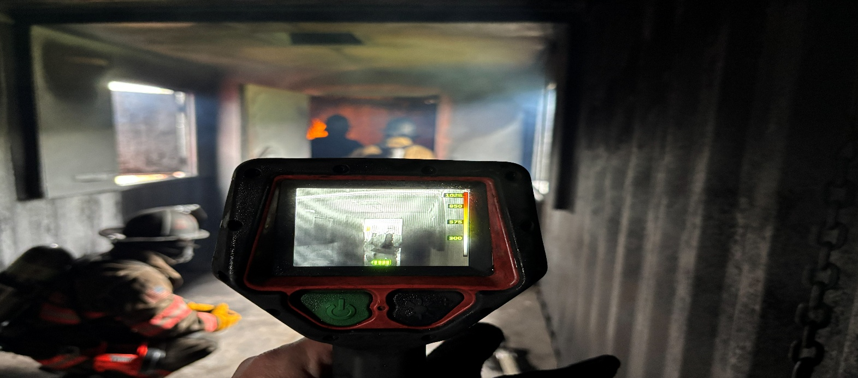
$250 Out-of-State Fire Companies

AERIAL APPARATUS OPERATIONS (18 HOURS) TC/IS

PURPOSE: The purpose of this course is to give foundational knowledge of Aerial Fire Apparatus.

CONTENT: The student will learn vehicle operation, response, proper stabilization and operating the Aerial Device or Platform. The students will attend three days of training and complete the requirements to the NFPA 1002 Standard. Students will be tested and those passing will receive their Pro-Board Driver/Operator of Fire Apparatus Equipped with an Aerial Device Certification.

AUDIENCE: Firefighters who will be operating Fire Apparatus equipped with an Aerial Device

PREREQUISITES: 18 years of age, Pro-Board Firefighter I or the State of Delaware Equivalent and EVO

EQUIPMENT NEEDED: Full PPE refer to Page 11. This course necessitates the use of fire company apparatus. The Fire Company of registered students may be asked to bring equipment.

CLASS LIMIT: 30 students

TUITION: $100 each In-State Fire Companies.
$200 for Out-of-State Companies.
In-service Class: $1,500 per class In-State Fire Companies.
Quote for Out-of-State Companies

DRIVER/OPERATOR (24 HOURS) TC/IS

PURPOSE: This course is designed to prepare a firefighter to become a pump operator in their respective fire departments. The course content has been designed to be applicable to all types of fire pumps.

CONTENT: This course will cover the following areas: Basic Operation, Operator Responsibility and Pump Types; Hydraulic Calculations, Rules of Thumb, Characteristics of Water Pressure and Control Devices, Priming Devices, Gauges, Transfer Valves, Valves and Drains, Drafting and Hydrant Evolutions, Preventive Maintenance and trouble shooting of the chassis, pump, electrical system, engine and accessories, water supply theories and application, pumper-to-pumper relay operations, tanker shuttle and tandem pumping operations.

AUDIENCE: Designed for a new pump operator or trainee who has limited or no experience in pump operations.

CLASS LIMIT: 30 students

PREREQUISITES: 18 years of age and EVO

TUITION PER STUDENT: $100 In-State Fire Companies.
$200 Out-of-State Fire Companies

EQUIPMENT NEEDED: The course requires the use of fire company apparatus. The Fire Company of registered students may be asked to bring equipment. Full PPE refer to Page 11.

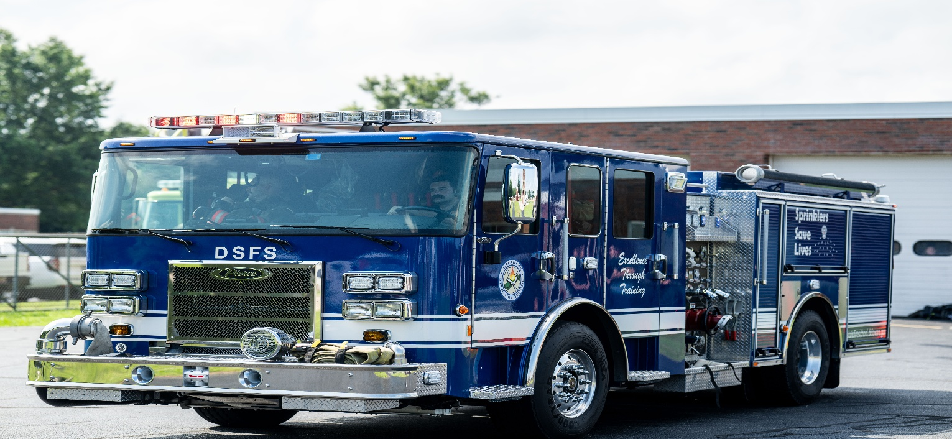
ENGINE COMPANY OPERATIONS (24 HOURS) IS

PURPOSE: The purpose of this course is to educate firefighters of the functions, objectives and skills needed to perform engine company operations

CONTENT: This course is designed to provide the firefighter with the ability to overcome issues and obstacles commonly found while operating a hose line. The course also provides the skills to operate in stand-piped occupancies and those with large fuel loads.

AUDIENCE: Firefighters & Fire Officers

CLASS LIMITS: Minimum 10 Maximum 20 students

PREREQUISITES: Pro-Board Firefighter I or the State of Delaware Equivalent and EVO

EQUIPMENT NEEDED: Full PPE refer to Page 11

TUITION PER CLASS: $100 In-State Fire Companies
$200 Out-of-State Companies

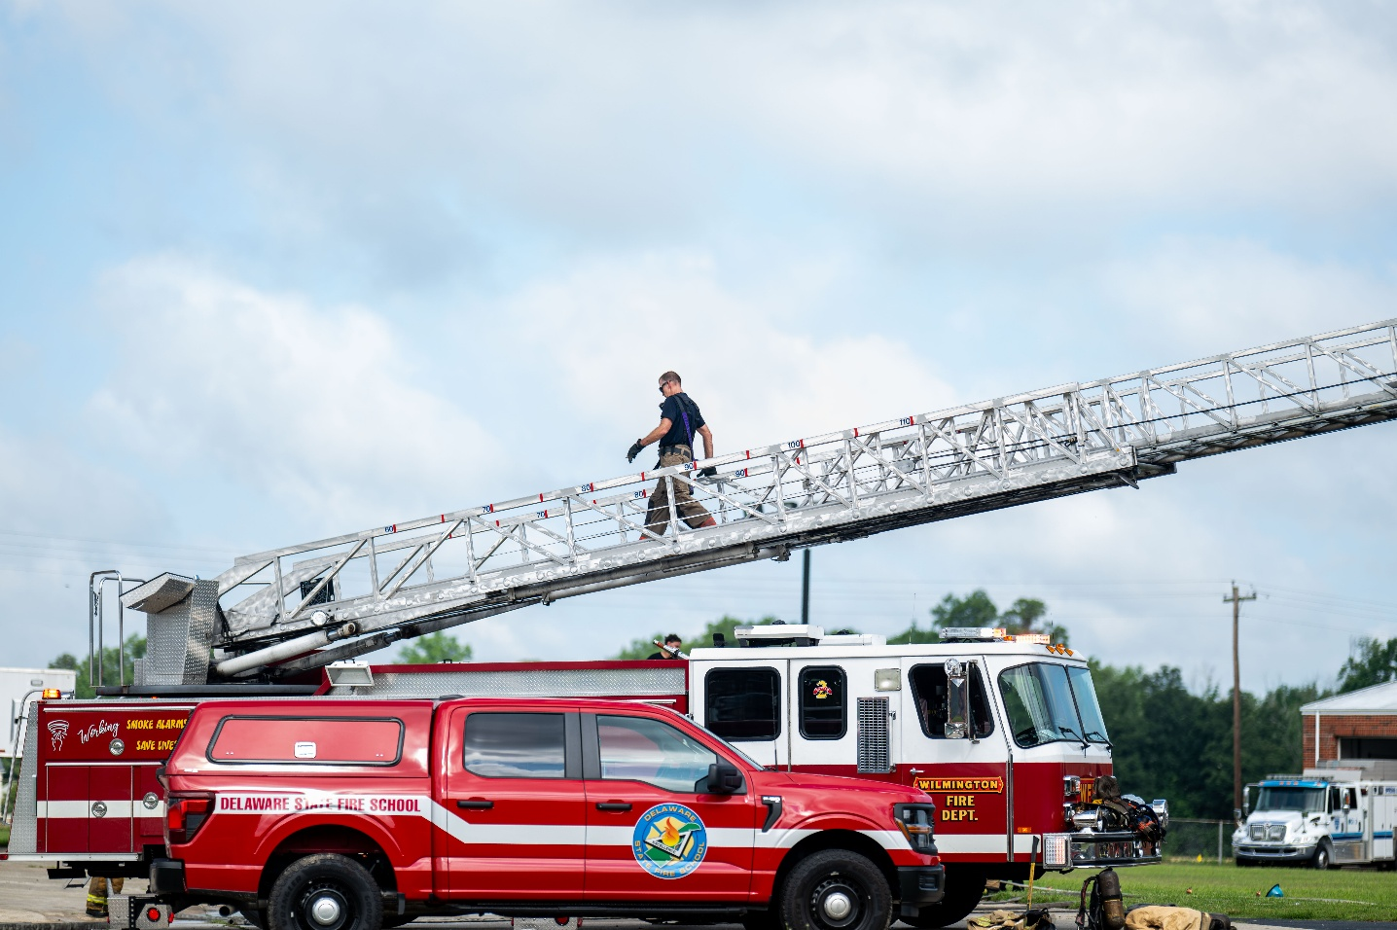

TRUCK COMPANY OPERATIONS (24 HOURS) IS

PURPOSE: The purpose of this course is to educate firefighters of the functions, objectives and skills needed to perform truck company operations and assignments.

CONTENT: This course is designed to provide the firefighter with the skills needed to operate as a member of a Ladder Company. The course covers skills including ventilation, search and rescue, forcible entry, and ground ladders. This course is a great option for a Fire Company who will acquire an Aerial for their district.

AUDIENCE: Firefighters, Fire Officers, and Aerial Apparatus Operators

PREREQUISITES: Pro-Board Firefighter I or the State of Delaware Equivalent and EVO

CLASS LIMITS: Minimum: 10 students; Maximum: 20 students

EQUIPMENT NEEDED: Full PPE refer to Page 11

TUITION PER CLASS: $100 In-State Fire Companies
$200 Out-of-State Companies
ARSON AWARENESS (3 HOURS) IS

PURPOSE: This course is designed to familiarize the members of the fire department with necessary information pertaining to the operation of the Fire Marshal's Office.

CONTENT: This course will be taught by members of the Fire Marshal's Staff. Topics will include Investigation Requests, Call Assignments, Areas of Responsibilities, the MIRT Team, Overhaul on Fire Scenes and answers to frequently asked questions.

{CONTACT THE FIRE MARSHAL’S OFFICE FOR THIS CLASS}

NATIONAL TRAFFIC INCIDENT MANAGEMENT RESPONDER TRAINING PROGRAM
(4 HOURS) TC/RC/IS

PURPOSE: This course is designed to enable all first responders to work together as a team in a coordinated manner from the moment the emergency call is made, to the correct deployment of response vehicles and equipment, to safe work area using traffic control devices.

CONTENT: This program focuses on Traffic Incident Management fundamentals and terminology, notification and scene size-up, safe vehicle positioning, scene safety, command responsibilities, traffic management, special circumstances, and scene termination. Pro-Board Certification is available with additional 1.5 hours for written and skills testing.

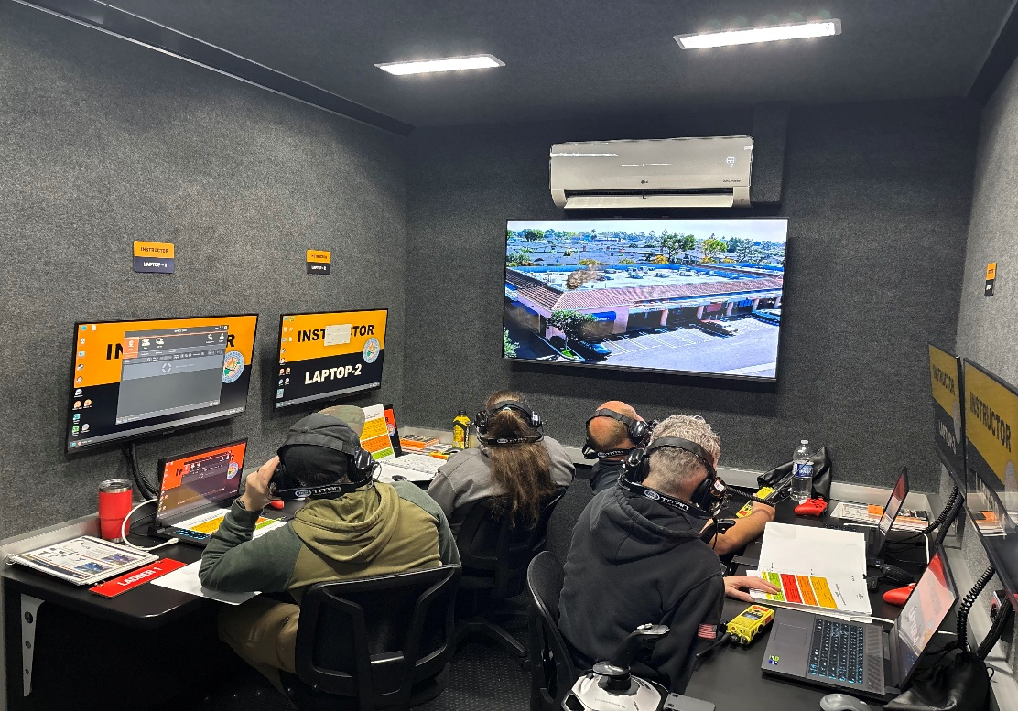
AUDIENCE: All First Responders

CLASS LIMIT: 50 students

PREREQUISITES: None

TUITION PER STUDENT: None

FIRE INSPECTOR NFPA 1030 COURSE
(80 HOURS) TC/BL

PURPOSE: This is a comprehensive, hands-on course designed for individuals looking to advance their careers in fire prevention and inspection.

CONTENT: This program provides an in-depth understanding of fire safety codes, building construction, and the responsibilities of a fire inspector in safeguarding life and property. Students will explore key topics including fire hazard identification, fire prevention techniques, inspection procedures, and code enforcement. Special emphasis will be placed on understanding and applying the National Fire Protection Association (NFPA) standards, local fire codes, and the legal aspects of fire inspection. By the end of the course, students will have the skills needed to conduct thorough fire safety inspections, identify compliance issues, and effectively communicate findings to building owners, contractors, and local authorities.

AUDIENCE: This course is ideal for new fire inspectors, building officials, and anyone pursuing a career in fire prevention safety or safety inspection.

CLASS LIMIT: 20 students

PREREQUISITES: Pro-Board or IFSAC NFPA 470 Hazmat Awareness and Operations, 18 years of age

TUITION PER STUDENT: $300 In-State Fire Companies
$500 Out-of-State Fire Companies

FIRE OFFICER I COURSE – NFPA 1021 (40 HOURS) TC/BL

PURPOSE: This course identifies the performance requirements necessary to perform the duties of a first line supervisor. This course is designed to assist the participants in making the transition from firefighter to company officer.

CONTENT: This course introduces the student to the basic concepts of management and supervision by concentration on such topics as organizational structure, communication skills, human resource management, public relations, planning, emergency service delivery, and safety. Upon completion of this course, the student will be able to explain the role and responsibilities of the company officer. The student will identify and use the four steps of the teaching techniques identified in NFPA 1041. The student will be able to identify the components of the Incident Command System as an emergency management tool and describe the elements of an incident analysis and fire behavior factors. They will also be able to describe the capabilities and limitations of engine and truck company operations and participate in scenarios that relate to the major tactical functions of the fire department and the need for coordination during tactical operations. All in-person class dates are mandatory attendance.

AUDIENCE: Persons of a fire department who will serve in a supervisory capacity

CLASS LIMIT: 30 students

PREREQUISITES: 18 years of age, NFPA 1001 Firefighter II, NFPA Instructor I, or the State of Delaware Equivalent

TUITION PER STUDENT: $300 In-State Fire Companies
$500 Out-of-State Fire Companies

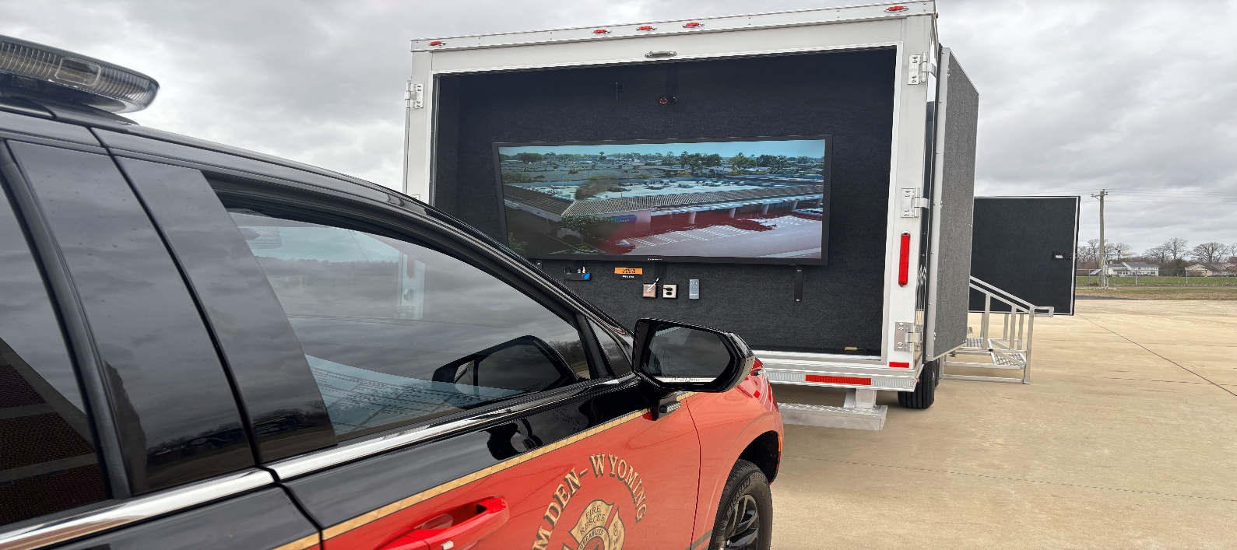

FIRE OFFICER II COURSE – NFPA 1021 (40 HOURS) TC/BL

PURPOSE: This course is designed for the fire officer who is ready to assume more of a leadership role by moving into middle management level of his/her department.

CONTENT: This course consists of subjects designed to give the officer more knowledge of management and supervision so that he/she can make basic evaluations of employee relations and assume a more proactive role in their department. This course expands on the knowledge base obtained in Fire Officer I by revisiting some of the same subjects and adding additional material. Some new subject areas include information management, government structure, department budget planning and management. All in-person class dates are mandatory attendance.

AUDIENCE: Persons who completed Fire Officer I and may serve as a Deputy and/or Chief Officer in their Company.

PREREQUISITES: 18 years of age, NFPA 1021 Fire Officer I or the State of Delaware Equivalent

CLASS LIMIT: 30 students

TUITION PER STUDENT: $300 In-State Fire Companies
$500 Out-of-State Fire Companies

FIRE OFFICER III COURSE – NFPA 1021 (40 HOURS) TC/BL

PURPOSE: This course is designed for the fire officer who is ready to advance into the upper management level of his/her department.

CONTENT: This course consists of subjects designed to give the officer more knowledge of management and administration so that he/she can make basic evaluations of employee relations and assume a more proactive role in his/her department. An individual at the Fire Officer III level, as part of his or her duties and responsibilities, establishes procedures for hiring, assigning, promoting, and encouraging professional development of members; develops programs that improve and expand service and build partnerships with the public; prepares a divisional or departmental budget, develops a budget management system, solicits bids, plans for resource allocation and works with information management systems; evaluates inspection programs to determine effectiveness and develops public safety plans; manages multi-agency planning, deployment, and operations; and develops, manages, and evaluates a departmental safety program. All in-person class dates are mandatory attendance.

AUDIENCE: Persons who completed Fire Officer II and may serve as a Deputy and/or Chief Officer in their Company.

PREREQUISITES: 18 years of age, NFPA 1021 Fire Officer II or the State of Delaware Equivalent

CLASS LIMIT: 30 students
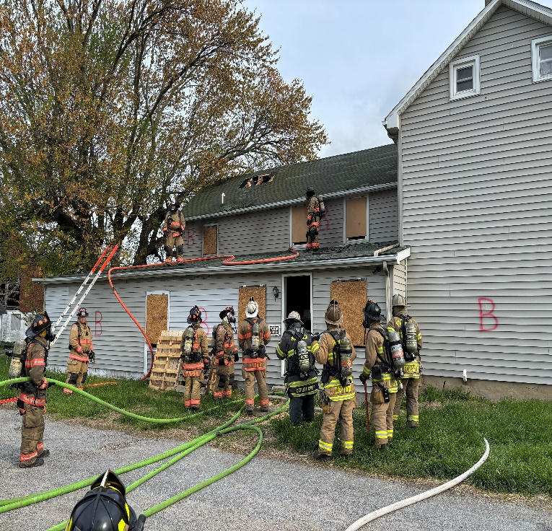
TUITION PER STUDENT: $300 In-State Fire Companies
$500 Out-of-State Fire Companies

FIRE OFFICER IV COURSE – NFPA 1021 (40 HOURS) TC/BL

PURPOSE: This course is designed for the fire officer who is ready to advance into the upper management level of his/her department.

CONTENT: This course is designed around classroom lectures and group interactive exercises to improve the officer’s abilities to manage a fire service organization. The course emphasizes community/government relations, model planning, budgeting, human resources, trends and support organizations, and emergency service delivery. The course includes a written project that requires the student to develop a strategic plan. All in-person class dates are mandatory attendance.

AUDIENCE: Persons who completed Fire Officer III and may serve as Deputy and/or Chief Officer in their Company.

PREREQUISITES: 18 years of age, NFPA 1021 Fire Officer III or the State of Delaware Equivalent

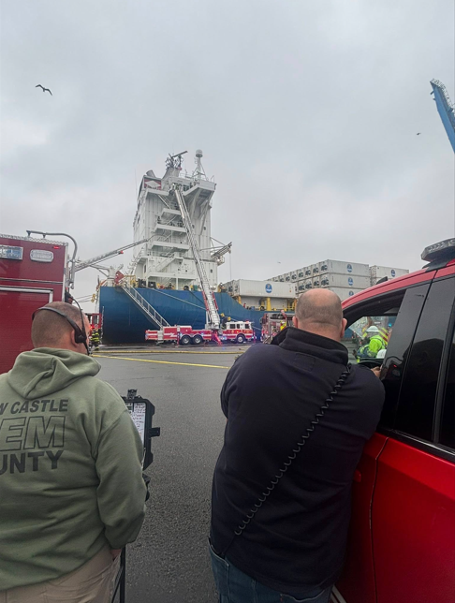
CLASS LIMIT: 30 students

TUITION PER STUDENT: $300 In-State Fire Companies
$500 Out-of-State Fire Companies

PROBOARD AND IFSAC CERTIFICATION CHALLENGE TESTING TC/RC

PURPOSE: Certification Testing has been developed to assess the student’s base knowledge and skills to successfully meet the requirements of the current NFPA standards. Challenge testing is for students who may not be able to attend the traditional DSFS training programs with certification included, and require some flexibility in their training opportunities, while still meeting minimum requirements to test.

CONTENT: Testing will cover the subject areas covered in the traditional training programs associated with those NFPA standards. Current prescheduled certification testing will be provided for Firefighter I, Firefighter II, Fire Officer I, Fire Officer II, Fire Officer III, Fire Officer IV, Incident Safety Officer, Driver/Operator, Hazardous Materials Awareness, Hazardous Materials Operations, and Traffic Incident Management. Some testing will involve practical skills evaluations. IFSAC certification is no longer automatic, but available upon request for some certifications.

Written testing will be made available at each division before the scheduled practical skills evaluation. Other levels of certification testing are available with scheduled courses or may be arranged with special scheduling. Written skills must be submitted before scheduling of any written testing.

All material and skills are based on the current edition of the associated IFSTA manual and materials. Those Manuals, Skills guides, and Test Preparation guides (if available) will be made available for purchase to the student before the testing when ordered.

All written testing may be scheduled on any Open Testing Center days already scheduled. Some levels may be available as an in-service or combined in-service and a regional center.

AUDIENCE: All fire service and government agency personnel and public safety personnel.

PREREQUISITES: Individuals must meet any age requirement for certification before testing date. Individuals must have the required prerequisite certifications and training, where applicable. Partial submission of prerequisite documentation does NOT guarantee registration if obtained and not submitted before the testing date.

All students challenging Firefighter I and Firefighter II MUST submit the Chief’s Declaration form and the DSFS Medical form before testing. Submission of all prerequisite documentation, including the DSFS certification testing application, is required before scheduling of a student for any certification written and skills testing.

TUITION PER STUDENT: In-State Out-of-State
Driver Operator, all Levels $200 $350
Firefighter I & II $250 $500
Firefighter II Only $150 $300
Fire Inspector $200 $400
Fire Officer I, II, III, IV $200 $400
Hazardous Materials Awareness $ 50 $100
Hazardous Materials Operations $ 75 $150
Hazardous Materials Technician $100 $200
Incident Safety Officer $200 $400
Traffic Incident Management $100 $200

EQUIPMENT: Full Turn-Out Gear for “Hands on” Firefighter I & II and Incident Safety Officer skill evaluations sessions. Helmet, work gloves, safety footwear, and eye protection for “Hands on” Driver Operator skill evaluations.

EMERGENCY VEHICLE OPERATIONS (6 HOURS) IS/TC/RC

PURPOSE: This course is designed to enable a person eighteen (18) years of age or older, with a valid Class “D” Delaware Driver’s License to drive an emergency vehicle exceeding 26,000 pounds if the chief officer or company policy so permits.

CONTENT: The program deals with topics bearing on both the potential and past problems as cited in a number of studies. Information given shows where apparatus shortcomings may be found during operation and suggests means to operate within safe ranges. The program's philosophy is that a safe operator will not operate his vehicle beyond safe boundary lines to the point of "no return". The undercurrent of this program is safety through avoidance. This course has been revised to emphasize highway safety, intersection safety and vehicle rollover prevention.

AUDIENCE: Emergency Services personnel who will be driving an emergency vehicle.

CLASS LIMIT: 50 students

PREREQUISITE: 18 Years of Age

TUITION PER STUDENT: $25

EMERGENCY VEHICLE OPERATIONS ONLINE COURSE (6 HOURS)

PURPOSE: This course is designed to enable a person eighteen (18) years of age or older, with a valid Class “D” Delaware Driver’s License to drive an emergency vehicle exceeding 26,000 pounds if the chief officer or company policy so permits.

CONTENT: The program is offered online through the Delaware Learning Center and deals with topics bearing on both the potential and past problems as cited in a number of studies. Information given shows where apparatus shortcomings may be found during operation and suggests means to operate within safe ranges. The program's philosophy is that a safe operator will not operate his vehicle beyond safe boundary lines to the point of "no return". The undercurrent of this program is safety through avoidance. This course has been revised to emphasize highway safety, intersection safety and vehicle rollover prevention.

AUDIENCE: Emergency Services personnel who will be driving an emergency vehicle.

PREREQUISITE: 18 Years of Age

TUITION PER STUDENT: $35

EMERGENCY VEHICLE OPERATIONS COMPETENCY COURSE (6 HOURS) IS

PURPOSE: This hands-on course is designed to measure driver proficiency in handling emergency vehicles.

CONTENT: The competency course duplicates eight situations in which the driver’s skill, judgment and knowledge of the limitations of the emergency vehicle, are required for effective maneuvering. This course is based on Appendix A of the NFPA #1002 standard. This is a VFIS course.

PREREQUISITE: Emergency Vehicle Operations and 18 Years of Age

TUITION PER CLASS: $50

CLASS LIMIT: 20 students

EQUIPMENT NEEDED: Company provided Emergency Apparatus

EMERGENCY VEHICLE OPERATIONS REFRESHER (3 HOURS) TC/RC/IS

PURPOSE: This course is designed to keep your emergency vehicle operator skills current and focused while operating emergency response vehicles regardless of size and type.

CONTENT: This program focuses on emergency vehicle operator responsibilities and attitude, backing practices, intersection safety, rollover risk factors and highway safety while on-scene of an emergency.

AUDIENCE: Current Emergency Vehicle Operators

CLASS LIMIT: 50 students

PREREQUISITE: Current Emergency Vehicle Operators

TUITION PER STUDENT: $25 In-State Fire Companies only

FIRE EMERGENCY SERVICES INSTRUCTOR I CERTIFICATION COURSE (24 HOURS) BL
PURPOSE: This blended learning course is designed to meet the NFPA 1041 Fire Service Instructor I Standard. It is intended to provide certification for persons wishing to fulfill the requirements for Fire Officer I Certification. This course is a pre-requisite for individuals desiring to take Fire and Emergency Services Instructor II.

CONTENT: This course includes Instructor as a Professional, Principles of Learning, Instructional Planning, Instructional Materials and Equipment, Learning Environment, Classroom Instruction, Skills-Based Training Beyond the Classroom, Testing and Evaluation and Records, Reports and Scheduling. Individuals choosing this course will be required to discuss a chosen topic and instruct a class from a prepared lesson plan.

AUDIENCE: Individuals desiring to achieve Fire Officer I Certification and Individuals desiring to attend the Fire and Emergency Services Instructor II Course.

PREREQUISITES:18 years old, High School Graduate and a member of Emergency Services organization

CLASS MAX LIMIT: KCD-24 Students
NCD-24 Students
SCD-16 Students

TUITION PER STUDENT: $250 In-State Fire Companies
$500 Out-of-State Fire Companies

FIRE EMERGENCY SERVICES INSTRUCTOR II CERTIFICATION COURSE (14 HOURS) BL

PURPOSE: This course meets or exceeds the NFPA 1041 Fire Service Instructor II Standard. Students successfully completing this course are eligible to receive Pro Board Fire Service Instructor II Certification.

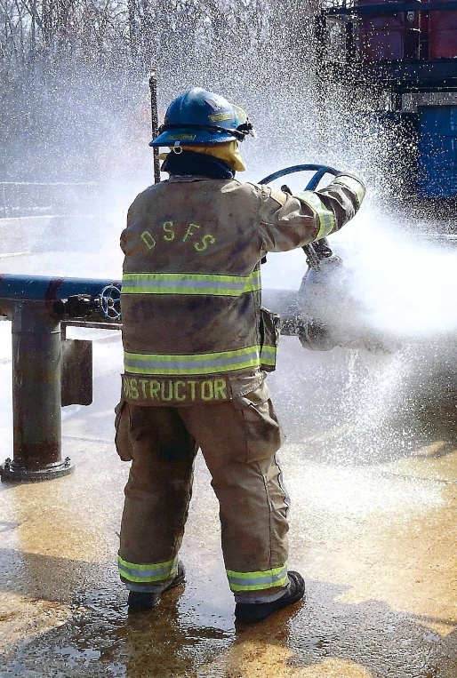
CONTENT: This course encompasses lesson plan development, training evolution supervision, test/exam item construction, supervisory and administrative duties and instructor and class evaluations. The student will be required to develop and submit a written lesson plan for review and to successfully pass a written exam.

AUDIENCE: Individuals desire to achieve Fire and Emergency Services Instructor II Certification and those individuals desire to become an Instructor for the Delaware State Fire School.

PREREQUISITES: Certified Fire Service Instructor I

CLASS LIMIT: Minimum of 8; maximum of 15 students.

TUITION PER STUDENT: $250 In-State Fire Companies
$500 Out-of-State Fire Companies

DELAWARE STATE FIRE SCHOOL INSTRUCTOR ORIENTATION COURSE (4 HOURS) TC

PURPOSE: This course is designed for individuals invited to become a Delaware State Fire School Instructor and has completed the necessary application process.

CONTENT: This course encompasses Delaware State Fire School Instructor roles and responsibilities, instructor characteristics, principles of learning, classroom instruction, documentation and recordkeeping, and audio/visual usage.

AUDIENCE: Persons who have completed the necessary application process and have been approved to teach for the Delaware State Fire School.

PREREQUISITES: Certified Fire Service Instructor II

CLASS LIMIT: Minimum of 8; maximum of 15 students.

TUITION PER STUDENT: $0

FIRE GROUND OPERATIONS – Size-Up (12 HOURS) IS

PURPOSE: The Fire Ground Operations – Size-up course is designed to provide the knowledge and skills required for Officers in Charge during the initial employment of resources at an emergency incident. The student will spend the majority of the class performing size-up and deployment tactics.

CONTENT: Day one consists of obtaining basic information, proper incident size-up, placement of resources, strategic objectives, utilization of Brief Initial Reports, assigning of tasks, along with the requesting of additional resources and the Transfer of Command. Also included is the Officer’s responsibility for scene safety and the use of a Rapid Intervention Team. Day two consists of table-top evolutions. Each student will “command” incidents requiring size up, apparatus placement and assignments.

AUDIENCE: This course is designed for line officers and firefighters who will be making size-up decisions.

PREREQUISITES: 16 years of age, Pro-Board Firefighter I or the State of Delaware Equivalent

CLASS LIMIT: 40 students

TUITION PER STUDENT: $50 In-State Fire Companies
$100 Out-of-State Fire Companies

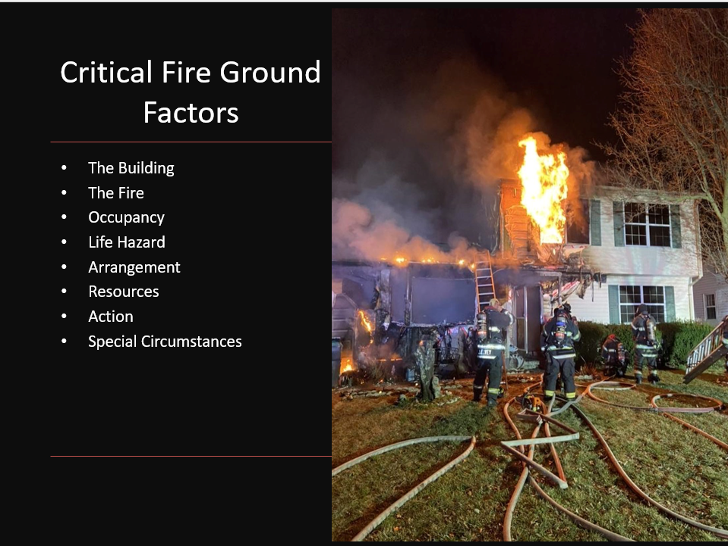

FIRE GROUND OPERATIONS – High Rise (12 HOURS) IS

PURPOSE: The Fire Ground Operations – High Rise course is designed to provide the knowledge and skills required for Officers in Charge when responding to a high-rise emergency. Fires in High Rise buildings have the potential to be one of the most challenging incidents we respond to.

CONTENT: Day one consists of discussing High Rise Considerations, Tactical Considerations, Lobby Control, Staging, Ventilation, Heating Ventilation and Air Conditioning (HVAC) Systems and Incident Command systems. Day two will consist of tabletop exercises to practice the skills learned.

AUDIENCE: Persons who serve as an Officer at a high-rise incident.

PREREQUISITES: 16 years of age, Pro-Board Firefighter I or the State of Delaware Equivalent

CLASS LIMIT: 40 students

TUITION PER STUDENT: $50 In-State Fire Companies
$100 Out-of-State Fire Companies

ADVANCED FIRE BEHAVIOR – Observation & Evolutions (8 HOURS) TC/IS

PURPOSE: This course is an advanced class designed to enhance the student’s knowledge of fire behavior and skills through observation and tactical evolutions required by a firefighter to operate as a member of a firefighting team in a structural firefighting situation.

CONTENT: Provides students with knowledge of fire behavior from incipient to pre – flashover conditions, effects of ventilation on fire, basic structural firefighting skills in an advanced, high paced setting.

AUDIENCE: All fire service personnel who participate in interior structural firefighting.

PREREQUISITES: Firefighter I or equivalent

TUITION PER STUDENT: $200 In-State Fire Companies
$400 Out-of-State Fire Companies
CLASS LIMIT: Minimum of 10; maximum of 20

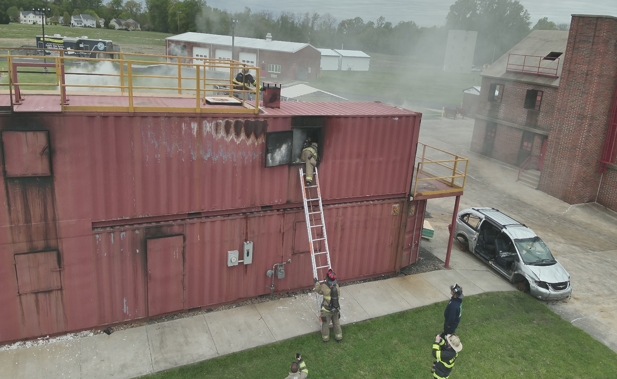
EQUIPMENT NEEDED: Full structural firefighting PPE refer to Page 11

INCIDENT COMMAND COURSES

PURPOSE: These courses are offered to provide training to Fire Service members with additional Incident Command System information and to develop organizational skills necessary for the successful mitigation of multi-jurisdictional or multi-agency incident.

ICS 100

Offered online only and here is the link www.statefireschool.delaware.gov under the Online Training tab

CONTENT: ICS 100, Introduction to the Incident Command System, introduces the Incident Command System (ICS) and provides the foundation for higher level ICS training. This course describes the history, features and principles, and organizational structure of the Incident Command System. It also explains the relationship between ICS and the National Incident Management System (NIMS).

AUDIENCE: Persons involved with emergency planning, response or recovery efforts.

ICS 200

Offered online only and here is the link www.statefireschool.delaware.gov under the Online Training tab

CONTENT: ICS 200 is designed to enable personnel to operate efficiently during an incident or event within the Incident Command System (ICS). ICS-200 provides training on and resources for personnel who are likely to assume a supervisory position within the ICS.

AUDIENCE: Persons involved with emergency planning, response or recovery efforts.

ICS 700

Offered online only and here is the link www.statefireschool.delaware.gov under the Online Training tab

PURPOSE: This course introduces and overviews the National Incident Management System (NIMS). NIMS provides a consistent nationwide template to enable all government, private-sector, and nongovernmental organizations to work together during domestic incidents.

CONTENT: ICS 700 describes the intent of NIMS; describes the key concepts and principles underlying NIMS; describes the purpose of the NIMS Components including: Preparedness, Communications and Information Management, Resource Management, Command and Management; and describe the purpose of the National Integration Center. It is not designed to replace Incident Command System and position-specific training.

AUDIENCE: Individuals with emergency management responsibilities including prevention, preparedness, response, recovery and mitigation.

ICS 800

Offered online only and here is the link www.statefireschool.delaware.gov under the Online Training tab

PURPOSE: The course introduces participants to the concepts and principles of the National Response Framework.

CONTENT: Describes the purpose of the National Response Framework; describes the response doctrine established by the National Response Framework; describes roles and responsibilities of entities as specified in the National Response Framework; describes the actions that support national response; describes the response organizations used for multiagency coordination; and describes how planning relates to national preparedness.

AUDIENCE: Government executives, private-sector and non-governmental organization (NGO) leaders, and emergency management practitioners. This includes senior elected and appointed leaders, such as Federal Department or agency heads, State Governors, mayors, tribal leaders, and city or county officials – those who have a responsibility to provide for effective response.

ICS 300 (24 HOURS) TC/RC/IS

PURPOSE: To build on the concepts covered in ICS 100 and ICS 200.

CONTENT: ICS 300 provides training and resources for personnel who require advanced knowledge and application of the ICS. This course expands upon information covered in the ICS 100 and ICS 200 courses.

AUDIENCE: Persons who will serve as command or general staff in an ICS organization, select department heads with multi-agency coordination system responsibilities, area commanders, emergency managers, and multi-agency coordination system/emergency operations center managers.

PREREQUISITES: ICS 100 and ICS 200

CLASS TIME: 8:00 am – 5:00 pm

CLASS LIMIT: 25 students

EQUIPMENT NEEDED: None

TUITION PER STUDENT: $100 In-State Fire Companies
$150 Out-of-State Fire Companies

ICS 400 (16 HOURS) TC/RC/IS

PURPOSE: This course provides training on and resources for personnel who require advanced application of the Incident Command System (ICS).

CONTENT: ICS 400 covers major and complex incidents, Area Command, and multiagency coordination.

AUDIENCE: Persons serving as command staff, section chiefs, strike team leaders, task force leaders, unit leaders, division/group supervisors, branch directors, and multi-agency coordination system/emergency operations center staff.

PREREQUISITES: ICS 300

CLASS TIME: 8:00 am – 5:00 pm
CLASS LIMIT: 25 students

EQUIPMENT NEEDED: None

TUITION PER STUDENT: $100 In-State Fire Companies
$150 Out-of-State Fire Companies

ENHANCING GRANT WRITING SKILLS FOR THE ASSISTANCE TO FIREFIGHTERS GRANT PROGRAM (3 HOURS) TC/IS/RC

PURPOSE: The purpose of this program is to introduce participants to how narrative presentations are rated by panelists. It is to improve the knowledge and skills of the student’s ability to draft a competitive Grant Narrative.

CONTENT: The course will cover an overview of the Assistance to Firefighters Grant Program. Students will practice their ability to use the application as a vehicle for a successful Grant Application and be able to express how they plan to improve their application planning and development. The course will highlight support resources the student can use during the grant writing process.

AUDIENCE: Any member of the Fire Service involved in the development of Assistance to Firefighters Grant.

PREREQUISITES: None

CLASS LIMIT: Maximum of 50 students

TUITION: Contact us for Quote

FIRE COMPANY IN-SERVICE TRAINING (3 HOURS) IS

PURPOSE: These classes are designed to provide customized training to fire companies who require training in
specific subjects or where companies wish to train the entire company as a group.

AUDIENCE: All fire company members who need refresher training.

PREREQUISITES: None STUDENTS MUST BRING THEIR OWN FIREFIGHTING GEAR

CONTENT: Offered in 3-hour sessions

CLASS LIMITS: Minimum 10 Students

TUITION: Most classes offered at no charge to Delaware Fire Companies.

TO SCHEDULE TRAINING: Complete the IN-SERVICE TRAINING form on our website.
https://statefireschool.delaware.gov/wp-content/uploads/sites/114/2017/08/In-ServiceTrainingRequest201401.pdf

FIRE CLASSES:
Advanced Fire Behavior Observation ($900 per class)
Advanced Life Firefighting Evolutions ($900 per class)
Automatic Fire Alarm Responses
Basement Fires Ropes & Knots (Firefighting Oriented)
Building Construction-General SCBA Evolutions or Theory
Building Construction-Residential Search and Rescue Evolution or Theory
Driver Operator Evolutions or Theory Self Survival Evolutions
Fire Alarm Basics Smoke Signals
Fire Attack Theory Sprinkler Alarms Systems Theory
Fire Extinguishers Theory Structural Firefighting Evolutions
Fire Extinguishers Evolutions Tactical Fire Evolutions
($125 per 3-hour program per instructor) Thermal Imaging Cameras (Lecture)
Tactical Thermal Imaging Evolutions ($900 per class)
Firefighter Renewable Energy Awareness Through-The-Lock Evolutions
Firefighter Safety Truck Company Evolutions or Theory
Fit Testing ($150 per kit) Truck Company Operator - Aerial
Foam Evolutions ($1,000 per class) Vehicle Firefighting
Foam Evolutions-Compressed Air ($1,000 per class) Ventilation Evolutions or Theory
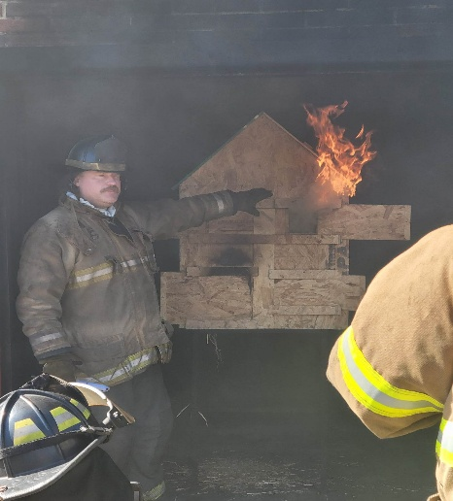
Ventilation Theory
Foam Theory
Forcible Entry Evolutions
($150 small trailer; $300 large trailer; per class)
Forcible Entry Theory
Gas-Electric Service Scenarios
High-Rise Theory or Evolutions
Hose Appliances Adaptations
Introduction to Power Tools
Ladder Evolutions
Ladder Theory
Lightweight Residential Construction
Miniature Fire Behavior Burn House
Modern Fire Behavior
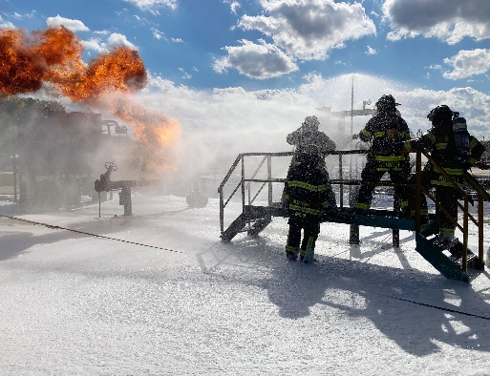
NFPA 1403- Acquired Structures
Officers Guide to Plan Review
Positive Pressure Ventilation

FIRE COMPANY IN-SERVICE TRAINING (con’t) (3 HOURS) IS

HAZARDOUS MATERIALS CLASSES:
Air Monitoring-Introduction
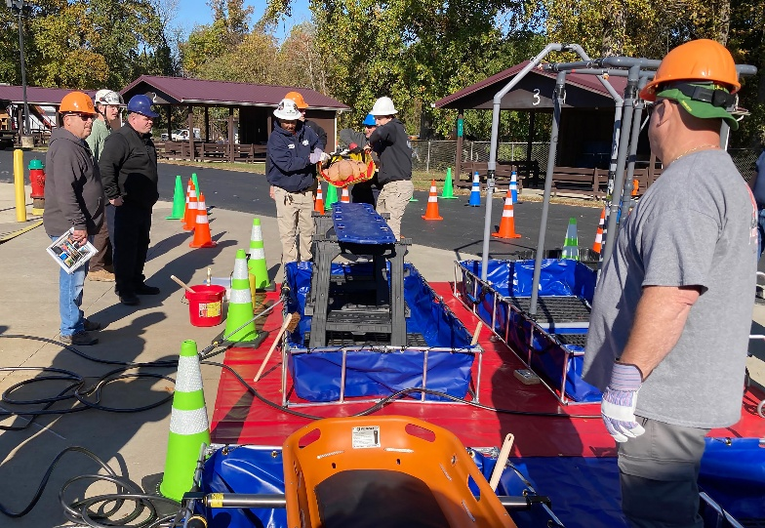
Decontamination Evolutions
Flammable Gases Evolutions
Flammable Liquids Evolutions
Hazardous Material Review and Awareness
Meth Lab Safety and Operations

RESCUE CLASSES:
Airbag Evolutions
Confined Space Rescue Awareness
Confined Space Rescue Evolutions
Elevator Rescue Evolutions
High Angle Evolutions
Responding To Hybrid Vehicle Incidents
RIT Evolutions
RIT Theory
Rope Rescue Evolutions
Structural Collapse Evolutions
Technical Rescue Awareness
Technical Rescue Evolutions
Vehicle Anatomy-Technical Rescue Awareness
Vehicle Rescue Evolutions
Water Rescue Evolutions

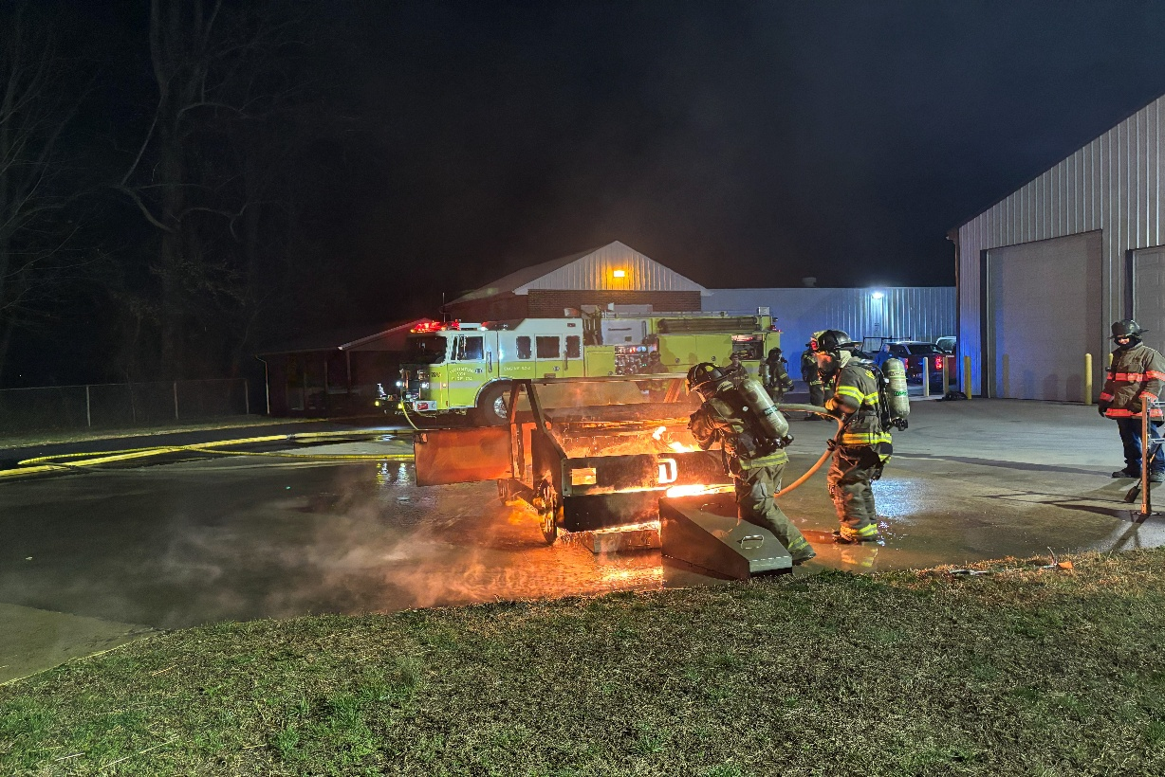

FIRE OFFICER CONTINUING EDUCATION CLASSES (3 HOURS) IS

PURPOSE: Courses are offered to provide customized training to fire company officers who wish to have refresher training.

AUDIENCE: Fire Line Officers, Administrative Officers, and Experienced Firefighters who want refresher training are encouraged to attend.

PREREQUISITES: Should be elected or appointed Fire Line Officers, elected or appointed Administrative Officers and/or experienced Firefighters.

CLASS LIMIT: Minimum 5 - Maximum 40

TUITION: Most classes offered at no charge to Delaware Fire Companies.

TO SCHEDULE TRAINING: Complete the IN-SERVICE TRAINING form on our website.
https://statefireschool.delaware.gov/wp-content/uploads/sites/114/2017/08/In-ServiceTrainingRequest201401.pdf

Contact the Fire School for Available Topics.

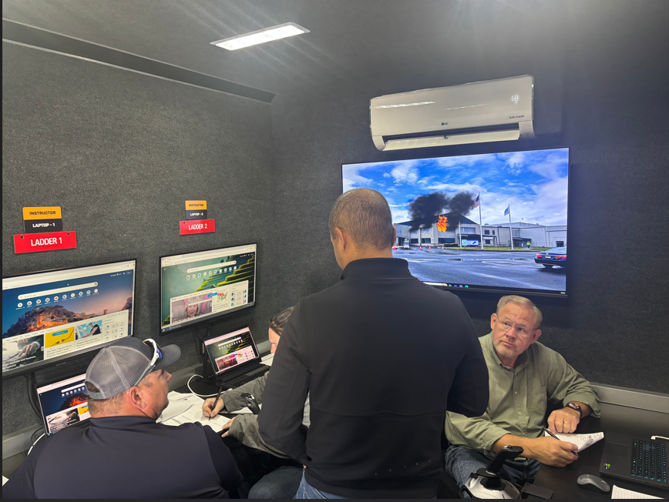

HARASSMENT/DISCRIMINATION AWARENESS TRAINING (2 HOURS) IS/OL

PURPOSE: For much of its history, the fire service had been a male-dominated field. Today’s fire service is made up of a diverse group of people committed to serve together. The purpose of this class is to make personnel aware of what constitutes sexual harassment and the laws that pertain to it. It is designed to be short enough to fit into the agenda of a company meeting in order to reach as many members as possible.

CONTENT: This course provides a definition of sexual harassment as well as an overview of the pertinent legal issues involved. Specific examples that pertain to the fire service are covered in detail. Other topics of harassment like discrimination and bullying are also covered.

AUDIENCE: Volunteer and career personnel

PREREQUISITES: None

CLASS LIMIT: 100 students

FIRE POLICE TRAINING

The Delaware State Fire School provides training for the Delaware State Fire Police Officer to obtain the basic knowledge to perform the duties of a duly sworn Fire Police Officer in the State. The training, in addition to any company-required training, will give you the knowledge of the duties of the Fire Police Officer, the laws and regulations surrounding the Fire Police Officer, and the roles and responsibilities to effectively and safely direct traffic at Fire and Emergency incidents in the State.
Once you have completed the online training required by the Delaware State Fire School, you may submit an application for training credit and a Basic Fire Police Certificate. Upon completion of the Basic Fire Police Course, a Delaware State Fire Police Identification Card can be issued with authorization from your sponsoring company.
More information on training and other requirements can be found on our website on the Fire Police Information Page.

DELAWARE FIRE POLICE ORIENTATION COURSE (1 HOUR) OL

PURPOSE: This course is to prepare the newly appointed Fire Police Officer with the basic knowledge surrounding basic fire police operations.

CONTENT: This course consists of basic fire police operations, fire police equipment, applicable Delaware State laws, and professionalism of the Fire Police Officer.

AUDIENCE: Those wishing to operate as a Fire Police Officer in the State of Delaware.

CERTIFICATION: NONE

PREREQUISITES: NONE

CLASS LIMITS: N/A

TUITION PER STUDENT: $10 In-State Companies

BASIC FIRE POLICE CERTIFCATE (1 HOUR) OL

PURPOSE: This certificate is to re recognize the efforts of the Delaware Fire Police Officer to advance their basic training. This certificate is required to apply for and be issued the DSFS Delaware State Fire Police Identification Card once sworn in by their County Sheriff.

CONTENT: This course consists of 4 online courses that compromise the previous DSFS Delaware Basic Fire Police Course.

AUDIENCE: Those wishing to operate as a Fire Police Officer in the State of Delaware.

CERTIFICATION: DSFS BASIC FIRE POLICE

PREREQUISITES: DSFS Basic Fire Police, ResponderSafety.com Intro to Fire Service Control Practices, ResponderSafety.com Safe Fire Service Control Practices, and Traffic Incident Management System full 4-hour course.

CLASS LIMITS: N/A

TUITION PER STUDENT: $10 In-State Companies

DRONE PILOT TRAINING

DRONE PILOT CERTIFICATION TEST PREPARATION (16 Hours) TC/RC/IS

PURPOSE: The Federal Aviation Administration requires that commercial or public safety operators of Small Unmanned Aircraft Systems (sUAS) pass a certification exam based on their Part 107 regulations. The purpose of this course is to provide the students with the information needed to challenge that exam and obtain their remote pilot certificate.

CONTENT: The courses consist of the information covered in the FAA Part 107 certification exam including regulations, safety, weather, airspace rules, airport operations, and basic flight principles. This course does not include the exam. The exam must be taken at an approved FAA testing facility for an additional fee.

AUDIENCE: All fire service and government agency personnel.

PREREQUISITES: None

TUITION PER STUDENT: $50 In-State Fire Companies and State Agencies; $100 Out-of-State Students
CLASS LIMIT: 30 Students

EQUIPMENT NEEDED: None


DRONE PILOT QUALIFICATION
(8 Hours) TC/IS

PURPOSE: This course is to provide drone pilots with the required skills to safely operate and maintain their aircraft.

CONTENT: This course will cover the safe operation of drones as well as basic maintenance. Students will be provided with sample policies, checklists, and log entries during the lecture portion. There will be practical evolutions including basic flight maneuvers and training missions. Students will also receive the ProBoard NFPA 2400 written exam for rPIC and Visual Observer.

AUDIENCE: All fire service and government agency personnel.

PREREQUISITES: FAA Part 107 Pilot Certification and most recent currency must be submitted with registration.

TUITION PER STUDENT: $100 In-State Fire Companies and State Agencies; $200 Out-of-State Students
CLASS LIMIT: 20 Students

EQUIPMENT NEEDED: None

NATIONAL FIRE ACADEMY TRAINING

PURPOSE: To provide members of the Fire Service with a specialized course developed by the National Fire Academy. Courses are presented by guest instructors or DSFS Instructors who are recognized in within an area of expertise. NFA Courses will be announced during the year for various course/program offerings on the DSFS web page.

AUDIENCE: Any member of the fire, rescue or EMS Service desiring the specialized courses.

PREREQUISITES: Determined by Course


CLASS LIMIT: 40 students

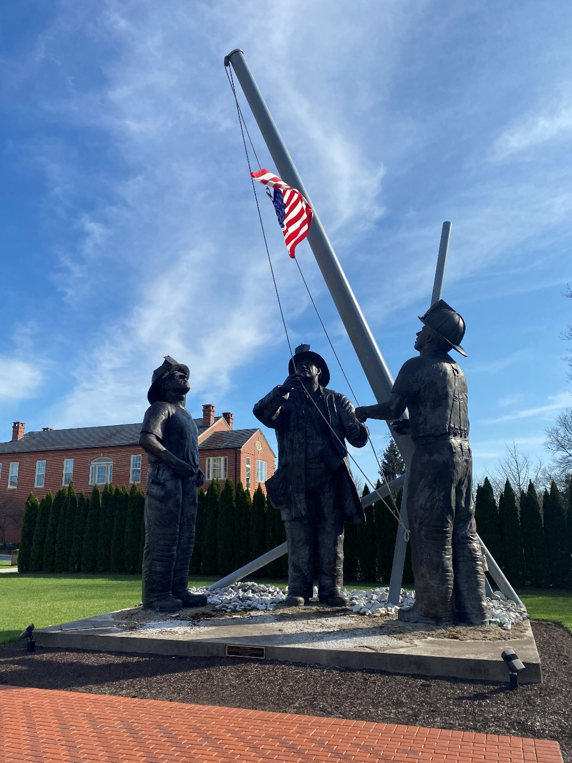

RESCUE TRAINING

VEHICLE RESCUE (32 HOURS) TC

PURPOSE: The Vehicle Rescue Course is designed to teach the theories and application of the necessary basic skills required in vehicle rescue.

CONTENT: During the classroom lecture, students will learn Scene Safety, Size-Up, PPE selection, Vehicle Anatomy, Equipment, and Extrication Strategies. Practical scenarios will include use of Hand, Electric, Hydraulic, and non-traditional tools. Skills include Stabilization and Extrication of Passenger Vehicles in the upright, overturned, and on-side positions. The course concludes with scenarios that are both Instructor and Student led. The students will be tested to Pro-Board Passenger Vehicle Awareness, Operations, and/or Technician level.

AUDIENCE: This course is offered to all fire, rescue, and EMS personnel

PREREQUISITES: 16 years of age, Introduction to Firefighting, Delaware EMT Certification, or State of Delaware Equivalents

CLASS LIMIT: 40 students

EQUIPMENT NEEDED: Full PPE refer to Page 11

TUITION PER STUDENT: $225 In-State Fire Companies
$450 Out-of-State Fire Companies

ADVANCED VEHICLE RESCUE (12 HOURS) TC

PURPOSE: The purpose of this course is to build upon the knowledge and skills learned in the Basic Vehicle Rescue Course and to provide the student with the technical skills and knowledge used to perform advanced techniques and theories required in vehicle rescue.

CONTENT: This course covers the principles of vehicle rescue following the ten-step method including advanced techniques in scene management, stabilization, patient care, gaining access and disentanglement. Advanced technical drills will be performed on the drill-grounds with overturned autos, trucks and school buses using a wide range of rescue tools including power tools, hand tools and airbags.

AUDIENCE: Experienced Fire, Rescue and EMS personnel are encouraged to attend.

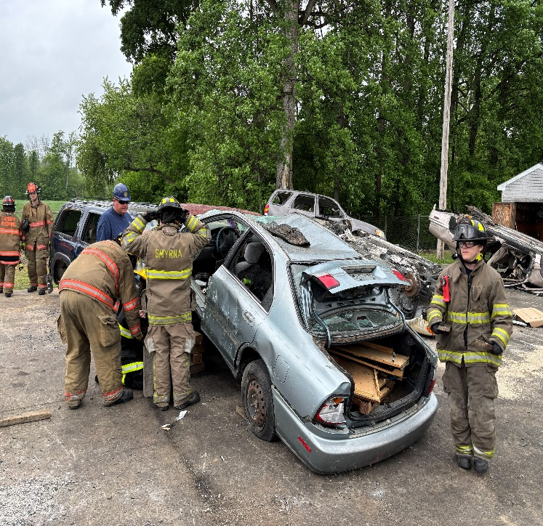
PREREQUISITES: Vehicle Rescue

EQUIPMENT NEEDED: Full PPE refer to Page 11

TUITION PER STUDENT: $225 In-State Fire Companies
$450 Out-of-State Fire Companies

CLASS LIMIT: Minimum of 10; Maximum 30 students

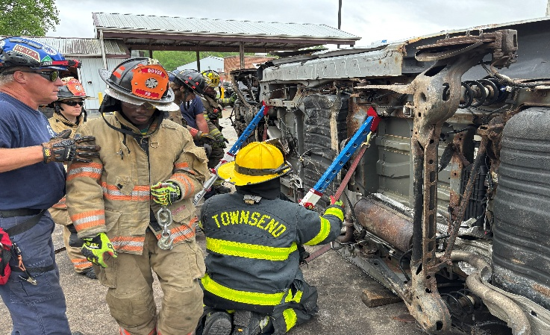

ELEVATOR RESCUE (6 HOURS) TC/IS
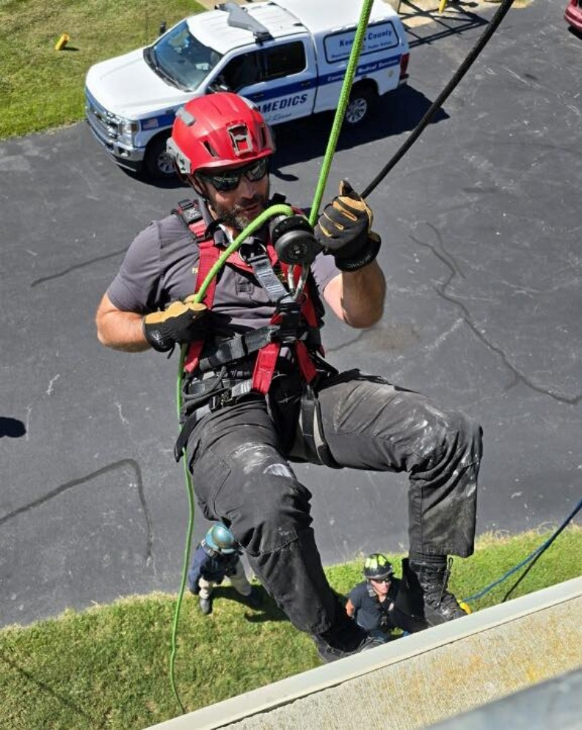
PURPOSE: The Elevator Rescue Course is designed to teach the fire, rescue, and EMS workers to operate safely, quickly and efficiently in the use of elevators during fires or other emergencies. The fire, rescue, and EMS worker must understand the necessary components and functions of an elevator to ensure a successful conclusion in an incident involving elevators.

CONTENT: Types of elevator installations, how elevators react to environmental changes, safety features incorporated in elevators and preparing the emergency service worker for his\her encounter with elevator emergencies through field exercises will be discussed in this course.

AUDIENCE: All fire, rescue, and EMS personnel.

PREREQUISITES: 16 years of age, Pro-Board Firefighter I or the State of Delaware Equivalent

TUITION PER STUDENT: $50 In-State Fire Companies
$100 Out-of-State Fire Companies

CLASS LIMIT: 40 students

EQUIPMENT NEEDED: Gloves, eye protection and helmet

ROPE RESCUE OPERATIONS (40 Hours) IS

PURPOSE: The Rope Rescue Operations Course is designed to teach the theories and application of the necessary basic skills required in Rope Rescue.

CONTENT: Types of ropes and their construction, utilization, inspection, cleaning and storage of ropes, terminology in knot tying, purpose and tying of knots and practical evolutions will be performed in this course. The student will be tested to the Pro-Board Rope Rescue Operations Level. For some courses, the first 8 hours will be held online.

AUDIENCE: All fire, rescue, and EMS personnel.

PREREQUISITES: 16 years of age and completion of Support Firefighter, Firefighter I or EMT.

TUITION PER STUDENT: $400 In-State Fire Companies
$800 Out-of-State Fire Companies
$750 In-State Industry
$1,000 Out-of-State Industry

CLASS LIMIT: Minimum 8, Maximum 30 Students

EQUIPMENT NEEDED: Rescue/Work Gloves, Eye Protection, Rescue or Fire Helmet, (Long Pants and Boots for evolutions).
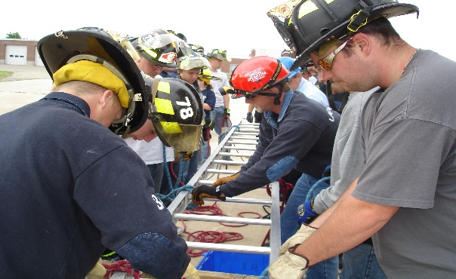

ROPE RESCUE TECHNICIAN (40 Hours) IS

PURPOSE: The Rope Rescue Technicians Course is designed to teach the theories and application of advanced and technical skills required in Rope Rescue.

CONTENT: Types of ropes and their construction, utilization, inspection, cleaning and storage of ropes, the use of specialized rope rescue equipment, hauling systems and technical skills used to perform the high angle rescue will round out this hands-on oriented course. The student will be tested to the Pro-Board Rope Rescue Technician Level.

AUDIENCE: Fire, Rescue and EMS personnel operating in a High-Angle Rescue environment.

PREREQUISITE: 18 years of age, Rope Rescue Operations.

CLASS LIMIT: Minimum 8, Maximum 30 Students

TUITION PER CLASS: $500 In-State Fire Companies
$1,000 Out-of-State Fire
$1,000 In-State Industry
$2,000 Out-of-State Industry

EQUIPMENT NEEDED: Rescue/Work Gloves, Eye Protection, Rescue or Fire Helmet, (Long Pants and Boots for evolutions).

CONFINED SPACE RESCUE TECHNICIAN (32 HOURS) TC/IS

PURPOSE: This course is designed to prepare fire, rescue and EMS personnel to safely enter into, treat and remove victims from Confined Space areas.

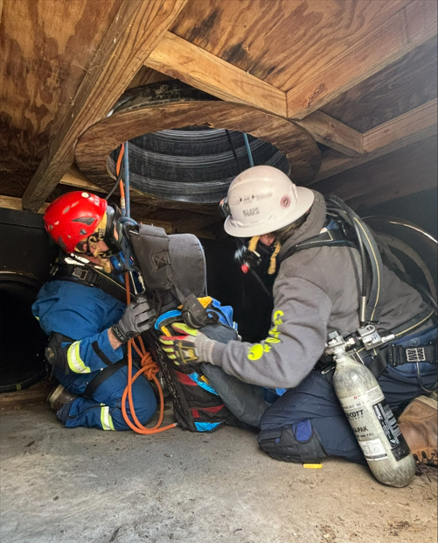
CONTENT: Raising and lowering of rescuers and victims in the confined space settings, through the use of ropes, rigging equipment, harness assemblies and tripods. Evolutions include the use of air monitoring, in-line breathing and first aid equipment. Practical evolutions will consist of horizontal and vertical rescue, underground rescue, and tank rescue. OSHA 29 CFR 1910.146 will serve as a guideline. The student will be tested to the Pro-Board Confined Space Rescue Operations and Technician levels

AUDIENCE: Fire, Rescue and EMS personnel operating in a Confined Rescue environment.

PREREQUISITES: 18 years of age, Rope Rescue Operations

CLASS LIMIT: Minimum 5; Maximum 24 Students

TUITION PER STUDENT:
$500 In-State Fire Companies
$1,000 Out-of-State Fire Companies
$1,000 In-State Industry
$2,000 Out-of-State Industry

EQUIPMENT NEEDED: Rescue/Work Gloves, Eye Protection, Rescue or Fire Helmet, (Long Pants and Boots for evolutions).

RAPID INTERVENTION TEAM TRAINING - BASIC (12 HOURS) TC/IS
IS providing certain conditions are met and approved by the Program Administrator

PURPOSE: This course is designed to provide the basic skills and theories that a firefighter may need when assigned as a RIT team member on an emergency scene.

CONTENT: This course covers the types of equipment and various methods of rescue associated with the RIT team purpose and function.

AUDIENCE: Rapid Intervention Team Training is offered to all fire service personnel, specifically those who may be assigned to function as a RIT team member in the future.

PREREQUISITES: 16 years of age, Pro-Board Firefighter I or the State of Delaware Equivalent

EQUIPMENT NEEDED: Full PPE refer to Page 11

TUITION PER STUDENT: $80 In-State Fire Companies
$160 Out-of-State Fire Companies

CLASS LIMIT: 40 students

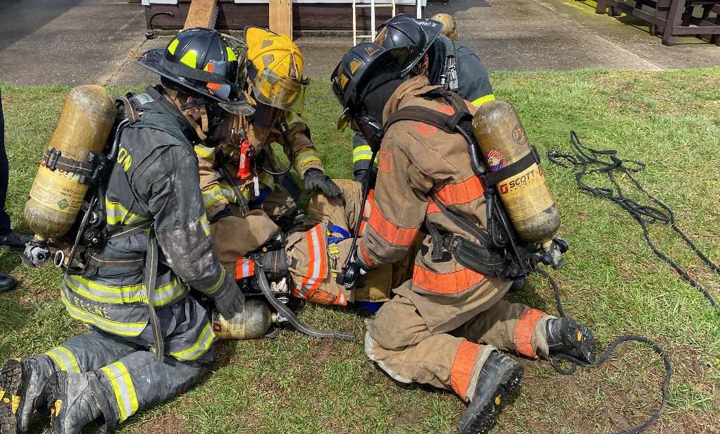

RAPID INTERVENTION TEAM TRAINING-ADVANCED (12 HOURS) TC

PURPOSE: This course is designed to provide advanced skills and theories that a firefighter may utilize when assigned as a RIT team member or team leader on an emergency scene.

CONTENT: This course will cover planning, proper selection of equipment, entry and exit points as well as the various methods of rescue and communication associated with the RIT purpose and function. Students will be required to complete a Physical Ability Circuit Course. Students will also be tested on subject knowledge and completion of physical evolutions by acting as part of a team to qualify as a RIT member. To receive credit, students must complete entire class.

AUDIENCE: Rapid Intervention Team Training is offered to all fire service personnel, specifically those who may be required to function as a RIT team member or team leader.

PREREQUISITES: RIT – Basic

CLASS LIMIT: 24 students

EQUIPMENT NEEDED: Full PPE refer to Page 11

TUITION PER STUDENT: $125 In-State Fire Companies
$250 Out-of-State Fire Companies

RAPID INTERVENTION TEAM TRAINING - LEADER (6 HOURS) TC/IS/RC

PURPOSE: This course is designed to provide advanced theories that a firefighter or officer may utilize when assigned as a RIT Officer or team leader on an emergency scene.

CONTENT: This course will cover planning, proper selection of equipment, entry and exit points as well as the various methods of rescue and communication associated with the RIT purpose and function. Students will also be taught subject knowledge and command responsibilities by acting as the leader of a RIT operation. Course will include case studies of RIT responses. To receive credit, students must complete entire class.

AUDIENCE: Rapid Intervention Team Training is offered to all fire service personnel, specifically those who may be required to function as a RIT team member or team leader.

PREREQUISITES: RIT-Basic and Advanced and 18 years of age

CLASS LIMIT: 24 students

EQUIPMENT NEEDED: None.

TUITION PER STUDENT: $25 In-State Fire Companies; $50 Out-of-State Fire Companies

WATER RESCUE CLASSES:

WATER RESCUE I (12 HOURS) TC/IS

PURPOSE: This land-based course is the beginning of a sequential Water Rescue Training Program to make all interested emergency service personnel aware of problems and solutions regarding water rescue operations.

CONTENT: This course will cover safety, self-survival, communications, support groups, equipment and techniques, the dive rescue team, knots and shore-based rescue. In-water evolutions will be held on the second day.

AUDIENCE: All fire, rescue and EMS personnel who may be called to the scene of a water rescue incident.

PREREQUISITE: 16 years of age

CLASS LIMIT: 40 students

TUITION PER STUDENT: $75 In-State Fire Companies
$150 Out-of-State Fire Companies

EQUIPMENT NEEDED: Clothing and footwear suitable for getting wet, and gloves

WATER RESCUE II (12 HOURS) TC/IS

PURPOSE: This water-based course is designed to enhance what was learned in Water Rescue I and to continue offering information regarding water rescue techniques.

CONTENT: Incident evaluation, towing, legal requirements, rules of the road, navigational aids, trailering and search and rescue response are covered in this course.

AUDIENCE: All fire, rescue and EMS personnel who may be called to the scene of a water rescue incident.

PREREQUISITES: Water Rescue I and 16 years of age

CLASS LIMIT: Minimum 8

TUITION PER STUDENT: $75 In-State Fire Companies
$150 Out-of-State Fire Companies
TUITION IN-SERVICE: $700 In-State Fire Companies
Quote for Out-of-State Companies

EQUIPMENT NEEDED: Clothing and footwear suitable
for getting wet, and gloves

RESCUE BOAT OPERATIONS (24 HOURS) IS

PURPOSE: This course is designed for emergency service personnel who maintain and operate rescue boats to ensure they are familiar with the various bodies of water, access points, marinas and shore points within their assigned area of responsibility allowing the safest and most timely response during an emergency situation.

CONTENT: This course will cover area familiarization, preplanning, boat handling, understanding weather and tide, hydro dynamics, charting and plotting, victim retrieval, towing and medical conditions that pertain to water rescues.

AUDIENCE: All fire, rescue and EMS personnel who may be called to the scene of an open water rescue incident.

PREREQUISITES: Water Rescue II

CLASS LIMIT: Minimum 8 students

TUITION PER CLASS: $1,500 In-State Fire Companies
Quote for Out-of-State Companies

EQUIPMENT NEEDED: Clothing and footwear suitable for getting wet, and gloves

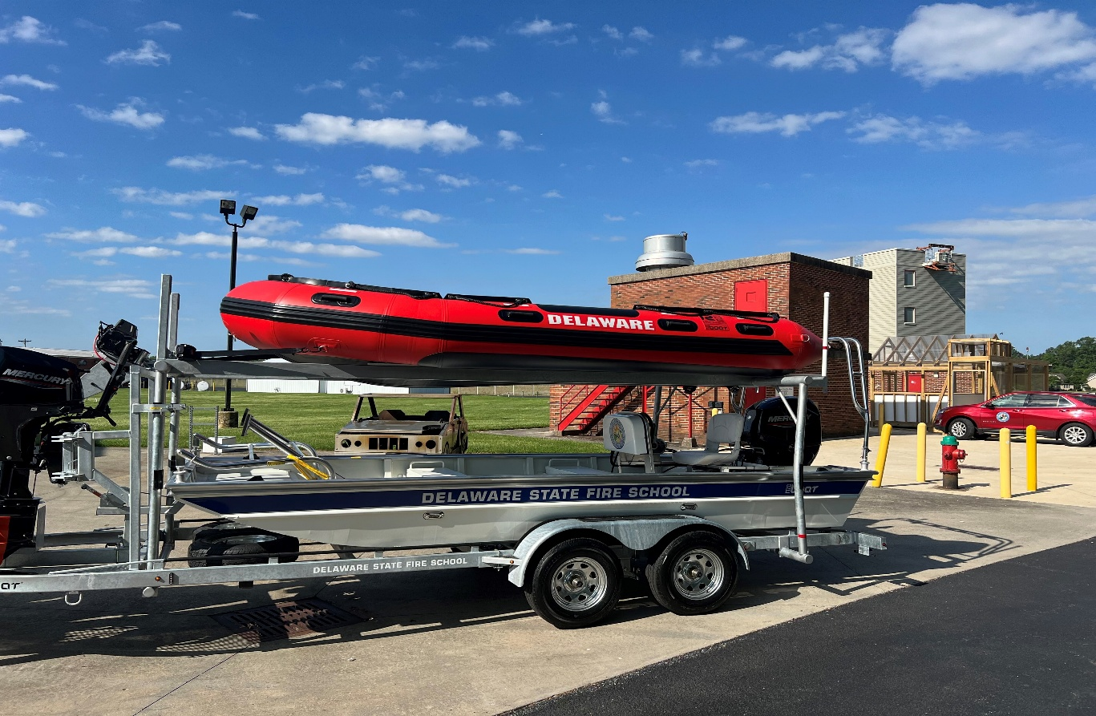

EMERGENCY MEDICAL SERVICES (EMS) TRAINING

EMS CONTINUING EDUCATION UNITS

PURPOSE: These courses provide the student with basic life support skills and knowledge. Topics deal with EMS related issues. These are intended to maintain and update EMT skills and knowledge base in the ever-changing field of Emergency Medical Services.

CONTENT: Courses are specific to EMS issues.

TUITION: In service - $125 per class
DSFS Training Centers: $20 per student

AUDIENCE: Pre-Hospital Personnel

PREREQUISITES: EMT Certification

TO SCHEDULE TRAINING: Complete the IN-SERVICE TRAINING form on our website.
http://www.statefireschool.delaware.gov/pdfs/In-ServiceTrainingRequest201401.pdf

See Training Schedule on www.statefireschool.delaware.gov for scheduled classes.

TC/RC/IS:
Abuse – Elder/Child/Dependents Heat Emergencies / Summer Months
Active Assailant Integrated Response (ALERRT) High Performance CPR / PIT CREW CPR
Ambulance Operations Human Trafficking
Bariatric Emergencies Medical Documentation
BLS Medications Neurological Emergencies
BLS Draw Up EPI OSP New Elicits – Drugs
Cardiac Emergencies OSHA Bloodborne Pathogens/HIPPA Annual
Cold Emergencies / Winter Months Pediatric Emergencies
Continuous Positive Airway Pressure (CPAP) Pregnancy Issues
Emerging Infectious Diseases Respiratory Emergencies
EMS Aviation Stop the Bleed
EMS Safety Taking Care of Our Own
End of Life Issues – DNR, TOR, Pronouncement Triage/MCI’s
Firefighter Down CPR/EMS Treat, No Transport

Links to other Non-DSFS Continuing Education online are available on our EMT Training Page.
https://statefireschool.delaware.gov/emt-training/

EMERGENCY MEDICAL RESPONDER

Emergency Medical Responders are an important part of the emergency medical services system. Emergency Medical Responders provide immediate patient care with little or no equipment. They have initial responsibility for scene survey, patient stabilization, trauma and medical patient care, automated external defibrillation (AED), vital signs, airway management, and oxygen therapy. They work collaboratively with EMT’s and paramedics in the pre-hospital setting. This program follows the most current curriculum guidelines of the National Highway Safety Administration National Standards for Emergency Medical Responders. At the successful completion of the Emergency Medical Responder Course, the student will be eligible for certification from the State Fire Prevention Commission as an Emergency Medical Responder provided all other requirements are met, which are outlined below. Students will also be eligible to obtain National Registry Certification as an Emergency Medical Responder, however they will need to successfully pass the NREMR written exam, which is an additional cost.

Initial Certification Requirements:

- Successfully pass a state-approved 48-Hour Emergency Medical Responder course based on the most current NHTSA’s National EMS Education Standards curriculum.
- AHA BLS Provider CPR/AED certification (or approved SFPC equivalent)
- Emergency Medical Responder Application (available on SFPC website and available through DSFS in class). Certificate of completion of the EMR completion program must be attached to application along with copy of AHA BLS Provider CPR/AED Card.
- State Fire Prevention Commission is responsible for ensuring compliance with the regulation and issuance of the Emergency Medical Responder Certification Card.
- Individuals not taking the DSFS course must submit copies of a State Fire Prevention Commission (SFPC) approved 48-hour course certificate with Office of EMS (OEMS) number and a current AHA BLS Provider CPR/AED card (or equivalent as approved by the Delaware State Fire Prevention Commission) along with the completed Emergency Medical Responder Application.
- Certification is good until 10/31, 2 years from year of issue.

Re-Certification:

- Successfully pass a state-approved 16-Hour Emergency Medical Responder Refresher course based on the most current NHTSA’s National EMS Education Standards curriculum.
- AHA BLS Provider CPR/AED certification is included in Delaware State Fire School (DSFS) Refresher course.
- Emergency Medical Responder Application will be completed in the DSFS Refresher course. Students must attach a copy of their NREMR certification (if applicable) or their DSFS EMR refresher completion certificate and their Current CPR certification and submit to the State Fire Prevention Commission.
- DSFS Emergency Medical Responder Refresher Completion Certificate, and the AHA BLS Provider CPR/AED card will be sent to individual. Sponsoring Company will receive notification.
- Individuals not taking the DSFS course must submit copies of a State Fire Prevention Commission (SFPC) approved 16-hour refresher course certificate with Office of EMS (OEMS) number and a current AHA BLS Provider CPR/AED card (or equivalent as approved by the Delaware State Fire Prevention Commission) along with the completed Emergency Medical Responder Application.
- Certification is good until 10/31, 2 years from year of issue.

Reinstatement for Lapsed Emergency Medical Responder:

- Emergency Medical Responders have two (2) years after their expiration to be reinstated. They will need:
  - Successfully pass a state-approved 16-Hour Emergency Medical Responder Refresher course based on the most current NHTSA’s National EMS Education Standards curriculum.
  - Current AHA BLS Provider CPR/AED card (or equivalent as approved by the Delaware State Fire Prevention Commission).
  - A completed Emergency Medical Responder Application.
  - This information needs to be submitted to the SFPC for certification.
  - Certification is good until 10/31, 2 years from year of issue.

National Registry:

- National Registry of Emergency Medical Responders is available but not mandatory. There is a practical and written component to National Registry. The practical evaluation is performed during the course, and all students must be successful to complete the course through DSFS. Students who wish to obtain National Registry must pay an additional fee to take the national registry exam for EMR through Pearson testing. DSFS is an approved Pearson Testing Center. Students who wish to explore this option may speak to the DSFS Program Manager for EMR.
DELAWARE EMERGENCY MEDICAL RESPONDER
CERTIFICATION THROUGH RECIPROCITY

- Emergency Medical Responders certified in another state may apply for reciprocity as an Emergency Medical Responder in Delaware by completing the following steps:
  - Submit a completed Emergency Medical Responder Application to State Fire Prevention Commission
  - Provide a copy of their State Emergency Medical Responder Card
  - Be affiliated with a Delaware entity that provides EMR level care
  - Attend and successfully complete the DSFS EMR refresher course (16 hours)
- Emergency Medical Responders who are nationally certified through NREMT may apply for certification as an Emergency Medical Responder by completing the following steps:
  - Submit a completed Emergency Medical Responder Application to the State Fire Prevention Commission.
  - Provide a copy of their NREMT Emergency Medical Responder certification card
  - Be affiliated with a Delaware entity that provides EMR level care
  - Provide a copy of current AHA BLS CPR/AED (or SFPC acceptable equivalent) that is valid through their NREMT EMR expiration date.

EMERGENCY MEDICAL RESPONDER COURSE (48 HOURS) RC/IS/TC

PURPOSE: This course is to provide the student with the basic life support skills and knowledge to assess, stabilize, and monitor the pre-hospital patient.

CONTENT: This course consists of airway management, CPR, AED, trauma management, medical emergencies, emergency operations, obstetrics, and pediatrics.

AUDIENCE: This course is intended for those individuals who respond to pre-hospital situations and must manage the patient until pre-hospital units arrive, or the patient can be transferred to individuals with more advanced levels of training.

CERTIFICATION: Personnel successfully completing the Emergency Medical Responder Course may be certified as an Emergency Medical Responder by the State Fire Prevention Commission for a two (2) year period, expiring on 10/31.

PREREQUISITES: Must be 16 years of age prior to the start of class, AHA BLS CPR Certification (or SFPC approved equivalent)

CLASS LIMIT: Minimum 10; Maximum 24

TUITION PER STUDENT: $275 In-State Volunteer Fire/Ambulance Companies
$450 All In-State agencies; $600 All Others

EMERGENCY MEDICAL RESPONDER REFRESHER (16 HOURS) RC/IS/TC

PURPOSE: This course is to re-fortify and enhance the skills and knowledge of the Emergency Medical Responder.
CONTENT: This course consists of airway management, CPR, AED, trauma management, medical emergencies, emergency operations, obstetrics, and pediatrics. This course is based upon the NCCP Model 12 in the most current NREMT program.

AUDIENCE: This course is intended for any individual currently certified as an Emergency Medical Responder.

CERTIFICATION: Personnel successfully completing the Emergency Medical Responder Refresher Course may be recertified as an Emergency Medical Responder for a two (2) year period.

PREREQUISITES: Must hold a current Emergency Medical Responder certification

TUITION PER STUDENT: $50 In-State Volunteer Fire/Ambulance Companies
$125 All In-State Agencies; $175 All Others
CLASS LIMIT: Minimum 10; Maximum 24
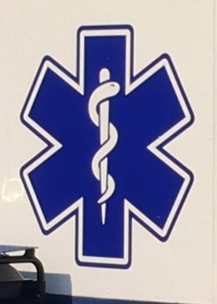
DELAWARE EMT – Emergency Medical Technician

This National Registry of Emergency Medical Technicians (NREMT) course meets the National EMS Education Standards guidelines. The curriculum provides the student with in-depth knowledge and skill-based training to appropriately assess, stabilize, monitor, and transport pre-hospital patients. Students are required to spend time in the clinical setting with actual time based upon student progress. Students successfully completing this course may sit for the National Registry exam. Upon presentation of required paperwork, State of Delaware EMT certification may be issued to individuals successfully completing NREMT requirements. The EMT must be affiliated with a Delaware EMS provider.

QUALIFICATIONS FOR TAKING DSFS NREMT COURSE

- Must be 16 years old prior to completion of the course.

- American Heart Association (AHA) Basic Life Support (BLS) Provider CPR/AED certification (or equivalent as approved by the Delaware State Fire Prevention Commission) is required to register for class. The following CPR/AED cards will be accepted:
  - American Heart Association (AHA) – BLS Provider
  - American Red Cross – Professional Rescuer CPR
  - American Safety and Health (ASHI) – CPR Pro for the Professional Rescuer
  - Emergency Care and Safety Institute – Professional Rescuer
  - EMS Safety Services, Inc.
  - ProTraining/ProCPR

- Twenty-five (30) seats are available in the regular classes, 25 seats available in the accelerated classes.

- Completed registration forms with a copy of current CPR/AED Certification will only be accepted until class limit is met or deadline date is reached. Seats cannot be reserved. You will be notified by email of your acceptance into the class.

- There is no charge for students sponsored by a Delaware Volunteer Fire Company or Volunteer Ambulance Company for the initial course. Cost of the course is supplemented by State funding. If a student withdraws, course material costs will be billed to the sponsoring company. If a student returns to take the course a second time, 50% of the course cost will be billed to the sponsoring company. If a student returns to take the course three times or more, the entire course cost will be billed to the sponsoring company.

- Tuition will be charged to all other students applying as individuals. Payment is due at time of registration. If student withdraws within first two weeks after the start of class, students will receive refund less than the cost of course materials; after 2 weeks and up until the midpoint of class, 50% course cost will be refunded; and after midpoint, no refund will be given.

- A self-paid student who applies for membership in a Delaware Volunteer Fire Company or a Delaware Volunteer Ambulance Company within 30 days of successful completion of the course may apply for reimbursement of the EMT course tuition fee upon written request. The sponsoring company, within 90 days of the completion of the course, is required to provide DSFS a letter indicating that the individual is a member in good standing for the Company. Reimbursement is based on student pre-payment, successful completion of the course, membership of a recognized service provider and available EMS funding.

- A mandatory state and federal background check must be completed while in the NREMT course. The background check must be performed by the Delaware State Bureau of Identification and students are responsible for payment. The Delaware State Bureau of Identification shall forward the background check to the State Fire Prevention Commission. Students MAY NOT hand deliver the background check. A receipt that the background check was performed must be given to the instructor before completion of course. The information for obtaining the background check is located on both the State Fire Prevention Commission website. If you have any questions, please call the Fire Commission directly at (302) 739-3160.

EMERGENCY MEDICAL TECHNICIAN COURSE (Meets the National Registry Requirements) TC/RC

PURPOSE: This National Registry of Emergency Medical Technicians (NREMT) course meets the National EMS Education Standards guidelines. The curriculum provides the student with in-depth knowledge and skill-based training to appropriately assess, stabilize, monitor, and transport pre-hospital patients. Students are required to spend time in the clinical setting with actual time based upon student progress. Students successfully completing this course may sit for the National Registry exam. Upon presentation of required paperwork, State of Delaware EMT certification may be issued to individuals successfully completing NREMT requirements. The EMT must be affiliated with a Delaware EMS provider. This course is offered in weeknight/weekend and accelerated weekday formats.

CONTENT: This course provides the student with in-depth knowledge and skill-based training to appropriately assess, stabilize, monitor, and transport the pre-hospital patient. Successful completion of this course will include passing a state approved practical and written exam (Note: State of Delaware uses the National Registry written/practical exam as the state approved exam).

AUDIENCE: This course is intended for those individuals who respond to pre-hospital situations and must manage, treat, and transport the patient to an appropriate medical facility.

MANDATORY BACKGROUND CHECK: All personnel taking the full EMT course will be required to have a State of Delaware and Federal Background check. This must be completed before patient contacts begin.

PREREQUISITES: Must be at least 16 years of age at completion of the course. Must have a current American Heart Association (AHA) Basic Life Support (BLS) Provider CPR/AED certification to register for class (for other certifications accepted, see previous page). Individuals attending this course will be REQUIRED to have a background check before completion of course. Students must be 17 years of age to obtain the State of Delaware EMT Card.

CLASS LIMITS: Minimum 10; Maximum 30 for the full class, 25 for the accelerated class. Completed registration forms will be accepted until class limit is met or deadline date is reached. You will be notified by email of your acceptance into the class.

TUITION PER STUDENT: $0 In-State Volunteer Fire/Ambulance Companies
$900 All Others
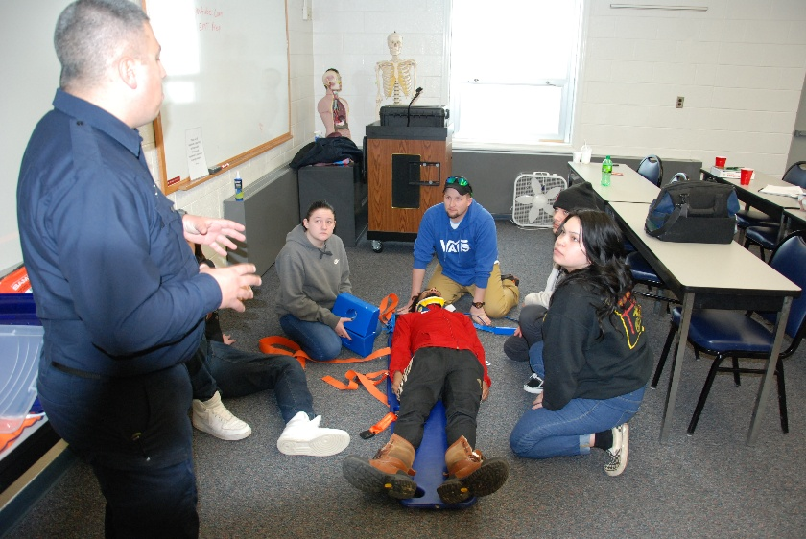
EMERGENCY MEDICAL TECHNICIAN (NCCP) REFRESHER (30 HOURS) RC/TC/BL First Day Online

PURPOSE: The course objective is to refresh/reinforce didactic knowledge and practical skills of the EMT, with the most current state protocols/standing orders presented.

CONTENT: For MTs renewing their certification, this course satisfies the 30-hour refresher and skills proficiency requirement necessary to maintain your state and national certification, per National Core Curriculum Program (NCCP) requirements. Students will be required to take two multiple choice tests, a protocol test on the most current approved protocols/standing orders, and a final test. Practical skills testing is also required to complete the State of Delaware and NCCP requirements for re-certification. Students must successfully complete all phases of the testing process to be issued a certificate. The course includes American Heart Association BLS Provider CPR AED.

AUDIENCE: This course is intended for any individual currently certified as a State or Nationally Registered EMT.

PREREQUISITES: Must hold a current EMT certification or have completed a DOT EMT curriculum.

CLASS LIMITS: Minimum of 10; Maximum of 25 students

TUITION: $0 Current Delaware EMTs of In-State Volunteer Fire/Ambulance Companies
$150 All Others when class is sponsored by DSFS.
$50 Will be charged to the Student for In-service class held at station regardless of EMT status

NREMT PRACTICAL SKILLS STATION – Request Only – $50 per Student

EMT RECIPROCITY CLASS (8 Hours) TC

Purpose: This course is to reinforce and recertify the skills and knowledge of the State and /or Nationally Registered Emergency Medical Technician, for application to the State Fire Prevention Commission for Delaware Certification as an Emergency Medical Technician

Content: This course provides the student with in-depth knowledge and skill-based training to appropriately assess, stabilize, monitor, and transport the pre-hospital patient. Successful completion of this course will include passing a state approved practical and written exam (Note: The State of Delaware uses the National Registry written/practical exam as the state approved exam).

AUDIENCE: This course is intended for any individual currently certified as a Nationally Registered EMT in another State and wishes to obtain State of Delaware certification as an EMT.

PREREQUISITES: Must hold a current National Registry Emergency Medical Technician card from another State and a current AHA BLS for the Healthcare Provider.

MANDATORY BACKGROUND CHECK: All personnel seeking reciprocity will be required to have a State of Delaware and Federal Background check. This must be completed before you are granted Reciprocity.

CLASS LIMITS: Minimum 10; Maximum 25
TUITION PER STUDENT: $100

FIELD TRAINING OFFICER (FTO) INITIAL TRAINING (8 hours) TC/RC

PURPOSE: The Delaware State Fire School has developed a comprehensive field training officer (FTO) program for experienced EMT’s who wish to mentor and coach new EMT field providers that have recently obtained certification or are in the process of obtaining certification while still in class to become an EMT.

CONTENT: This course goes over fundamentals of being a good FTO and issues and personality concerns/variances that can exist and how to best handle situations to maintain a professional aspect but also be a good trainer and coach to a new clinician. Upon successful completion of the DSFS FTO course, the student will be issued a certificate to present to the SFPC to be certified as an FTO. FTO certification runs concurrently with EMT certification period, not to exceed two years.

AUDIENCE: Intended for senior EMT’s that have a desire to assist in training and mentoring new EMS clinicians.

PREREQUISITES: Currently certified Emergency Medical Technician for at least five years, written recommendation from chief officer or EMS manager/administrator, no disciplinary actions on file with SFPC must be submitted at the time of registration.

CLASS LIMITS: Minimum 6; Maximum 12

TUITION PER STUDENT: $50

FIELD TRAINING OFFICER RECERTIFICATION COURSE (3 hours) TC/RC/Online

The Delaware State Fire School will offer an online update through an online learning platform or via in-person continuing education course. This course will review current state practices and regulations regarding Field Training. Students will be encouraged to complete online round-table discussions on current issues facing EMS; specifically issues regarding training. Upon completion of this course, students must submit the course Certificate of Completion to the State Fire Prevention Commission to receive re-certification as a Field Training Officer. Certification will run concurrently with Delaware EMT certification.

PREREQUISITES: Currently certified Field Training Officers

TUITION PER STUDENT: $25

QUALITY ASSURANCE OFFICER TRAINING PROGRAM (8 hours) TC/RC

PURPOSE: The Delaware State Fire School has developed a comprehensive Quality Assurance Officer training course that is intended to standardize what is required for evaluating, critiquing, praising and reporting of EMS run reports through DEMRS.

CONTENT: This course goes over quality assurance, milestones and standards, reporting requirements, critique communications, quality improvement tools and quality improvement metrics.

AUDIENCE: This course is intended for current officers and supervisors (or those who aspire to become) who conduct Emergency Medical Services Quality Assurance as part of their assigned duties.

PREREQUISITES: Currently certified Emergency Medical Technician. Written recommendation of Chief Officer or Supervisor must be submitted at the time of registration.

CLASS LIMITS: Minimum 10; Maximum 24

TUITION PER STUDENT: $50

PREHOSPITAL TRAUMA LIFE SUPPORT 10TH EDITION – PHTLS (NAEMT) (16 Hours) TC/RC

PURPOSE: This course provides a prehospital trauma care philosophy, stressing the need to treat the multi-system trauma patient as a unique entity with specific needs that requires an approach to treatment that varies from traditional treatment modalities.

CONTENT: This course is CAPCE approved for 16 hours of continuing education. This course, along with an approved refresher course, meets the minimum requirements for recertification as an EMT. NAEMT PHTLS certification is a four-year certification. Methods of instruction include lecture, discussion, and team-focused practical exercises. Students must pass the NAEMT written examination with a minimum score of 76%.

AUDIENCE: This course is intended to strengthen knowledge and treatment provided by emergency medical services providers to a trauma patient. Skills include national scope as well as Delaware specific treatments.

PREREQUISITES: Delaware or National Registry EMT or higher

CLASS LIMITS: Minimum 10; Maximum 24 Students

TUITION: $125 In-State Fire/Ambulance
$225 Out of State/Non-affiliated Fire/Ambulance

TACTICAL EMERGENCY CASUALTY CARE 2ND EDITION - TECC (NAEMT) (16 Hours) TC/RC

PURPOSE: This course covers topics designed to decrease preventable death in the tactical situation. Major topics covered include hemorrhage control; surgical airway identification and needle decompression identification; strategies for treating wounded responders in threatening environments; caring for pediatric patients; and techniques for dragging and carrying victims to safety.

CONTENT: This course is CAPCE approved for 16 hours of continuing education. This course, along with an approved refresher course, meets the minimum requirements for recertification as an EMT. NAEMT TECC certification is a four-year certification. Methods of instruction include lecture, discussion, and team-focused practical exercises. Students must pass the NAEMT written examination with a minimum score of 76%.

AUDIENCE: This course is intended to strengthen knowledge and treatment provided by emergency medical services providers to a trauma patient involved in an active assailant situation. Skills include national scope as well as Delaware specific treatments. This course will assist EMS providers with integration with ALERRT training.

PREREQUISITES: Delaware or National Registry EMT or higher

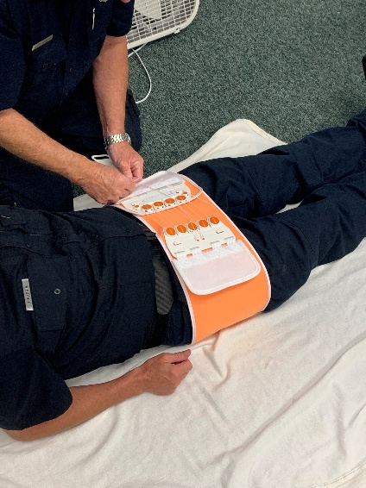
CLASS LIMITS: Minimum 10; Maximum 24 Students

TUITION: $125 In-State Fire/Ambulance
$225 Out of State/Non-affiliated Fire/Ambulance

ADVANCED MEDICAL LIFE SUPPORT - AMLS (NAEMT) (16 Hours) TC/RC

PURPOSE: This course provides an in-depth understanding of medical assessment and treatment. AMLS uses an assessment pathway, a systematic tool for assessing and managing common medical conditions with urgent accuracy. EMS Clinicians will expand their knowledge on respiratory and cardiac disorders as well as shock, sepsis, neurological disorders, endocrine/metabolic disorders, environmental issues, infectious diseases, abdominal disorders and toxicological emergencies.

CONTENT: This course is CAPCE approved for 16 hours of continuing education. This course, along with an approved refresher course, meets the minimum requirements for recertification as an EMT. NAEMT AMLS certification is a four-year certification. Methods of instruction include lecture, discussion, and team-focused practical exercises. Students must pass the NAEMT written examination with a minimum score of 76%.

AUDIENCE: This course is intended to strengthen knowledge and treatment provided by emergency medical services providers to identify, assess and treat medical emergencies. Skills include national scope as well as Delaware specific treatments.

PREREQUISITES: Delaware or National Registry EMT or higher

CLASS LIMITS: Minimum 10; Maximum 24 Students

TUITION: $125 In-State Fire/Ambulance
$225 Out of State/Non-affiliated Fire/Ambulance

EMERGENCY PEDIATRIC CARE - EPC (NAEMT) (16 Hours) TC/RC

PURPOSE: This course provides an in-depth understanding of the pathophysiology of the most common pediatric emergency issues, and stresses critical thinking skills to help practitioners make the best decisions for their patients. Major topics covered in this course include understanding pediatrics, ABC’s, Oxygenation, abuse and neglect, medical emergencies, hypoperfusion and shock, resuscitation of newborns, pediatric trauma, and special needs.

CONTENT: This course is CAPCE approved for 16 hours of continuing education. This course, along with an approved refresher course, meets the minimum requirements for recertification as an EMT. NAEMT EPC certification is a four-year certification. Methods of instruction include lecture, discussion, and team-focused practical exercises. Students must pass the NAEMT written examination with a minimum score of 76%.

AUDIENCE: This course is intended to strengthen knowledge and treatment provided by emergency medical services providers to pediatric and pregnant patients. Skills include national scope as well as Delaware specific treatments.

PREREQUISITES: Delaware or National Registry EMT or higher

CLASS LIMITS: Minimum 10; Maximum 24 Students

TUITION: $125 In-State Fire/Ambulance
$225 Out of State/Non-affiliated Fire/Ambulance

GERIATRIC EDUCATION FOR EMS - GEMS (NAEMT) (8 Hours) TC/RC

PURPOSE: This course provides a prehospital provider with geriatric specific issues. Major topics include aging, changes, communications, assessment, end of life issues, trauma, falls, immobilization, neurological emergencies and altered metal status, medication toxicity, pharmacology, and elder abuse and neglect.

CONTENT: This course is CAPCE approved for 8 hours of continuing education. This course, along with an approved refresher course, meets the minimum requirements for recertification as an EMT. NAEMT GEMS certification is a four-year certification. Methods of instruction include lecture, discussion, and team-focused practical exercises. Students must pass the NAEMT written examination with a minimum score of 76%.

AUDIENCE: This course is intended to strengthen knowledge and treatment provided by emergency medical services providers to a geriatric patient. Skills include national scope as well as Delaware specific treatments.

PREREQUISITES: Delaware or National Registry EMT or higher

CLASS LIMITS: Minimum 10; Maximum 24 Students

TUITION: $50 In-State Fire/Ambulance
$150 Out of State/Non-affiliated Fire/Ambulance

EMS Safety (NAEMT) (8 Hours) TC/RC

PURPOSE: This course provides a prehospital provider with a more in-depth look at practicing safety while performing as an EMS clinician. Topics include crew resource management, situational awareness, roadway safety, operating emergency vehicles safely, patient and crew safety, lifting mechanics, and medication safety.

CONTENT: This course is CAPCE approved for 8 hours of continuing education. NAEMT EMS Safety certification is a four-year certification. Methods of instruction include lecture, discussion, and team-focused practical exercises. Students must pass the NAEMT written examination with a minimum score of 76%.

AUDIENCE: This course is intended to strengthen knowledge and treatment provided by emergency medical services providers while acting safely and having a keener sense of situational awareness. Skills include national scope as well as Delaware specific treatments.

PREREQUISITES: Delaware or National Registry EMT or higher

CLASS LIMITS: Minimum 10; Maximum 24 Students

TUITION: $50 In-State Fire/Ambulance
$150 Out of State/Non-affiliated Fire/Ambulance

BLS PROVIDER CPR/AED CERTIFICATION (4 HOURS) TC/RC/IS

PURPOSE: This course is designed to teach skills and knowledge of adult one- and two-person CPR, pediatric CPR, AED and management of the choking pediatric and adult patient for first responders. This course requires successful completion of a written and skills evaluation. A course completion eCard for BLS Provider is issued for this course with a re-certification period every two years.

CONTENT: This course covers CPR (Adult, Child and Infant), AED, and Choking.

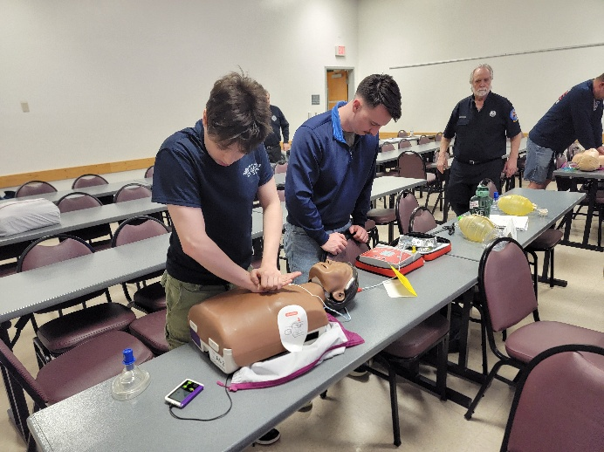
AUDIENCE: This course is intended for those individuals who respond to pre-hospital situations, or any Healthcare Provider. This is the mandatory course for all certified Emergency Medical Responders and EMTs in the State of Delaware.

PREREQUISITES: None

CLASS LIMITS: Minimum 6; Maximum 24 students

TUITION PER STUDENT: $50 In-State Fire/Ambulance/Police
$65 All Others (scheduled division class)
$80 Client Scheduled

BLS PROVIDER CPR/AED HEARTSAVER FIRST AID
(7 HOURS) IS

URPOSE: This course is designed to teach first responders the knowledge and psychomotor skills they need to recognize emergencies and give first aid for first responders. The first aid section covers general principles, medical emergencies, injuries, and environmental emergencies. The CPR section covers adult, child, and infant CPR and choking, and the AED covers theory and operation of the AED for the BLS Provider level. Successful completion requires passing skills evaluations. Course completion eCards for both BLS Provider and Heartsaver First Aid are issued for this course with a re-certification period every two years.

AUDIENCE: Firefighters, police officers and other first responders such as security guards and lifeguards, who also need First Aid training for their position.

CLASS LIMITS: Minimum 6; Maximum 24

TUITION PER STUDENT: $80 In-State Fire/Ambulance/Police
$95 All Others (scheduled division class)
$105 Client Schedule

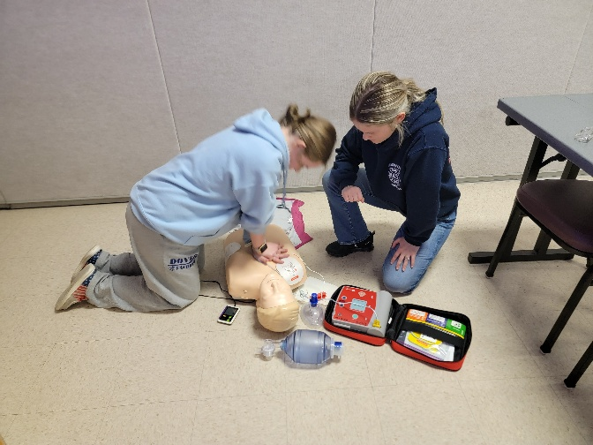
HEARTSAVER CPR/AED (3 HOURS) IS

PURPOSE: This course is designed to teach rescuers the knowledge and psychomotor skills they need to recognize emergencies and provide cardio-pulmonary resuscitation for the layperson. The CPR section covers adult, child, and infant CPR. AED use and choking are also reviewed. Successful completion requires passing skills evaluations. A course completion eCard Heartsaver CPR AED is issued for this course with a recertification period every two years.

AUDIENCE: Any non-healthcare worker such as utility workers, office employees, security guards, or other members of the general public

CLASS LIMITS: Minimum 6; Maximum 24

TUITION PER STUDENT: $45 In-State Fire/Ambulance/Police
$60 All Others (scheduled division class)
$75 Client Scheduled

HEARTSAVER FIRST AID (3 HOURS) IS

PURPOSE: This course is designed to teach rescuers the knowledge and psychomotor skills they need to recognize emergencies and give first aid for the layperson. This covers general principles, medical emergencies, injuries and environmental emergencies. Successful completion requires passing skills evaluations. A course completion eCard Heartsaver First Aid is issued for this course with recertification period every two years.

AUDIENCE: Any non-healthcare worker such as firefighters, police officers, lifeguards, utility workers, office employees, security guards, or other members of the general public.

CLASS LIMITS: Minimum 6; Maximum 24

TUITION PER STUDENT: $45 In-State Fire/Ambulance/Police
$60 All Others (scheduled division class)
$75 Client Scheduled
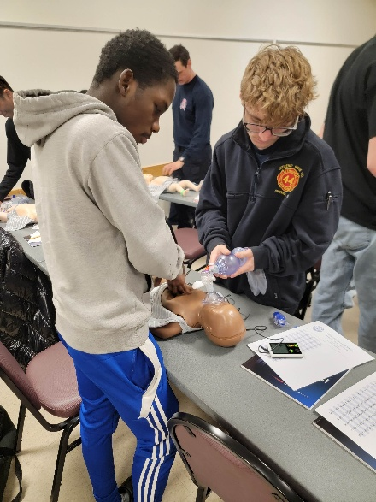

HEARTSAVER FIRST AID AND CPR/AED (6 HOURS) TC/IS

PURPOSE: This course is designed to teach rescuers the knowledge and psychomotor skills they need to recognize emergencies and give first aid for the layperson. The first aid section covers general principles, medical emergencies, injuries, and environmental emergencies. The CPR section covers adult, child, and infant CPR and choking, and the AED covers theory and operation of the AED. Successful completion requires passing skills evaluations. A course completion eCard for Heartsaver First Aid CPR/AED is issued for this course with a re-certification period every two years.

NOTE: Those who are required to hold a current CPR/AED card as a requirement for employment or membership need to verify that they may use this level to meet those requirements, and not the higher level of the BLS Provider CPR/AED course.

AUDIENCE: Firefighters, general public, and other non-healthcare providers such as day care workers, custodians, utility workers, babysitters, and those who may provide care before first responders arrive.

CLASS LIMITS: Minimum 6; Maximum 24

TUITION PER STUDENT: $70 In-State Fire/Ambulance/Police
$85 All Others (scheduled division class)
$100 Client Scheduled
INDUSTRIAL TRAINING

INCIPIENT BRIGADE (12 HOURS) TC

PURPOSE: This course is intended to meet or exceed the provisions of NFPA 1081 for those facilities selecting the Incipient Brigade Option. It is a blend of classroom study and practical drill ground evolutions. It is designed to enable even the non-fire-oriented employee to successfully extinguish an incipient fire with a fire extinguisher or small diameter hose line.

CONTENT: Fire Brigade Organization, Fire Extinguisher, Hose Handling, Chemistry of Fire and Incipient Firefighting are covered in this course.

AUDIENCE: Personnel who currently serve on or will be assigned to an Incipient Brigade are encouraged to attend.

PREREQUISITES: None

EQUIPMENT NEEDED: Hard Hat, gloves and eye protection

CLASS LIMITS: 50 students

CLASS TIME: 9:00 am – 4:00 pm

TUITION PER STUDENT: $400 All Students

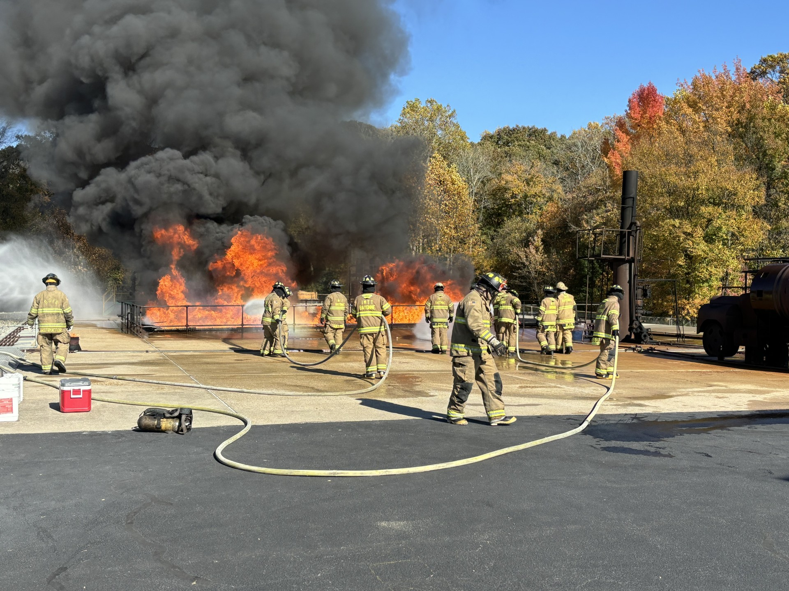

BASIC BRIGADE SKILLS (24 HOURS) TC
(Class starts at 8:00 a.m.)

PURPOSE: This course is the first step in our training program. It is designed to bring even the non-fire oriented industrial worker to a training level where they will be able to function as a useful member of the industrial emergency response team.

CONTENT: Fire Brigade Organization, Chemistry of Fire, Fire Extinguisher, The Incident Management System, Hose Handling/Appliances, Self Contained Breathing Apparatus, Interior Firefighting, Flammable Liquids Firefighting, and Flammable Gas Firefighting are covered in this course.

AUDIENCE: Any personnel currently serving on or will be assigned to serve on a fire brigade are encouraged to attend.

PREREQUISITES: None

CLASS LIMIT: 60 Students

CLASS TIME: 8:00 am – 5:00 pm

EQUIPMENT NEEDED: Full PPE refer to Page 11

TUITION PER STUDENT: $550 All Students

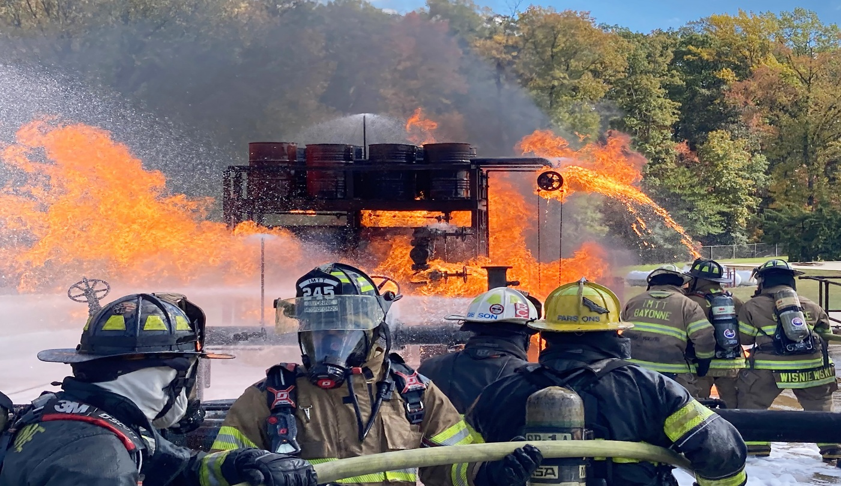

ADVANCED EXTERIOR BRIGADE SKILLS (24 HOURS) TC
(Class starts at 8:00 a.m.)

PURPOSE: This course is intended to provide essential training for personnel assigned to fire brigades seeking to meet NFPA 1081 Advanced Exterior or Advanced Exterior/Interior Structural options. Building on the skills learned in Basic Brigade Skills, it allows the brigade member to fight more complex fires.

CONTENT: Storage Vessels, Flammable Liquid Firefighting, Flammable Gas Firefighting, Hazardous Materials Tactics and Firefighting Foam are covered in this course.

AUDIENCE: Any personnel who are currently serving on, or who will be
assigned to an Advanced Exterior or Advanced Exterior/Interior Structural
Brigades are encouraged to attend.

PREREQUISITES: Basic Brigade Skills

CLASS LIMIT: 40 Students

CLASS TIME: 8:00 am – 5:00 pm

EQUIPMENT NEEDED: Full PPE refer to Page 11

TUITION PER STUDENT: $600 All Students

ADVANCED INTERIOR BRIGADE SKILLS (24 HOURS) TC (Class starts at 8:00 a.m.)

PURPOSE: This course is intended to provide essential training for personnel assigned to fire brigades seeking to meet NFPA 1081 Interior Structural or Advanced Exterior/Interior Structural options. Building on the skills learned in Basic Brigade Skills or Fire Brigade I, it takes the brigade member beyond merely the application of water or fire extinguisher agent. It enables the brigade members to fight larger, more complex fires and to learn additional critical fire emergency functions.

CONTENT: This course covers Automatic Sprinklers, Electrical Safety, Search and Rescue, Ventilation, Salvage, RIT (Rapid Intervention Team), Tactics and Structural firefighting.

AUDIENCE: Any personnel who are currently serving on, or who will be assigned to an Interior Structural or Advanced Exterior/Interior Structural Brigade are encouraged to attend.

PREREQUISITES: Basic Brigade Skills

CLASS LIMIT: 40 Students

CLASS TIME: 8:00 am – 5:00 pm

EQUIPMENT NEEDED: Full PPE refer to Page 11

TUITION PER STUDENT: $500 All Students

BRIGADE LEADERSHIP SKILLS (18 Hours) TC

PURPOSE: This course is designed to develop leadership skills for brigade members who are serving in leadership positions. It acquaints the student with the supervisory skills necessary to direct a fire brigade emergency team during an in-plant emergency using an emergency management system. Students spend two of the three days of the course on the drill ground actually leading teams to control "emergencies" on our Structural, Flammable Liquids, and Flammable Gasses Pads.

CONTENT: This course is designed to teach team leader skills, principles of size-up, decision making in table-top exercises, structural firefighting with student leaders, flammable liquids firefighting with student leaders and flammable gas firefighting with student leaders.

AUDIENCE: Experienced Fire Brigade members who are or will be assuming leadership roles during plant emergencies are encouraged to attend.

PREREQUISITES: Interior Structural Brigade; or Advanced Exterior Brigade.

EQUIPMENT NEEDED: Full PPE refer to page 11

CLASS LIMIT: 30 Students

CLASS TIME: 9:00 am – 4:00 pm

TUITION PER STUDENT: $350 All Students

BRIGADE REVIEW - FLAMMABLE LIQUIDS/GAS FIREFIGHTING (6 HOURS) TC

PURPOSE: This course is intended to provide hands-on refresher training for experienced personnel in the area of Flammable Liquids and Gasses firefighting. It seeks to provide a source of practical firefighting not easily obtained on the plant site.

CONTENT: Subject areas included in this course are: Flammable Liquids Firefighting and Flammable Gas Firefighting.

AUDIENCE: Experienced Brigade members who are required to have refresher training in Flammable Liquids and Gas Firefighting are encouraged to attend.

PREREQUISITES: Basic Brigade Skills

CLASS LIMIT: 40 Students

CLASS TIME: 9:00 am – 4:00 pm

EQUIPMENT NEEDED: Full PPE refer to Page 11

TUITION PER STUDENT:
$400 All Students

BRIGADE REVIEW - STRUCTURAL FIREFIGHTING (6 HOURS) TC

PURPOSE: This course is intended to provide hands-on refresher training for experienced personnel in structural firefighting. It seeks to provide a source of practical firefighting experience not easily obtained on the plant site.

CONTENT: Structural Firefighting is discussed in this course

AUDIENCE: Experienced Brigade members who are required to have refresher training in Structural Firefighting are encouraged to attend.

PREREQUISITE: Basic Brigade Skills

CLASS LIMIT: 40 Students

EQUIPMENT NEEDED: Full PPE refer to Page 11

TUITION PER STUDENT: $160 All Students

CLASS TIME: 9:00 am-4:00 pm

ADVANCED EXTERIOR BRIGADE 1081 CERTIFICATION COURSE (40 HOURS) TC
(Class starts at 8:00 a.m.)

PURPOSE: This course is intended to prepare the student for certification testing to achieve certification to the advanced exterior brigade member category of the NFPA 1081, Standard for Industrial Fire Brigade Member Professional Qualifications.

CONTENT: Safety; Personal Protective Equipment; Self-Contained Breathing Apparatus; Fire Behavior; Product Identification; Fire Extinguishers, Fixed Detection and Suppression Systems; Water Supply, Hose Streams and, Appliances; Master Streams; Firefighting Foam; Tactical Priorities and Considerations; and Ladders are covered in this course. At the conclusion of the course, students will complete both the written and practical tests for certification. Successful candidates will be certified to this section of the NFPA 1081 standard by the National Board on Fire Service Professional Qualifications (Pro Board).

AUDIENCE: Any Brigade member who wishes to be certified as an advanced exterior brigade member.

CLASS LIMITS: 15 minimum; 30 maximum

CLASS TIME: 8:00 am – 5:00 pm

EQUIPMENT NEEDED: Full PPE refer to Page 11

TUITION PER STUDENT: $1,450 All Students

INDUSTRIAL CONFINED SPACE RESCUE (24 HOURS) TC/IS (Class starts at 8:00 a.m.)

PURPOSE: This course is designed to prepare industrial fire and rescue personnel to safely enter confined space areas to stabilize and remove victims.

CONTENT: "Hands-on-Training" to include raising and lowering of rescuers and victims in the confined space setting, through the use of ropes, rigging equipment, harness assemblies, and tripods. Evolutions include the use of air monitoring, in-line breathing, and first aid equipment. Practical evolutions utilizing "The Rescue Team Concept" will consist of horizontal and vertical rescue, underground rescue, and vessel-type rescues. OSHA 20 CFR 1910.146 will serve as a guideline. The student will be tested to the Pro-Board Confined Space Rescue Operations and Technician levels.

AUDIENCE: This course is designed for fire, rescue and ambulance personnel who may be required as a member of a fire brigade to perform in a confined space rescue.

PREREQUISITES: 18 years of age and Rope Rescue I or its equivalent. All people attending this course must be in good physical condition since all students will be required to participate in ALL course activities. Each student must be a participant in their Company’s medical surveillance program complying with OSHA 1910.120, Section F and trained to operate and use Self Contained Breathing Apparatus (SCBA) addressed in OSHA 1910.134.

CLASS LIMIT: Minimum of 8; Maximum of 24

CLASS TIME: 8:00 am–5:00 pm

EQUIPMENT NEEDED: Confined Space Rescue Equipment refer to Page 11

TUITION PER STUDENT: $410 In-State Companies
$530 Out-of-State Companies

INDUSTRIAL CONFINED SPACE RESCUE REFRESHER (16 HOURS) TC/IS (Class starts at 8:00 a.m.)

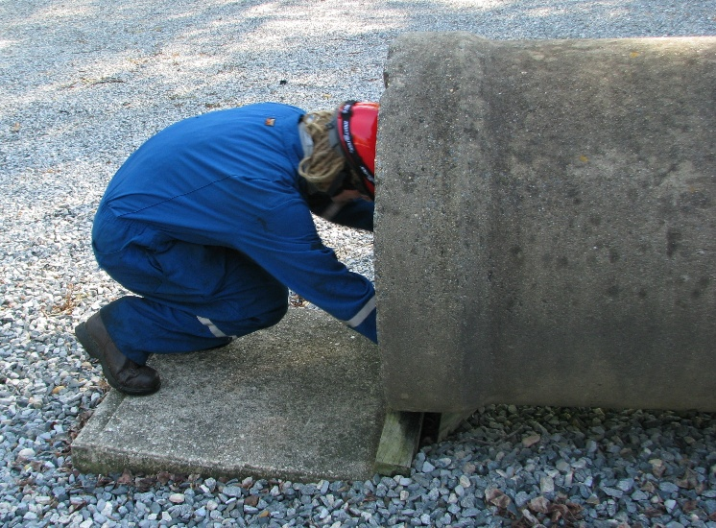
PURPOSE: This course is designed to prepare fire, rescue and EMS personnel to safely enter into, treat and remove victims from Confined Space areas.

CONTENT: Raising and lowering of rescuer and victims in the confined space settings, through the use of ropes, rigging equipment, harness assemblies and tripods. Evolutions include the use of air monitoring, in-line breathing and first aid equipment. Practical evolutions will consist of horizontal and vertical rescue, underground rescue, and tank rescue. OSHA 29 CFR 1910.146 will serve as a guideline. The student will be tested to the Pro-Board Confined Space Rescue Operations and Technician levels.

AUDIENCE: Industrial Fire, Rescue and EMS personnel operating in a Confined Rescue Environment.

PREREQUISITES: 18 years of age. Industrial Students do NOT require Rope Operations. Pro-Board Certification will only be issued if the student has Pro-Board Rope Rescue Operations.

CLASS LIMIT: Minimum of 8; Maximum of 24

EQUIPMENT NEEDED: Confined Space Rescue Equipment refer to Page 11

CLASS TIME: 8:00 am – 5:00 pm

TUITION PER STUDENT: $500 In-State Companies
$1,000 Out-of-State Companies
$1,000 In-State Industry
$ 2,000 Out-of-State Industry

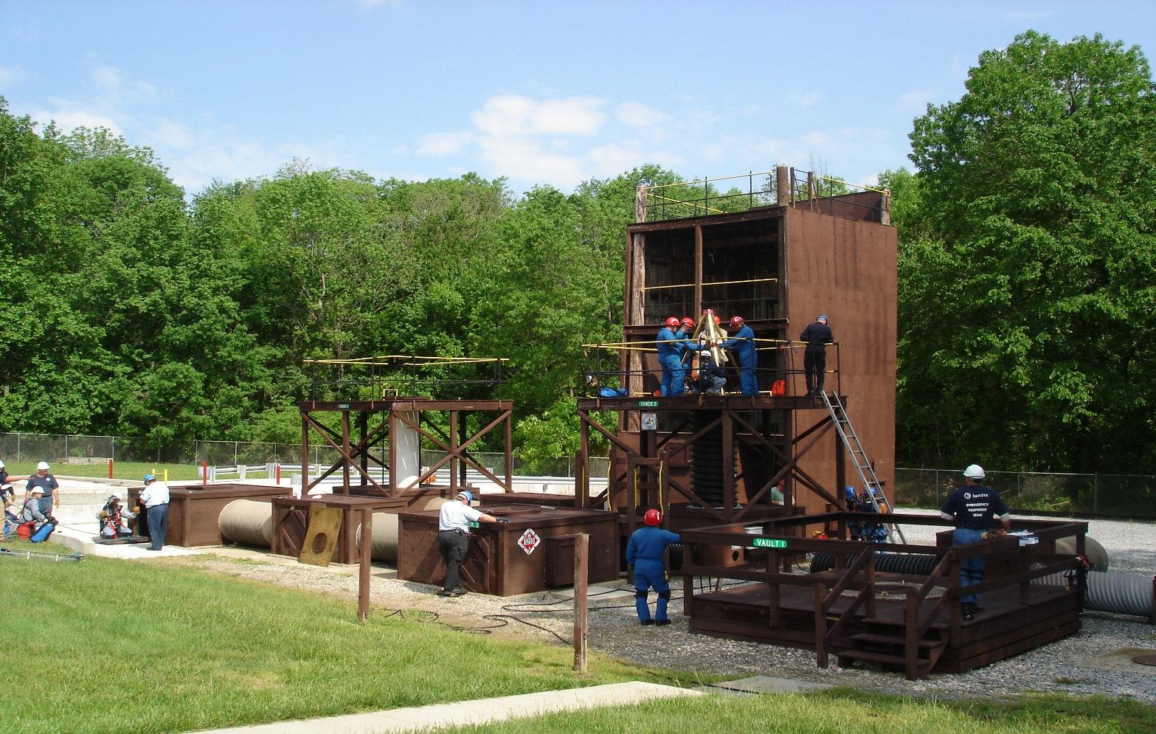

SPECIAL FIRE BRIGADE TRAINING TC/IS

VARIOUS PROGRAMS OFFERED ARE:
(Hours determined by course material chosen)

Chemistry of Fire-Fire Characteristics
Confined Space Rescue Review
Fire Brigade Organization
Fire Extinguishers
Fire Protection Systems
Flammable Gas Firefighting
Flammable Liquids Firefighting
Foam Firefighting
Hazardous Materials
Hose Handling
Incident Command
Incipient Firefighting-Review
Master Streams
Search and Rescue
Self-Contained Breathing Apparatus
Storage Vessels
Structural Firefighting
Tactics
Theory of Structural Firefighting
Ventilation

PURPOSE: To enable brigade members to train together and to provide specialized training as needed to enhance Brigade Skills and/or knowledge in a customized format.

AUDIENCE: General Fire Brigade Members

PREREQUISITES: Varies between subjects

CLASS LIMIT: Varies

EQUIPMENT NEEDED: Full PPE refer to Page 11

TUITION: Contact us for Quote

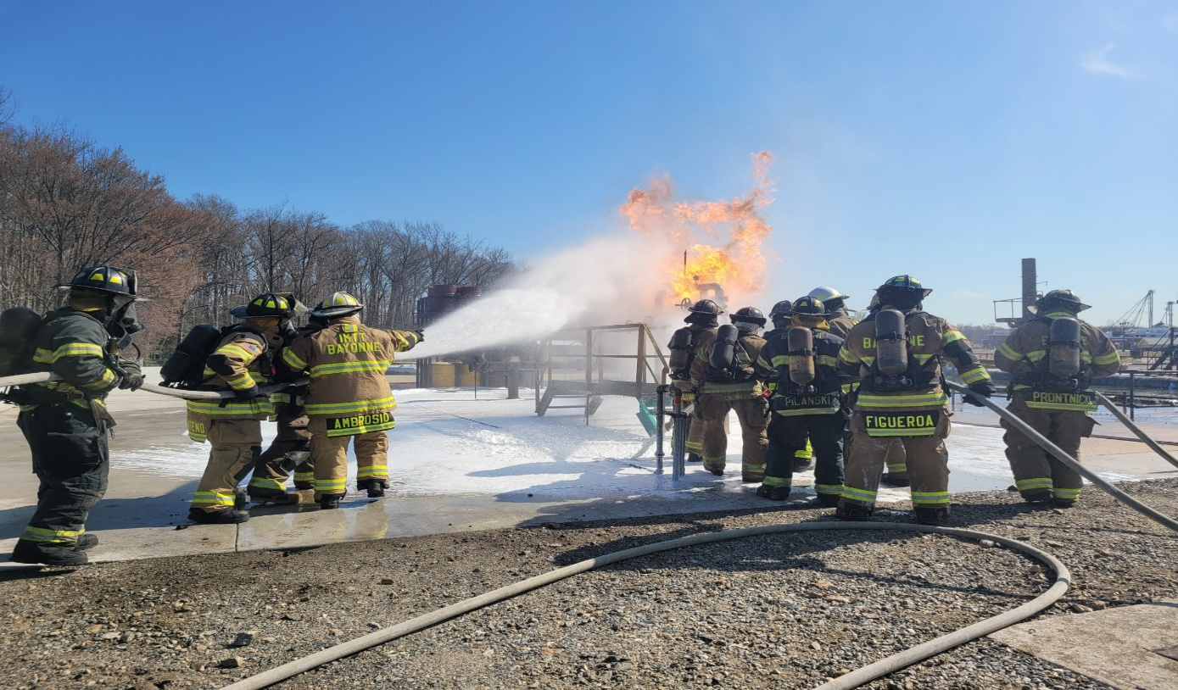

HAZARDOUS MATERIALS TECHNICIAN TRAINING

HAZARDOUS MATERIALS AWARENESS (4 HOURS) TC/RC/IS
PURPOSE: This course is designed for emergency responders who, in the course of their normal duties, could encounter an emergency involving hazardous materials or weapons of mass destruction (WMD) and who are expected to recognize the presence of hazardous materials/WMD, protect themselves, call for trained personnel, and secure the area.
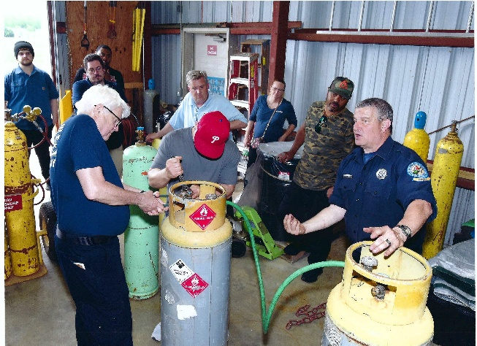
CONTENT: This course is offered in conjunction with a certification test to provide the student with the opportunity to become nationally certified to NFPA 470 requirements. Students who successfully pass the written test at the end of the course are eligible to receive a certificate from the National Board on Fire Service Professional Qualifications and International Fire Service Accreditation Congress.

AUDIENCE: This course is an entry level course suitable for training new personnel or as a review program for personnel who have never been certified in Hazardous Materials Operations.

PREREQUISITES: None

CLASS LIMITS: 30 students

EQUIPMENT NEEDED: Classroom appropriate attire refer to Page 11

TUITION PER STUDENT: $50 In-State Fire Companies
$100 Out-of-State Fire Companies

HAZARDOUS MATERIALS OPERATIONS (20 HOURS) TC/RC/IS

PURPOSE: Today, many fire departments must respond to Hazardous Materials and terrorist incidents. Firefighters must be knowledgeable in operating at these incidents. After completing this lesson, the student shall be able to summarize the basic operations at Hazardous materials and terrorist incidents and perform emergency decontamination and defensive procedures. This course complies with the NFPA 470 requirements for Hazardous Materials Operations.

CONTENT: This course is offered in conjunction with a certification test to provide the student the opportunity to become nationally certified to NFPA 470 requirements. This course covers operations and management structure at hazardous materials or terrorists incidents, how the strategic goal of isolation and scene control is achieved, general guidelines for decontamination, the strategic goal of spill control and confinement, and the actions taken during the recovery and termination phase of a Hazardous Materials or terrorist incident. Students who successfully pass the written test at the end of the course are eligible to receive a certificate from the National Board on Fire Service Professional Qualifications and International Fire Service Accreditation Congress.

AUDIENCE: Personnel who have Awareness Level Certification and wish to be certified to the Operations Level.

PREREQUISITES: Hazardous Materials Awareness

CLASS LIMIT: 30 students

TUITION PER STUDENT: $75 In-State Fire Companies
$150 Out-of-State Fire Companies

EQUIPMENT NEEDED: Classroom appropriate attire refer to Page 11

HAZARDOUS MATERIALS AWARENESS AND OPERATIONS (24 HOURS) TC/RC/IS

PURPOSE: The Hazardous Materials Awareness and Hazardous Materials Operations classes (on page 56) may be taken together to form one 24-hour course. The content of both courses will be covered in one in this combined offering. Students who successfully pass the written test at the end of the course are eligible to receive a certificate from the National Board on Fire Service Professional Qualifications and International Fire Service Accreditation Congress.

AUDIENCE: This course is suitable for training new personnel or as a review program for personnel who have never been certified in Hazardous Materials Operations.

PREREQUISITES: None

CLASS LIMITS: 30 students

EQUIPMENT NEEDED: Classroom appropriate attire refer to Page 11

TUITION PER STUDENT: $125 In-State Fire Companies
$250 Out-of-State Fire Companies

HAZARDOUS MATERIALS TECHNICIAN CERTIFICATION COURSE (40 HOURS) TC

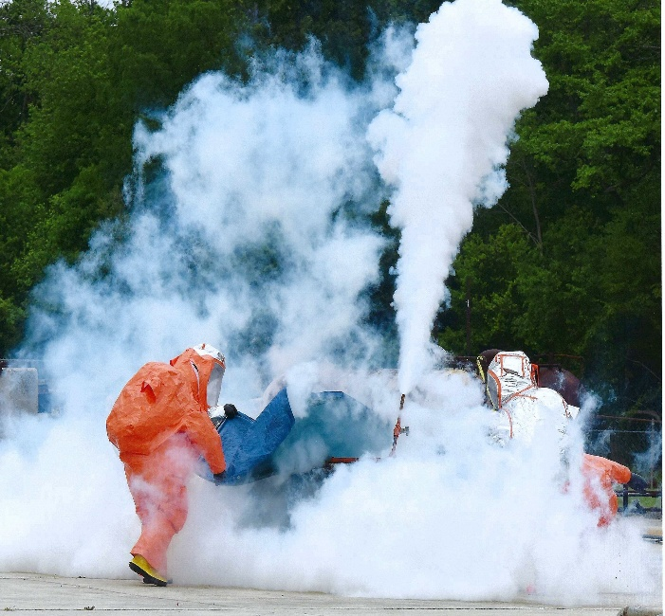
PURPOSE: This course is used to familiarize and train potential Emergency Response Team Members in regulations, guidelines, procedures and techniques in mitigating a chemical release and/or spill on or off site. This course will address the training requirements of applicable occupational safety and health administration and national fire protection association at the Hazardous Materials Technician Level. The goal of the course is to allow the student to safely and effectively respond to Chemical Emergencies and meet the required NFPA 470 Standard for Hazmat Awareness, Operations and Technician and 29 CFR 1910.120.

CONTENT: This course will provide information on the following subject areas: regulation overview, toxicology, chemistry of hazardous substances, pesticides, materials safety data sheets, incident command, department of transportation hazardous materials classifications, shipping documents, labels, placards and emergency guidebook, NFPA hazard identification system, incident assessment criteria, monitoring and instrumentation guidelines, chemical protective clothing, de-contamination, medical monitoring, non-bulk containers, patching of non-bulk containers, theory and use of chlorine a, b, & c and midland kits, cargo tank and van trailers, intermodal containers, rail cars, container damage assessment, transloading operations, flaring and/or emergency de-inventory operations, sorbents, spill confinement, fixed site emergencies, media relations and a review of selected hazardous materials terms and bibliographies. Throughout the class, students will be expected to demonstrate the application of specific theories, skills and techniques and successfully pass written quizzes and an examination with a grade of 70% or better. Upon the successful completion of all tests and course requirements the student will receive Pro Board (IFSAC certification available) in Hazmat Awareness, Operations and Technician as well as state certification for Technician.

AUDIENCE: This course is designed to provide education and experience to a newly designated Emergency Response Team member, with minimal training and experience in the Hazardous Materials Emergency Response field.

PREREQUISITES: Hazardous Materials Operations

CLASS LIMIT: 30 students

EQUIPMENT NEEDED: Work clothing and steel toe boots

CLASS TIME: 8:00 am – 5:00 pm

TUITION PER STUDENT: $1,500

HAZARDOUS MATERIALS TECHNICIAN REFRESHER COURSE (8 HOURS) TC/IS

PURPOSE: This course is provided to re-familiarize emergency response team members in guidelines, procedures and techniques in mitigating a chemical release and/or spill on or off site from a container. This course will address refresher training requirements of applicable occupational safety and health administration and national fire protection association at the hazardous materials technician level. The goal of the course is to allow for the student to safely and effectively respond to chemical emergencies.

CONTENT: This course will provide information on the following subject areas: Incident Command, Incident Assessment criteria, Monitoring and Instrumentation activities, Chemical Protective Clothing and Respiratory Protection, Decontamination and evolutions involving non-bulk containers, Cargo Tank and Van trailers, Intermodal Containers and Rail Cars, Transloading Operations, Flaring and/or Emergency De-inventory Operations, Sorbents and Spill Confinement. Throughout the Class, students will be required to demonstrate the application of specific theories, skills and techniques. Upon the successful completion of all tests and course requirements the student will receive state certification for Haz Mat Technician.

AUDIENCE: This course is designed to provide continuing education and experience to Emergency Response Team members, who respond to Hazardous Materials Emergencies.

PREREQUISITES: DSFS HAZARDOUS MATERIALS TECHNICIAN COURSE or approved equivalent.

CLASS LIMIT: 30 students

EQUIPMENT NEEDED: Work clothing and steel toe boots

TUITION PER STUDENT: $400

CLASS TIME: 8:00 am – 5:00 pm

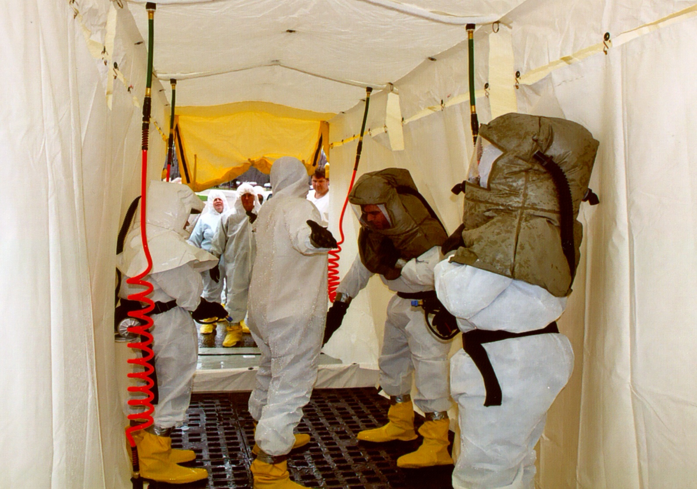

AGENCY/INSTITUTION TRAINING

Many institutions and agencies, both private and state owned, are required to know and practice various activities concerning fire and fire safety. The Delaware State Fire School provides the instruction for these organizations. Courses concerning Police Orientation, Institutional Fire Safety and many Health Care Facility subjects make up the curriculum concerning Agency and Institution Training. The students come from State, County, and Municipal Police Departments, Hospitals and Health Care Facilities, School Custodians and Institutional Staff Personnel. Primarily, anyone with a need to know about fire or fire safety who is employed by an agency or institution is eligible for training.

For tuition information contact Delaware State Fire School for information.

CUSTODIAL FIRE PROCEDURES COURSE

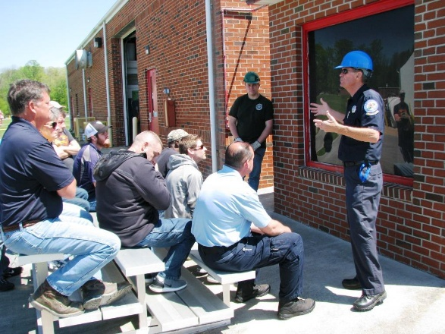
(6 HOURS) TC

PURPOSE: To make those employed in Custodial positions familiar with proper fire safety practices and the skills they need to intervene to prevent an emergency from occurring.

CONTENT: Fire characteristics, extinguisher usage, flammable liquids and gases, as well as hazardous materials are topics of study in this course as they pertain to those employed within an educational setting.

AUDIENCE: Those employed in custodial positions within educational facilities.

CLASS LIMIT: 100 Students

EQUIPMENT NEEDED: Clothing suitable in the event of getting soiled

TUITION PER STUDENT: $35

DIVISION OF DEVELOPMENT DISABILITIES SERVICES SPECIAL HOME FIRE S

(3 HOURS) RC/IS/TC

PURPOSE: This course is offered to provide fire safety training for certification.

CONTENT: The course includes guidelines and information in fire safety and prevention to include: installation, location, and maintenance of smoke detectors, importance of preplanning, and practicing home escape drills and information on the principles of fire and fire behavior.

AUDIENCE: This course is designed for foster family providers from the Department of Disabilities.

CLASS LIMIT: Minimum 10; maximum 100 Students

SMOKE DETECTORS & SPRINKLERS: This course will discuss the general importance, placement, and maintenance of smoke detectors‬‬‬‬

ESCAPE PLANNING: Students are trained on the proper sequence of events that must take place to safely escape
a fire.

FIRE BEHAVIOR: Discussion on the make-up and characteristics of fire will take place. Students are given information on toxic gases and how they may travel.

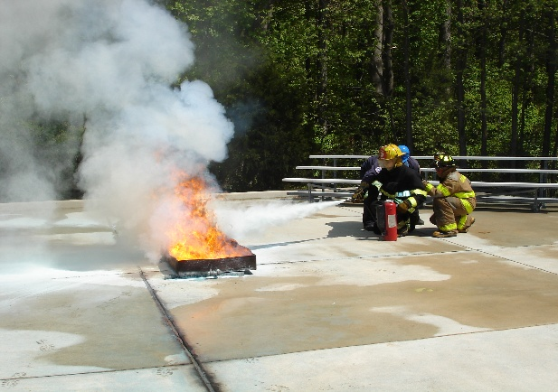
FIRE EXTINGUISHER TRAINING (3 HOURS) TC/RC/IS

PURPOSE: This course is designed to familiarize the student with the types and usage of fire extinguishers.

CONTENT: Characteristics of fire and the proper use of fire extinguishers are discussed in this class.

AUDIENCE: Non-fire-oriented personnel.

PREREQUISITES: None

CLASS LIMIT: 20 students

EQUIPMENT NEEDED: Clothing suitable in the event of getting soiled

TUITION PER CLASS: Commercial Clients - $150 per 3-hour program per instructor
State Agencies - $125 per 3-hour program per instructor

HEALTHCARE FIRE SAFETY (6 HOURS) TC

PURPOSE: This course is designed to prepare health care personnel for the fire that may occur in their facility with the emphasis on prevention, evacuation and extinguishment.

CONTENT: Skills development of patient removal and fire extinguisher usage with demonstrations of various situations that the student may encounter on the job are discussed in this class.

AUDIENCE: Any acute or chronic care facility employees involved in either patient care or support services are encouraged to attend.

PREREQUISITES: None

CLASS LIMIT: 80 students

TUITION: $35

EQUIPMENT NEEDED: Clothing suitable in the event of getting soiled

PATIENT EVACUATION (3 HOUR) TC/IS

PURPOSE: The purpose of the class is to increase the skill level of the health care employees in evacuation
procedures.

CONTENT: Lifts, carries and evacuation procedures are discussed in this class.

AUDIENCE: All health care and institutional personnel are encouraged to attend.

PREREQUISITES: None

CLASS LIMIT: 20 students

EQUIPMENT NEEDED: Clothing suitable in the event of getting soiled

LAW ENFORCEMENT FIRE ORIENTATION (14 HOURS) TC

PURPOSE: This course is designed to orient the police officer with the operation of the fire service in the State of Delaware. Familiarize the officer with fire survival in relationship to structural fires, hazardous materials and flammable liquids and gasses incidents.

CONTENT: Fire characteristics, extinguisher usage, flammable liquids and gases and hazardous materials are topics of discussion in this course. Students will be offered Hazardous Materials Awareness Certification.

AUDIENCE: State, county, municipal police officers and cadets.

PREREQUISITES: None

CLASS LIMIT: 60 students

EQUIPMENT NEEDED: Clothing suitable in the event of getting soiled

FIRE SAFETY – INJURY PREVENTION PROGRAMS

The purpose of the Public Fire and Injury Prevention programs is to provide an awareness to the citizens of Delaware of the devastation of fire and some of the precautions they can follow to protect themselves and their loved ones from this type of tragedy occurring. Fire and Injury Prevention presentations are available upon request from the Delaware State Fire School, and all lessons are designed according to the age of the audience. Please provide a two- week advance notice when requesting a program so that we may have adequate time to schedule instructors and gather materials. For tuition information please contact Delaware State Fire School.

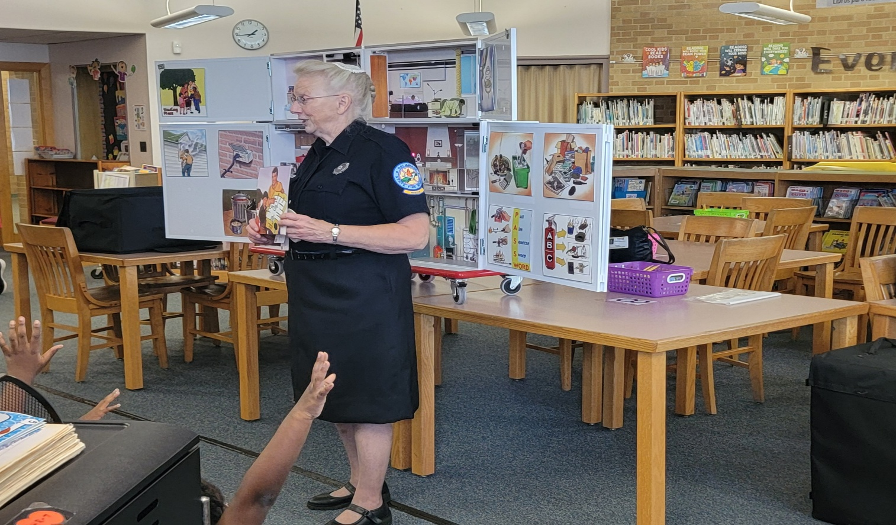

CAMPUS FIRE SAFETY (3 HOURS) TC/IS/RC

PURPOSE: The purpose of this course is to increase awareness of Fire Safety Procedures to those who live on our campuses.

CONTENT: Discussion is held regarding Fire Behavior. A presentation is made regarding Escape Planning and the interaction between students and staff. A video presentation takes place regarding actual incidents on college campuses that had tragic results.

AUDIENCE: Students, Dormitory Staff, Educators and Security Personnel who live or have contact with those who live on Campus are encouraged to attend.

CLASS LIMIT: Minimum 10; Maximum 100 Students

KITCHEN FIRE SAFETY (3 HOURS) IS

CONTENT: Carelessness while cooking is one of the major causes of fires in the home. The Kitchen Fire Safety Workshop includes discussion on electrical fires, clothing fires, micro-wave oven safety, using small appliances safely and a table-top demonstration of products normally used in attempting to extinguish a stove top fire.

CLASS LIMIT: Minimum 10; Maximum 100 Students

CHILDREN'S FIRE SAFETY PROGRAMS RC/IS

PURPOSE: To teach children to recognize and avoid fire and burn hazards and to train them with what they need to know to protect themselves in a fire or burn emergency.

AUDIENCE: The course is designed for children’s groups to include, but not limited to preschool, schools, scouting groups, civic groups, and the general public

CLASS LIMIT: 100 Students
‬‬‬‬

COMMUNITY HELPERS: The effect of seeing a firefighter in full turnout gear in a flaming, smoke-filled environment or in the classroom can be a horrible, frightening experience for a young child. This block of instruction provides young children with a positive, pleasant experience of meeting a firefighter in full turnout gear in a familiar and safe setting for the first time‬‬‬‬

BASIC FIRST AID: Children can administer basic first aid in an emergency to help themselves or others. This block provides information on burns and scalds and the hazards associated with them. Also included are basic methods to stop nose bleeds, identify products which are poisonous and identify other injuries and basic methods to treat them while waiting for help‬‬‬‬

BASIC KITCHEN FIRE SAFETY: The kitchen can be the most dangerous room in the house. In this block children are taught basic fire safety practices in the kitchen and especially the dangers associated with stoves, electrical appliances, hot liquids, and pan fires

HOME HAZARDS: In this lesson the students take a trip through a simulated home. This block will provide information for children to identify hazards in the home and ways they can assist adults in removing them to protect from a fire or burn incident. Discussion take place regarding smoke alarm use and planning proper escape route‬‬‬‬

BASIC FIRE BEHAVIOR: Smoke is the killer in most fire fatalities. This block will provide information on the fire triangle, the products contained in smoke, their dangers, and methods of breaking the fire triangle to prevent fires‬‬‬‬

EMERGENCY CALLING: What to do if you have an emergency. Questions you should be prepared to answer and actions one should take. A simulated 911 call is used as an interactive activity‬‬‬‬

STAY AWAY FROM HOT THINGS: This is an interactive lesson for Pre-K and Kindergarten students on hazards around the home. Also, included is information on matches and lighters

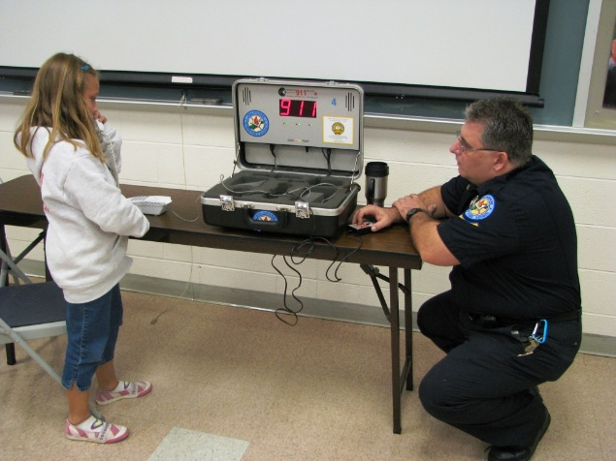
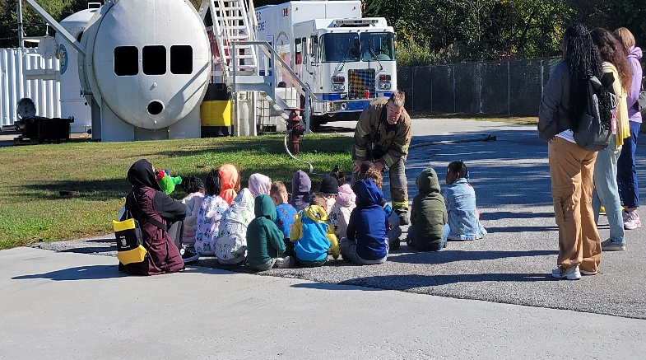

DELAWARE STATE FIRE SCHOOL FIELD TRIPS/TOURS TC/RC

PURPOSE: The course is designed to familiarize the public on the activities and training provided by the Delaware State Fire School.

CONTENT: The course offers tours at the training facilities and provides an opportunity for the public to learn about fire safety and firefighting training. Students will learn about various fire safety topics by rotating through various stations: Emergency Calling, Hazards in the Home, Friendly Firefighter, Escape Planning, Fire Behavior, First Aid, Kitchen Safety, Volunteerism, and Staying Away from Hot Things. The Stations are age appropriate based on the group that visits for the tour.

AUDIENCE: The course is designed for children’s groups to include, but not limited to, preschools, schools, scouting groups, civic groups, child-care facilities, summer camps, and the general public.

CLASS LIMIT: None

FIRE SAFETY TOUR AT A SCHOOL IS

PURPOSE: This course is designed to be taken to
the schools to educate the students on a variety of fire
safety topics.

CONTENT: This program is designed to the fire school tour to the schools that are unable to afford the rising transportation costs. The children will rotate through various fire safety stations and have the ability to practice some of their skills at each station. The topics that are offered include: Friendly Firefighter, Hazards in the Home, Emergency Calling, First Aid, and Escape Planning. For the older grade levels, the children are given a presentation on fire safety, and they are able to practice their skills in a fire safety relay competing for the best time as a class.

AUDIENCE: These programs are designed for children in grades Pre-K through 5th in the classroom setting.

CLASS LIMIT: None

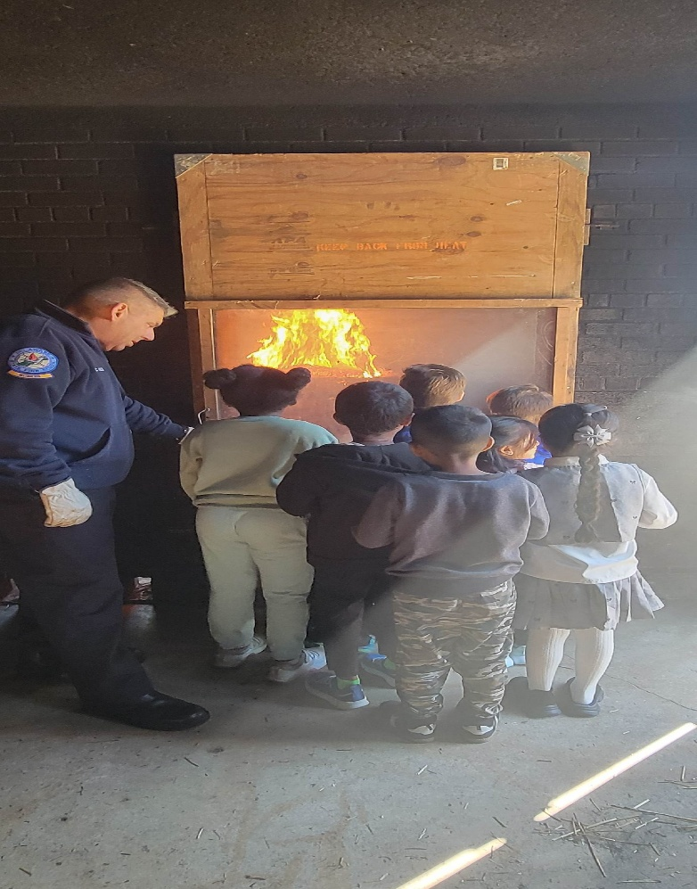
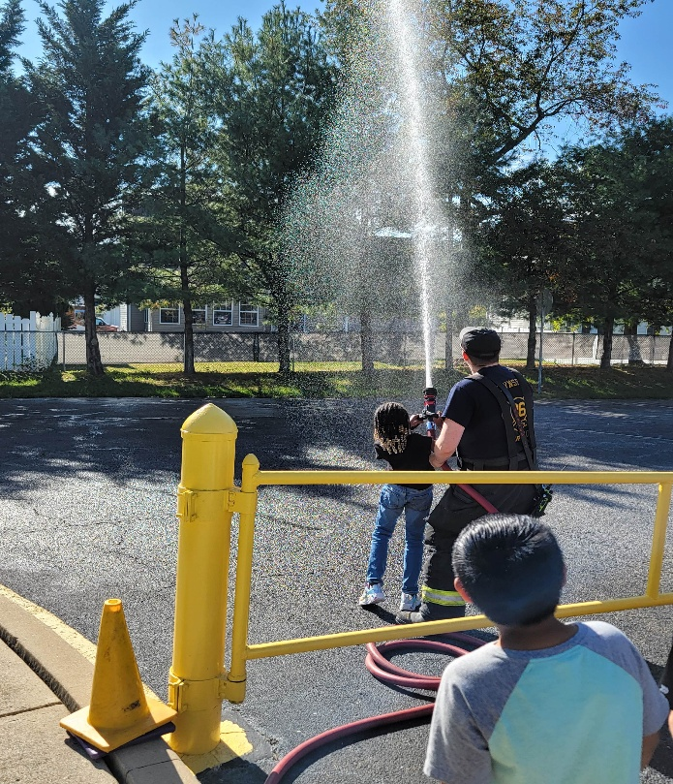
FIRE SAFETY DISPLAYS (3 HOURS) IS

PURPOSE: To provide citizens with awareness of Fire Safety Lessons, Injury Prevention and the Role of the Delaware State Fire School through appearances at Public Events.

CONTENT: The Fire School provides informational handouts, displays and interactive activities to increase the public’s awareness of Fire Safety and Injury Prevention.

AUDIENCE: Anyone with an interest in Fire Safety and Injury Prevention are encouraged to attend

ESCAPE PLANNING (3 HOURS) RC/IS

PURPOSE: Escape Planning means being prepared before a fire emergency occurs. The course will provide guidelines on preparing an escape plan, selection of smoke detectors, and emergency calling.

CONTENT: In this lesson students will learn how to prepare and practice an escape plan for their place of residence in case of an emergency. Students will also learn about smoke alarms, how and where to install them in their residence and maintenance.

AUDIENCE: The course is designed for adults and children’s groups and will be presented according to their age to include, but not limited to preschools, schools, scouting groups, civic groups, and the general public.

CLASS LIMIT: Minimum 10; Maximum 100 Students

SMOKE ALARMS (3 HOURS) RC/IS

PURPOSE: There is a tremendous amount of information out there regarding protecting our families and communities itself by the use of home smoke alarms and carbon monoxide alarms. This course gives general information regarding the proper purchase and placement of alarms. Also, we will discuss the proper Home Fire Escape procedure.

HOME FIRE SAFETY FOR ADULT GROUPS IS

PURPOSE: This provides one (1) hour blocks of instruction on specific general home fire safety subjects.

AUDIENCE: The course is designed for anyone interested in fire safety education to include, but not limited to, Ladies Auxiliary members, fire company officers, firefighters, fire service instructors, fire prevention personnel, teachers and the general public.

CLASS LIMIT: Minimum 10; Maximum 100 Students

KITCHEN FIRE SAFETY: The Kitchen Safety Block provides the student with information on the fire hazards normally found in the kitchen area. This will include discussions on using small electrical appliances safely, including microwave ovens. A tabletop demonstration of products normally used to extinguish a stove top fire will be provided to emphasize the importance of knowing the correct actions to follow when a fire occurs‬‬‬‬

FIRE EXTINGUISHERS: The Fire Extinguisher Block will provide the participants information on the four (4) classes of fire, guidelines on the type of extinguisher to purchase and a guide for placement and maintenance‬‬‬‬

HOME FIRE HAZARDS: The Home Fire Hazard Block will provide the student with guidelines in identifying fire and burn hazards located in the home and preventive measures to follow to correct them to prevent a fire incident‬‬‬‬

FIRE SAFETY FOR SCOUTING (2 HOURS) TC/RC/IS

PURPOSE: This program is developed to teach lessons of fire safety to members of the scouting community. The intent is to also support scouts as they work towards their merit badges.

CONTENT: Power-point can be done for local meetings. Program contains interactive lessons. Topics discussed are Fire Behavior, Home Fire Escape, Fire Safety at Public gatherings, burn injuries, causes of fires in the home, fire extinguisher usage as well as Outdoor Fire Safety.

AUDIENCE: Any member of the Scouting community that has an interest in fire and life safety.

CLASS LIMIT: 25 Students

TUITION: None

INJURY PREVENTION PROGRAMS RC/IS

PURPOSE: Curriculum addresses major risk areas that injure or kill children the most in Delaware and across the country. This program teaches children how to be much safer to prevent injuries and gives them the skills and knowledge needed to recognize and avoid risks in the future.

AUDIENCE: These programs are designed for children in grades Pre-K through 5th in the classroom setting. They are best designed for 1-2 classrooms with the ability to move to each class to reach an entire grade level or school.

CLASS LIMIT: Minimum 10; Maximum 60 Students per presentation.

BIKE SAFETY: This block of instruction discusses the importance of wearing a bike helmet to prevent head injuries and shows the proper way to fit a helmet. It will also provide information on the rules of the road and safety rules to‬‬‬‬
follow while riding a bicycle.

POISON PREVENTION: This block of instruction is designed to show children how medicines and other household products can look like poisons. Discussions include learning the poison control center phone number, identifying look-a-likes, and other safety tips to prevent accidental poisoning in the home.

PEDESTRIAN SAFETY: This block of instruction will educate children on the rules of crossing the street safely, proper behavior at the bus stop, and other safety rules when you are a pedestrian.

HALLOWEEN SAFETY: This block of instruction includes discussions on the following topics: costumes and fire safety, stranger safety, pedestrian safety at night, and poison prevention.

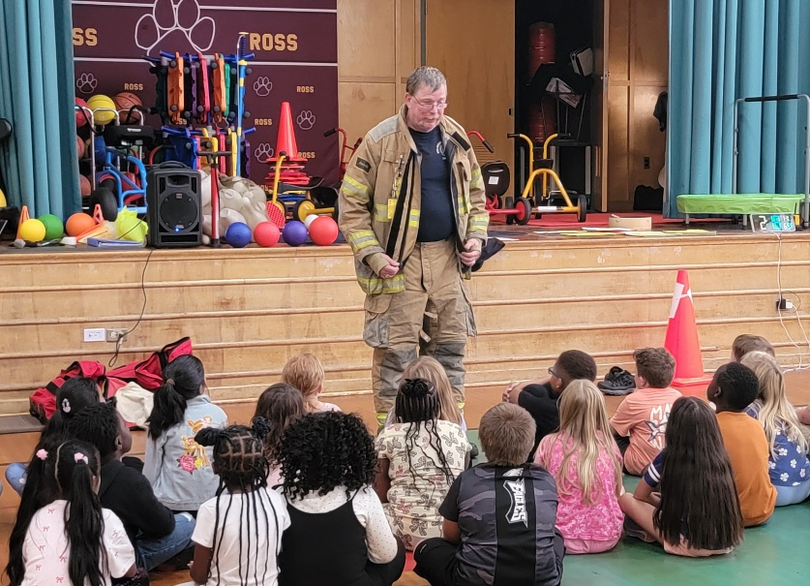
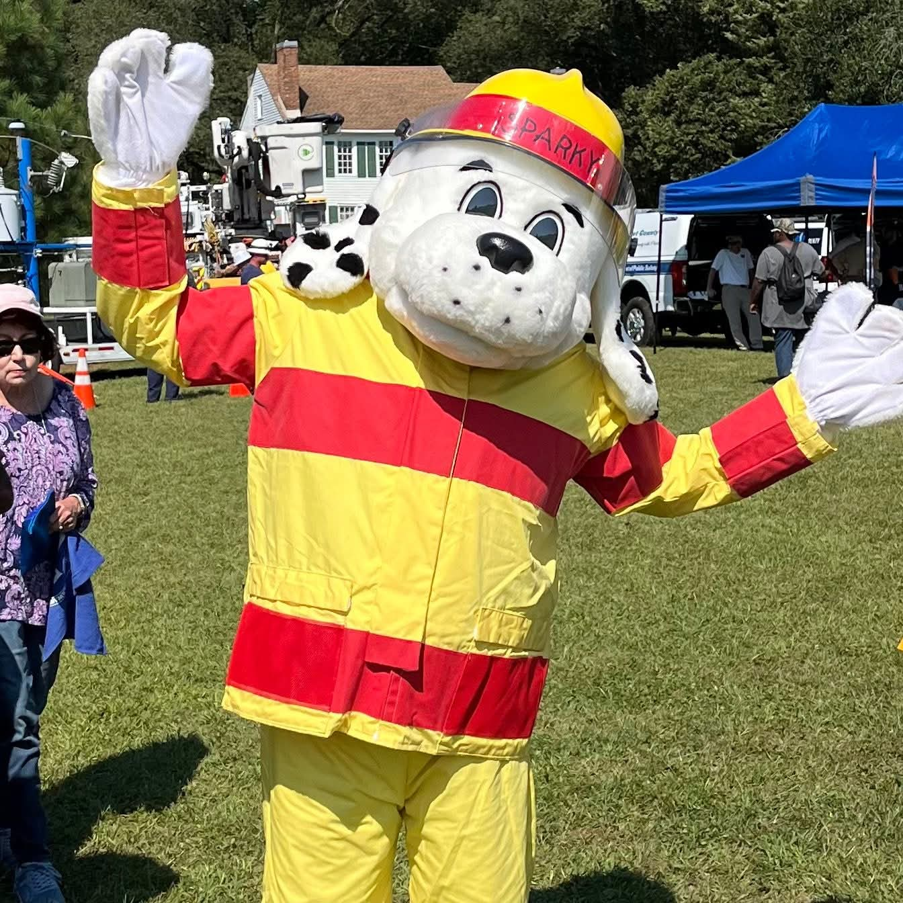

DSFS SUMMER PROGRAMS

JUNIOR FIRE ACADEMY TC

PURPOSE: The Junior Fire Academy has been designed to display the necessary skills and knowledge that a new firefighter may utilize on an emergency scene. This camp allows the camper to experience parts of fire-training courses provided by the school, to experience a small portion of training available as a member of a fire company.

CONTENT: Orientation, Protective Equipment, Fire Behavior, Fire Extinguisher usage, Forcible Entry Equipment, and Hoses will be discussed. Students will be able to take fire service-related tours as part of the experience.

AUDIENCE: Those who are 13 to 17 years of age that have an interest in fire and rescue service.

CERTIFICATION: None

PREREQUISITES: None

TUITION PER STUDENT: $50 Per Student

CLASS LIMIT: Minimum 10; Maximum 50

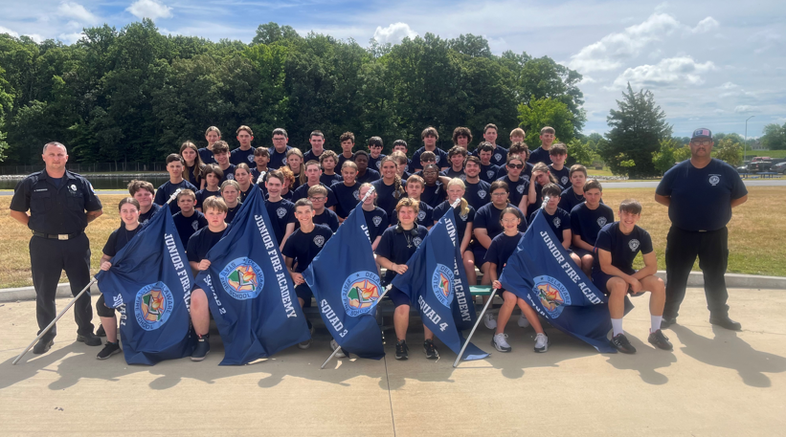

DELAWARE STATE FIRE SCHOOL

RECIPROCITY POLICY FOR OUT OF STATE TRAINING

The Delaware State Fire School accepts for training purposes the following as equivalent. However, we will not give credit for out of state programs, but we will waive the prerequisite requirements for advanced programs.

Students that have successfully completed Basic Firefighting Skills, Structural Firefighting Skills, Hazardous Materials Response Skills, and Vehicle Rescue will be considered as having the equivalent of Delaware Firefighter I and II.

Students that have national certification as a Fire Officer I or II, will be considered as having the equivalent of Delaware Fire Officer I or II.

Students that have not obtained state or national certification as a Firefighter I (out of state that meets NFPA 1001) or national certification as a Firefighter I or II but have taken only individual courses shall be required to attend the Delaware Firefighter I & II program.

Students that have obtained armed forces Firefighter training and have certification as a Firefighter I or II shall be considered as having the equivalent of Delaware Firefighter I and II. Separate courses (such as Shipboard Firefighting, etc.) will not be considered as an equivalent to DSFS training.

Any student, who has certification, State or National, that specifically meet ALL the requirements of NFPA 1010 for Firefigher II, will be considered as having the equivalent of Delaware Firefighter I and I.

A complete copy of previous training certificates must be submitted by the sponsoring Fire Company’s Training Officer for review and approval by the Delaware State Fire School.

Updated 12/2023

STUDENT DISCLOSURE POLICY

Section 1 – Authority

Under the provisions of Section 6614, Title 16, of the Delaware Code, the State Fire Prevention Commission has been given authority to make all rules and regulations necessary for governing the Delaware State Fire School.

Section 2 – Purpose

The purpose of these procedures is to set forth the conditions governing the protection of privacy of students as it relates to the disclosure of training records maintained and supervised by the Delaware State Fire School.

Section 3 – Definitions

1. "Student" includes any individual for whom the Delaware State Fire School maintains a training record.
2. "Student Training Record" means those training records related to a student and are maintained by the Delaware State Fire School. The term does not include lesson plans, outline tests, test keys and other materials used for training the student.
3. "Certified Ambulance Attendant" means a student who has successfully completed the certification requirements for EMT as established by the State Fire Prevention Commission.

Section 4 - Disclosure of Student Training Record Information

1. The Delaware State Fire School shall disclose student training record information to the student who is or has been in attendance at Delaware State Fire School programs.
2. The Delaware State Fire School may disclose student training record information without the written consent of the student if the disclosure is:
a. To the Fire Department provided the request is made by the Fire Chief and the student is a member of the Fire Department.
b. To Volunteer Ambulance Organizations provided the request is made by the Chief Ambulance Officer and the student is a member of the ambulance organization.
c. To Industrial Organizations provided the request is made by an authorized official and the student is an employee of the organization.
d. To agencies and institutions provided the request is made by an authorized official and the student is an employee of the agency or institution.
e. To state and local officials or authorities to whom information is specifically required to be reported or disclosed pursuant to state statute including requests under the Freedom of Information Act (FOIA).

Section 5 - Right to Inspect and Review Training Records

1. The Delaware State Fire School shall permit the student who is or has been in attendance at Delaware State Fire School sponsored programs, to inspect and review the training records of the student.
2. The Delaware State Fire School shall permit other organizations to inspect student records provided written permission has been given by the student or the organizations meet the conditions outlined in Section 4 of these procedures.
3. Training records requested through the Freedom of Information Act (FOIA) will be referred by the Fiscal Advisor to the Deputy Attorney General assigned to the State Fire Prevention Commission for review.

Section 6 – Fees

- The Delaware State Fire School may charge a fee for copies of the student training records provided the fee does not prevent the student from exercising the right to inspect and review those records.

Section 7 – Disclosure of EMTs and EMRs

- The State Fire Prevention Commission discloses that a student is or is not a certified EMT or EMR.

NOTE: Any student objecting to the release of training record information to the sponsoring organization without their expressed consent shall be required to so state in writing to the Director of the Delaware State Fire School; otherwise, provisions of this policy will be followed.

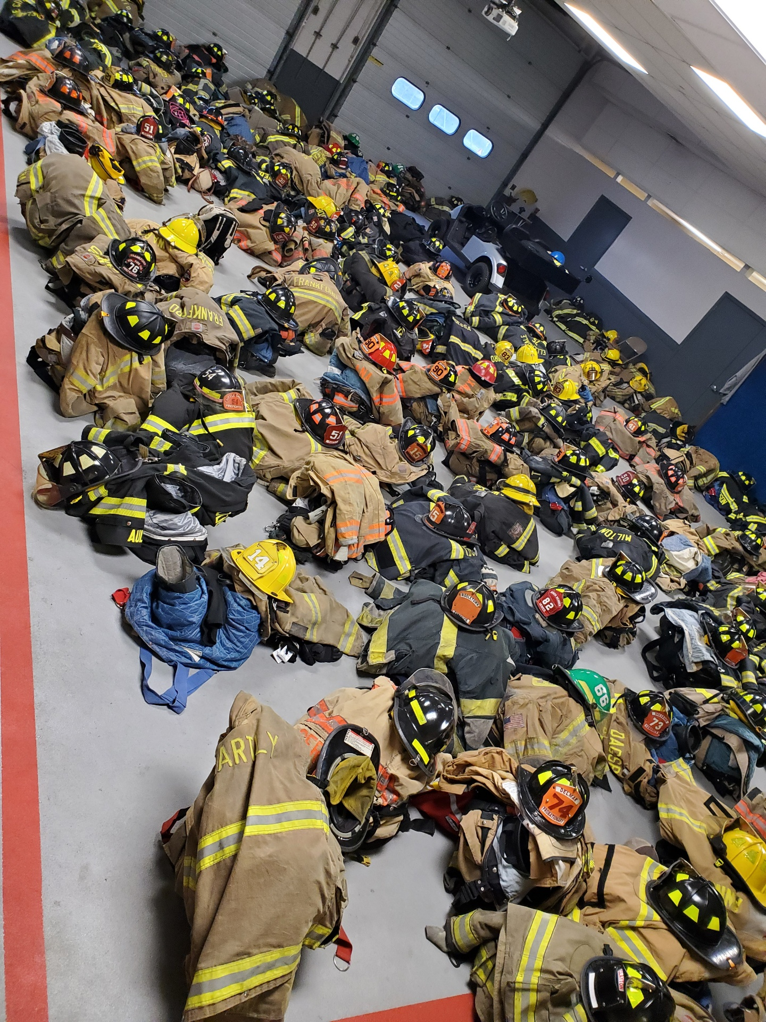

Training is the key to professionalism

